Heat exchange
Heat exchange (or transfer) refers to adding heat, e.g. cooking, or removing heat, e,g. refrigerating or freezing. The exchange of heat to or from foods is necessary in both domestic food preparation and industrial food manufacture.

Complete the following chart remembering that one or more methods of heat exchange may be used when cooking different dishes.

Recipe | Method of heat exchange (transfer)
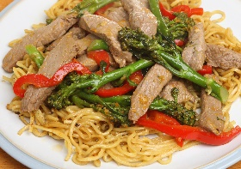  Pork stir fry | Pork stir fry:  Boiled noodles:
  Cheese on toast | Bread:  Cheese:  Sliced tomatoes:
  Griddled chicken with rice and green beans | Chicken:  Rice:  Green beans:
  Cod baked en papiolotte served with couscous | Cod:  Couscous:

