Courgette and cheese muffins
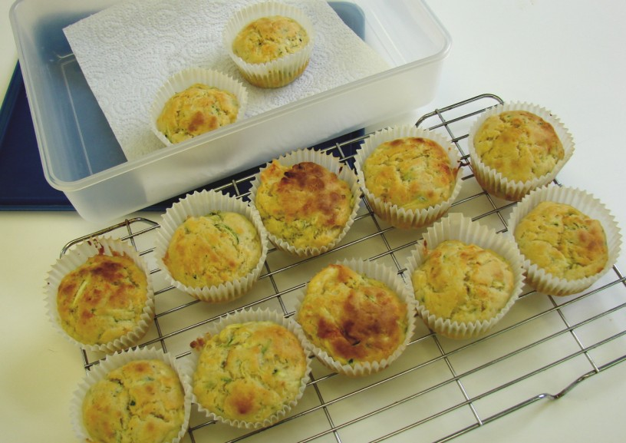
Complexity: low - medium
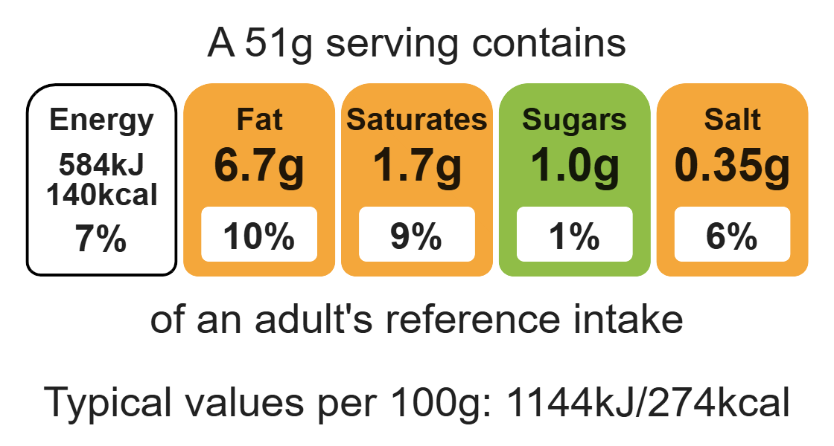

Ingredients (serves 12)

Equipment

weighing scales

12 muffin cases

muffin tray

chopping board

sharp knife

grater

measuring jug

mixing bowl

heat-resistant spoon

2 metal spoons

cooling rack

100g courgette
100g reduced-fat Cheddar cheese
125g white self-raising flour
100g wholemeal self-raising flour
50ml oil
175ml semi-skimmed milk
1 egg
Black pepper

Method
- Preheat oven to 200°C or gas mark 6.
- Place the muffin cases in the muffin tin.
- Cut the ends of the courgette.
- Grate the courgette and cheese.
- Mix the courgette, grated cheese, four, oil, milk, egg and black pepper together in a mixing bowl to form a smooth batter.
- Divide the mixture equally between the muffin cases using 2 spoons.
- Bake for 20 minutes, until golden brown.
- Allow to cool on a cooling rack.

Top tips
- Reduce food waste: Use up any leftover vegetables and add them to the muffins such as carrots.
- Focus on fibre: Use 225g of wholemeal self-raising flour to boost the fibre.
- Turn up the flavour: Try adding ½ x 5ml spoon of mustard, chilli or ginger. Try different types of cheese e.g. Edam or feta.

Food skills
Weigh, measure, grate, cut, chop, slice, dice and trim, mix, stir and combine, portion/divide, bake.

