Chilli con carne

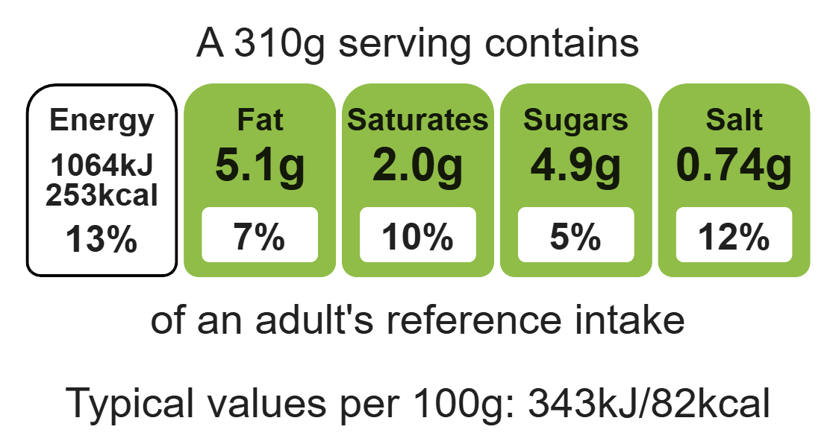


Ingredients (serves 3)
Complexity: medium
1 onion
1 clove garlic
1 pepper
250g minced beef
2 x 5ml spoon flour
1 reduced-salt beef stock cube
250ml water
1 x 400g can red kidney beans
1 x 15ml spoon tomato puree
1 x 5ml spoon chilli powder
Equipment
Sharp knife
Chopping board
Garlic press
Measuring spoons
Frying pan
Heat-resistant spoon
Measuring jug
Kettle
Can opener
Colander

Method
1. Prepare the vegetables:
• peel and chop the onion;
• peel and crush the garlic;
• deseed and chop the pepper.
2. Dry fry the onion, garlic and minced beef until the mince has browned.
3. Stir in the flour.
4. Make up the stock.
5. Pour in the stock.
6. Drain the red kidney beans and add to the meat.
7. Stir in the tomato purée and chilli powder.
8. Bring to the boil, then reduce the heat and simmer for 20 minutes.
9. Add the pepper and allow to cook for a further 15 minutes.

Top tips
- Serving suggestion: Serve with rice, a jacket potato or a taco shell.
- Turn up the flavour: Add extra chilli powder, cayenne pepper or Worcestershire sauce for an extra kick.
- Reduce food waste: Use up any leftover vegetables such as carrots or courgette.

Food skills
Weigh, measure, peel, cut, chop, slice, dice and trim, fry and sauté, mix, stir and combine, melt, simmer and boil, drain.

