Free sugars line up – answers

Cola (330ml)  Free sugars (per portion): 36g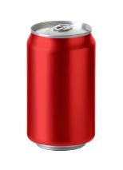 | Diet cola (330ml)  Free sugars (per portion): 0g  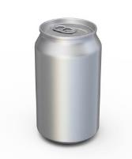
Red wine (175ml)  Free sugars (per portion): 0.4g  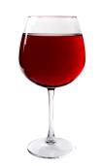 | Fruit squash (50ml)  Free sugars (per portion): 23.8g  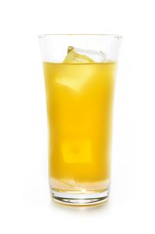
Plain yogurt (125g) with berries (80g)  Free sugars (per portion): 0g | Fruit yogurt (125g)  Free sugars (per portion): 11.25g
Slice of lemon cake with icing (50g)  Free sugars (per portion): 21.3g | Digestive biscuit (15g)  Free sugars (per portion): 2.7g
Orange (80g)  Free sugars (per portion): 0g  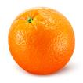 | Table sugar (4g)  Free sugars (per portion): 4g  