Session: Bakers Haven

Welcome
This session is about the production of bread based products. As with other sessions, students will revisit many skills and techniques, therefore making them more confident cooks. It also provides you with the opportunity to assess students' practical capability. You could use the practical observation sheet to help.
During this session, students will make either Bread rolls or Pesto pizza or Finnish fruit plait. These have been chosen as they improve essential knowledge of yeast and flour based products, act as a reminder for the safe use of the cooker and can be cooked by students easily at home to have as a snack or as part of a meal. If some of your students are intolerant to gluten, use gluten free flour.
There is lots of room for students to be creative, selecting different types of ingredients that could be combined into the dishes. You could get your students to use the Bread rolls or Pesto pizza or Finnish fruit plait recipe writing frames before cooking to develop their own ideas. The students’ own recipe creations could then be used in this session.

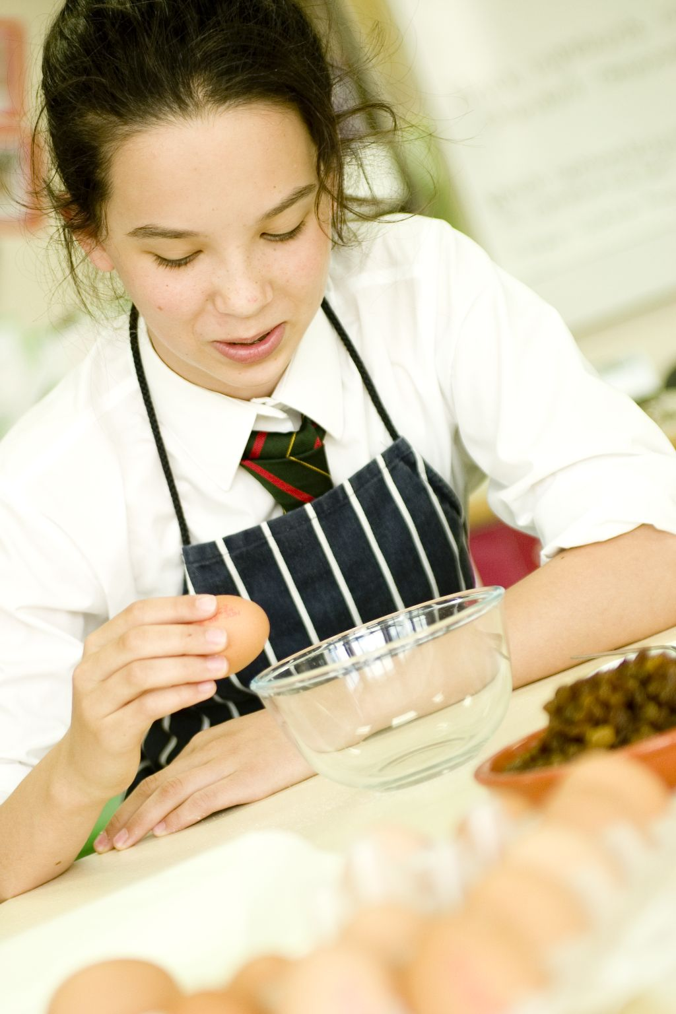
If you have an established lesson plan and/or recipe, which supports the aims and objectives of this session, feel free to use it instead. Look at the support materials provided within this session as they support this activity and may well be useful in your own lessons, e.g. worksheets, PowerPoint presentations.
This session can act as a stand-alone lesson, focusing on knife skills. Alternatively, it could be integrated into a series of lessons, e.g. exploring mass food production, designing a bread, historical and cultural variations in breads.
Aims and objectives
Aim
For students to:
- become more confident preparing and cooking a variety of yeast baked products.
Objectives
Students should be able to:
- demonstrate making a dough confidently;
- prepare a range of ingredients, e.g. sifting flour, preparing a yeast culture, proving a dough, kneading a dough;
- use the oven safely to bake yeast and flour based products;
- bake one bread yeast dough, e.g. Bread rolls or Pesto pizza or Finnish fruit plait.

Cooking session
Three cooking session plans, based on the Licence to Cook recipes are supplied within this session.

If you have your own tried and tested Bread rolls or Pesto pizza or Finnish fruit plait recipe, feel free to use it instead. In addition, you may wish to make other types of dishes, such as Chelsea buns.
Each plan refers to aspects of healthy eating, wise food shopping and food safety and hygiene which are themes that run through each session.
Before the cooking session
There are a number of factors that you need to consider before the cooking session. More detailed guidance is available in the Cooking session guide.

You will need to consider:
- Ingredients: who will be providing the ingredients and where will they be stored? Are there any students with allergies?
- Recipe: are students going to use a printed-out copy or follow instructions on an interactive whiteboard?
- Equipment: is all the equipment needed for the session available, clean and in good working order? Check that all the ovens are in good working order and clean. Students will require the use of a baking tray - check that there are enough. You may ask students to share a baking tray. Lining, not greasing, saves time and washing up.
- Aprons: do you have enough and are they clean?
- Hair: do you have ties/bands for long hair?
- Containers: will students be able to take away the bread products they make? If so, in what?
- Waste: do you have adequate disposal facilities, including recycling or composting?
- Cooking area: is it clean and ready to use?

Differentiation and inclusion
Before this practical session, you will need to consider the age, ability, previous experience and any special requirements of your students. This will determine recipe selection, any advanced ingredient preparation and equipment used.
Do any of your students need:
- pre-prepared ingredients, such as grated cheese or ingredients pre-
weighed?
- support using the oven?
- to follow different recipes. The Bread rolls recipe is slightly easier than
the Finnish fruit plait and good for making in pairs.
- to be challenged, perhaps allowing them to prepare, cook and market their
yeast and flour-based products?
- gluten or dairy free alternatives?

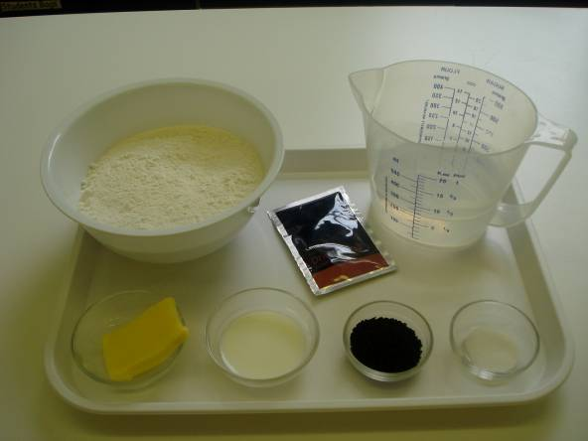
Demonstration
Although the three recipes suggested vary in the way in which the bread mixture is prepared, go through the main stages of the cooking and checking process with the students. You will probably not need to demonstrate any knife skills or oven use again at this stage. However, do remind students to prepare ingredients and cook safely.

Ensure that you have all the ingredients and equipment you need before the session, perhaps on trays for ease, for your demonstration.
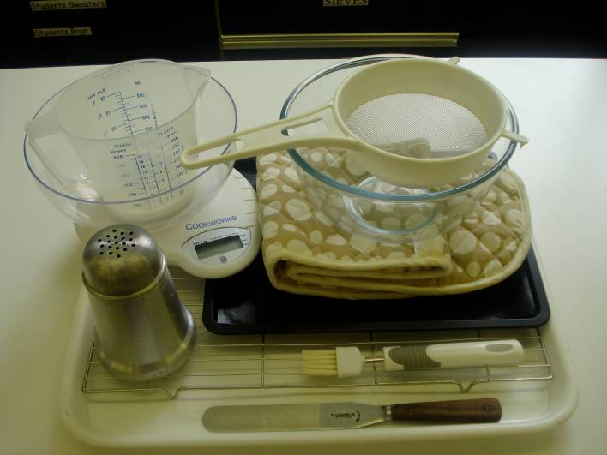
Think about:
- describing the ingredients
and equipment used;
- highlighting the techniques
of kneading, proving,
forming and shaping
dough;
- showing how to turn on and
set the oven temperature;
- ensuring that students have
followed and understood the
method.

More detailed guidance is available in the Demonstrating guide.

Risk assessment

The three cooking session plans and recipes highlight a number of different hygiene and safety issues which need to be considered before, during and after the cooking session.

Before the cooking session, you will need to assess these risks in relation to the number of students being taught, as well as their experience, and consider measures that can be put into place to manage the risk. Below are examples of potential risks, along with preventative measures.

Bread rolls
Potential risk | Measure | Likelihood
Burn from placing and removing bread in oven | Demonstrate safe use of the oven, promote the use of oven gloves and monitor students’ use | Low/Med
Dirty hands whilst kneading | Ensure all pupils have washed hands thoroughly before and during cooking. | Low/Med

Pesto pizza
Potential risk | Measure | Likelihood
Dirt or food poisoning bacteria present on raw food, causing cross contamination | Wash vegetables before use | Low
Burn from placing and removing pizza bread base in oven | Demonstrate safe use of the oven, promote the use of oven gloves and monitor students’ use | Low/Med
Dirty hands used for kneading | Wash hands thoroughly and regularly during cooking | Med

Finnish fruit plait
Potential risk | Measure | Likelihood
Salmonella from raw egg | Remind students to wash their hands after touching raw egg | Low/Med
Dirty hands used for kneading | Wash hands thoroughly and regularly during cooking | Med
Burn from placing and removing bread in oven | Demonstrate safe use of the oven, promote the use of oven gloves and monitor students’ use | Low/Med

Time
The session plans are based on a 60 minute session.

Due to the need to allow bread to prove, these recipes will require additional time. It might be that you use the recipe for Irish soda bread, or a scone based pizza, instead, due to timetable restraints.

If you have less time available, you will need to modify the session plan to better suit your circumstances. For example, within this session you might:
- demonstrate the safe use of the oven another time;
- demonstrate key aspects from the recipe, rather than every stage;
- have ingredients pre-measured;
- use ready lined baking trays, to save washing up and therefore time;
- allow students to work with a partner – sharing a bread dough and then halving the mixture before baking.
During the lesson
Time (mins) | Activity: Bread rolls | Equipment/ Resources
0 | Registration.  Explain to the students that they will be making Bread rolls. Go through the aims and objectives for the lesson. | Bread rolls  recipe
5 | Gather the students around a demonstration area, with your tray of ingredients and equipment. Ensure that all students have their apron on, hair tied back and hands washed.  Briefly talk through the recipe – note your expectations, for example:  * preparing the ingredients carefully and accurately;  * safe use of the oven;  * using yeast – what is it and how does it work?  * temperature of the water and the yeast activity.  * kneading – what is it and why do it?  * proving – what is it and why do it?  * forming a soft dough – avoiding making it too dry/wet;  * adding glaze or topping if used;  * being hygienic and safe when preparing food. | Aprons  Demonstration ingredient and equipment tray
10 | Demonstration  * Place out the mixing bowl, sieve, measuring jug, palette knife, pastry brush and flour dredger.  * Remind students about pre-heating the oven. Remind students that when placing and removing items from the oven they must always wear oven gloves.  * Sieve the flour into a mixing bowl and add salt.  * Open the packet of yeast and stir into the flour mixture.  * Make a well in the centre of the flour and add warm water to the dough activates the yeast. Water that is too cold or too hot will not promote good yeast activity.  * Demonstrate kneading and stress the importance of the length of time of kneading (10 mins). Look for the changes in the dough as it becomes smooth and stretchy.  * Divide the dough into 4 pieces and shape into rolls.  * Place the rolls on the greased baking tray.  * Cover the dough and leave to prove in a warm place, until they double in size.  Ensure that all students wash their hands. Allow them to start making their Bread rolls. | Fire blanket
15  20-30 | During this time, circulate the room to ensure that students are preparing ingredients and using the oven safely. In this time, students should:  * preheat the oven and prepare the baking tray;  * measure their ingredients;  * sieve the flour and salt;  * add yeast and warm water;  * form a soft dough – ensuring that it is not too dry or wet, just smooth;  * knead for about 10 minutes.  * divide the dough into 4 pieces and shape into rolls.  * place the rolls on the greased baking tray.  * cover the dough and leave to prove in a warm place, until they double in size.  At this stage most students should have formed a soft dough. Check all the mixtures before students leave the dough to prove. Then, students should clean up their work surface.  Demonstration  * Glaze the risen rolls with milk and sprinkle with toppings if used.  * Use oven gloves to place the bread on the middle shelf in the oven.  * Remind the students how to check if the rolls are cooked.
40 | All Bread rolls should be baking, as they take at least 10 minutes in the oven. During this time students should be washing up, cleaning work surfaces and putting away equipment.
50 | Give a 5 minute time warning.  Remind students that all washing up should be completed, work surfaces should be clean, and their Bread rolls should be on a cooling rack ready to be placed into their containers.  Circulate the room, ensuring that sinks are clean, and equipment is put away properly.
55 | Plenary  Pose the following questions to the students:  * What were the main skills demonstrated today?  * Name the main stages of bread making.  * How could this recipe be modified to make it healthier?
60 | Finish

After the session
Check that the room is clean and tidy. Students should leave the room as they find it.

The Bread rolls may need to be left with the container open for half an hour because the food will become soggy if the steam is not able to escape. If this is the case, ensure that each container is partially covered and clearly labelled with the student’s name and group. No pests such as flies should have easy access to the food. Once cooled, seal the containers to ensure the bread rolls do not go stale.

If time, you may wish for the students to eat the Bread rolls as part of the lesson but remind them about portion sizes.

If the same students are with you for another cooking session in the next few days or week, remind them of the ingredients and/or containers they need to bring, if appropriate. You may wish to provide students with recipes or writing frames.

During the lesson
Time (mins) | Activity: Pesto pizza | Equipment/ Resources
0 | Registration.  Explain to the students that they will be making Pesto pizza. Go through the aims and objectives for the lesson. | PowerPoint  Pesto pizza Recipe
5  10  15 | Gather the students around a demonstration area, with your tray of ingredients and equipment. Ensure that all students have their apron on, hair tied back, and hands washed.  Briefly talk through the recipe – note your expectations, for example:  * preparing the ingredients carefully and accurately;  * using the oven safely;  * forming a soft dough;  * kneading dough;  * being hygienic and safe when preparing food. | Aprons  Demonstration ingredient and equipment tray
 | Demonstration  * Place out sieve, mixing bowl, and flour dredger.  * Sieve flour and add salt into a mixing bowl. Stir in the yeast.  * Add the oil and enough warm water to mix into a soft dough with your hands.  * Explain the importance of kneading the bread dough and the changes the dough will undergo as it becomes smoother and stretchier.  * Remind the students that once their dough is being proved they will need to clean up and begin the topping preparation.  Ensure that students all wash their hands. Allow them to start preparing their pizza topping.  During this time, circulate the room to ensure that students are preparing ingredients and using the oven safely. In this time, students should:  * preheat the oven;  * measure their ingredients;  * sieve the flour and add salt;  * add yeast and warm water  * form a soft dough – ensuring that it is not too dry or wet, just smooth.  * knead for about 5 - 10 minutes. | Aprons  Demonstration ingredient and equipment tray

20 | Demonstration  * Place out the chopping boards, vegetable knife, and plate.  * Spread the pesto on the pizza until it just reaches the edges. Explain the ingredients of pesto and how it is made.  * If time, you may wish to explain how to prepare the vegetables. Stress the importance of using the Bridge hold and Claw grip technique.  * Arrange the tomato and olives on top of the two bases and sprinkle with feta cheese.  * Use oven gloves to place the pizza on the middle shelf for 10-15 minutes. | Basic equipment  Ingredients
30 | Students should be rolling out the dough, preparing the topping and assembling their pizzas.
40 | During the remaining time students should be washing up, cleaning work surfaces and putting away equipment.
50 | Give a 5 minute time warning.  Remind students that all washing up should be completed, work surfaces should be clean, and their Pesto pizza should be placed in a container.  Circulate the room, ensuring that sinks are clean, and equipment is put away properly.
55 | Plenary  Pose the following questions to the students:  * What were the main skills demonstrated today?  * Name 5 different coloured vegetables that could be added.  * Bread can be relatively high in salt. What is the purpose of salt in bread?
60 | Finish

After the session
Check that the room is clean and tidy. Students should leave the room as they find it.

The Pesto pizza may need to be refrigerated until the end of the school day, if so, ensure that each container is loosely covered and clearly labelled with the student’s name and group. The refrigerator should be between 0-5ºC.

If the same students are with you for another cooking session in the next few days or week, remind them of the ingredients and/or containers they need to bring, if appropriate. You may wish to provide students with recipes or writing frames.
During the lesson
Time (mins) | Activity: Finnish fruit plait | Equipment/ Resources
0 | Registration.  Explain to the students that they will be making Finnish fruit plait. Go through the aims and objectives for the lesson. | PowerPoint Finnish fruit plait  Recipe
5 | Gather the students around a demonstration area, with your tray of ingredients and equipment. Ensure that all students have their apron on, hair tied back and hands washed.  Briefly talk through the recipe – note your expectations, for example:  * preparing the ingredients carefully and accurately;  * using the oven safely;  * forming a soft dough;  * kneading dough;  * plaiting bread dough;  * being hygienic and safe when preparing food. | Aprons  Demonstration ingredient and equipment tray
 | Demonstration  * Place out sieve, mixing bowl, and flour dredger.  * Sieve flour and add salt into a mixing bowl. Stir in the currants, mixed peel and yeast with a palette knife.  * Add the warm milk to the sugar to dissolve it.  * Make a well in the centre of the flour and pour in the milk. Melt the margarine and then add it and ½ the beaten egg to the flour mixture. Mix to make a smooth dough using hands. Remind students to wash their hands after using raw egg.  * Explain the importance of kneading the bread dough and the changes the dough will undergo as it becomes smoother and stretchier.  * Remind the students that once their dough is being proved they will need to clean up their work area. | Aprons  Demonstration ingredient and equipment tray
 | Ensure that all students wash their hands. Allow them to start making their Finnish fruit plait. | Aprons  Demonstration ingredient and equipment tray
15 | During this time, circulate the room to ensure that students are preparing ingredients and using the oven safely. In this time, students should:  * preheat the oven;  * measure their ingredients;  * sieve the flour and add salt;  * add yeast and warm water;  * form a soft dough – ensuring that it is not too dry or wet, just smooth;  * knead for about 5 minutes.  At this stage most students should have formed a soft dough.  Demonstration  * Place out flour dredger, and prepared baking tray.  * Show the students how to divide the mixture into three equal portions with the side of their hand and work the dough into long sausage shapes before plaiting them together. Remind the students that the dough will increase in size with proving so the plait will need to be thin and long. | Basic equipment  Wok or saucepan  Ingredients
Check all the mixtures before students leave the dough to prove. Then, students should:
* clean up their work surface.

Before baking all Finnish fruit plaits should be brushed with the remaining egg before being placed into the middle shelf of the oven.

All Finnish fruit plaits should be baking, as they take at least 10 minutes in the oven. During this time students should be washing up, cleaning work surfaces and putting away equipment.
40 | During the remaining time students should be washing up, cleaning work surfaces and putting away equipment.
50 | Give a 5 minute time warning.  Remind students that all washing-up should be completed, work surfaces should be clean, and their Finish fruit plait should be placed in a container.  Circulate the room, ensuring that sinks are clean, and equipment is put away properly.
55 | Plenary  Pose the following questions to the students:  * What were the main skills demonstrated today?  * What are three things that students could have done better?  * What other types of breads could be made?
60 | Finish
After the session
Check that the room is clean and tidy. Students should leave the room as they find it.

The Finnish fruit plait should be placed in a container is loosely covered and clearly labelled with the student’s name and group. Once the Finnish fruit plait has cooled completely the containers can be sealed.

If the same students are with you for another cooking session in the next few days or week, remind them of the ingredients and/or containers they need to bring, if appropriate. You may wish to provide students with recipes or writing frames.

Areas of learning
Healthy eating
- Use wholemeal flour, instead of white, for additional fibre.
- Experiment with different types of fruit to add to Finnish fruit plait.
- Thick base for Pesto pizza.

Wise food shopping
- Buy economy brands to save money.
- Freeze the bread dough after shaping for another time.

Food safety and hygiene
- When getting ready to cook, always wear an apron, tie back long hair, roll up long sleeves, remove any jewellery and wash your hands.
- Check that the eggs are within their date-mark and that the shells are not damaged.

Extending this activity
This session provides a great opportunity to be integrated into existing lessons or be developed into a mini-scheme of work.
For example, students could:
- explore the range of breads available to buy in shops, noting their ingredients and sensory appeal;
- explore other methods of making breads such as bagels and gluten-free;
- plan and create new recipe ideas for bread based on inspirations from regional breads from Britain or Ireland;
- evaluate their own, and class friend’s recipes, suggesting possible modifications in relation to healthy eating.

Appropriate aspects of ICT could also be integrated, including:
- recording the nutritional profile of a recipe;
- creating a recipe plan or flow-chart;
- modelling cost for economy or luxury versions of a recipe;
- exploring the internet for inspiration through travel websites.

Shopping list
Bread rolls
Ingredient | x 1 | x 10 | x 20
Strong white plain flour | 300 | 3kg | 6kg
Salt | ½ x 5ml spoon | 25ml | 50ml
Margarine | 15g | 150g | 300g
Quick acting yeast | 1 sachet | 10 sachets | 20 sachets
Water | 200ml | 2Ltr | 4Ltr
Milk for glazing | 15ml | 10 x 15 ml | 20 x 15ml
Poppy/Sesame seeds | 15ml spoon | 15 x 15ml spoon | 20 x 15ml spoon

Pesto pizza
Ingredient | x 1 | x 10 | x 20
Strong white plain flour | 75g | 750g | 1.5kg
Strong wholemeal flour | 25g | 250g | 500g
Salt | ½ x 5ml spoon | 5 x 5ml spoon | 10 x 5ml spoon
Dried yeast | ½ sachet | 5 sachets | 10 sachets
Sunflower Oil | 10ml spoon | 150ml | 300ml
Warm water | 50ml | 500ml | 1L
Pesto | 2 x 15ml spoon | 300ml | 600ml
Sundried tomatoes | 25g | 250g | 500g
Black olives (pitted) | 5 | 50 | 100
Feta cheese | 30g | 300g | 600g
Basil leaves | Handful | 1 Bunch | 2 Bunches

Finnish fruit plait
Ingredient | x 1 | x 10 | x 20
Strong white plain flour | 250g | 2.5kg | 5kg
Salt | ¼ x 5ml spoon | 5 x 5ml spoon | 10 x 5ml spoon
Margarine | 15g | 150g | 300g
Milk | 125ml | 1.25L | 2.5l
Dried yeast | 1 sachet | 10 sachets | 20 sachets
Currants | 75g | 750g | 1.5kg
Mixed peel | 25g | 250g | 500g
Caster sugar | 25g | 250g | 500g
Mixed spice or cinnamon | 1/2 x 5ml spoon | 5 x 5ml spoon | 10 x 5ml spoon
Egg | 1 | 10 | 20

Equipment list

Bread Rolls

Baking tray, pastry brush, weighing scales, sieve, mixing bowl, measuring jug, flour dredger, and palette knife.

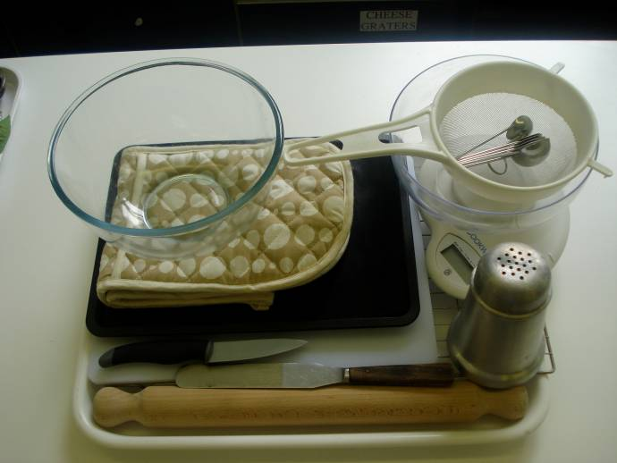
Pizza bread base
Baking tray, pastry brush, weighing scales, sieve, mixing bowl, measuring spoons, measuring jug, flour dredger, rolling pin, palette knife, chopping board, sharp knife, and cooling tray.

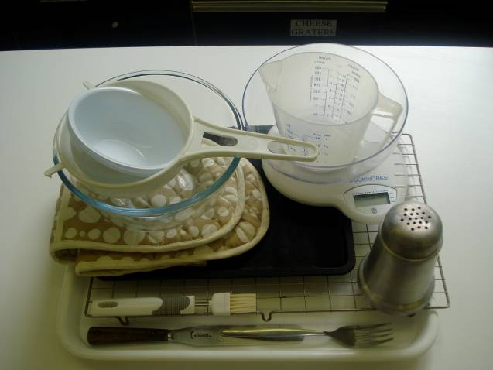
Finish fruit plait

Baking tray, pastry brush, weighing scales, mixing bowls, sieve, wooden spoon, measuring jug, palette knife, flour dredger, saucepan, small bowls, fork, and cooling rack.

Containers

If students take their dishes, they will need to bring (or be provided with by the school) a suitable container, such as a foil container with a lid, or a freezer bag.

