Perico

Ingredients

Complexity: low-medium
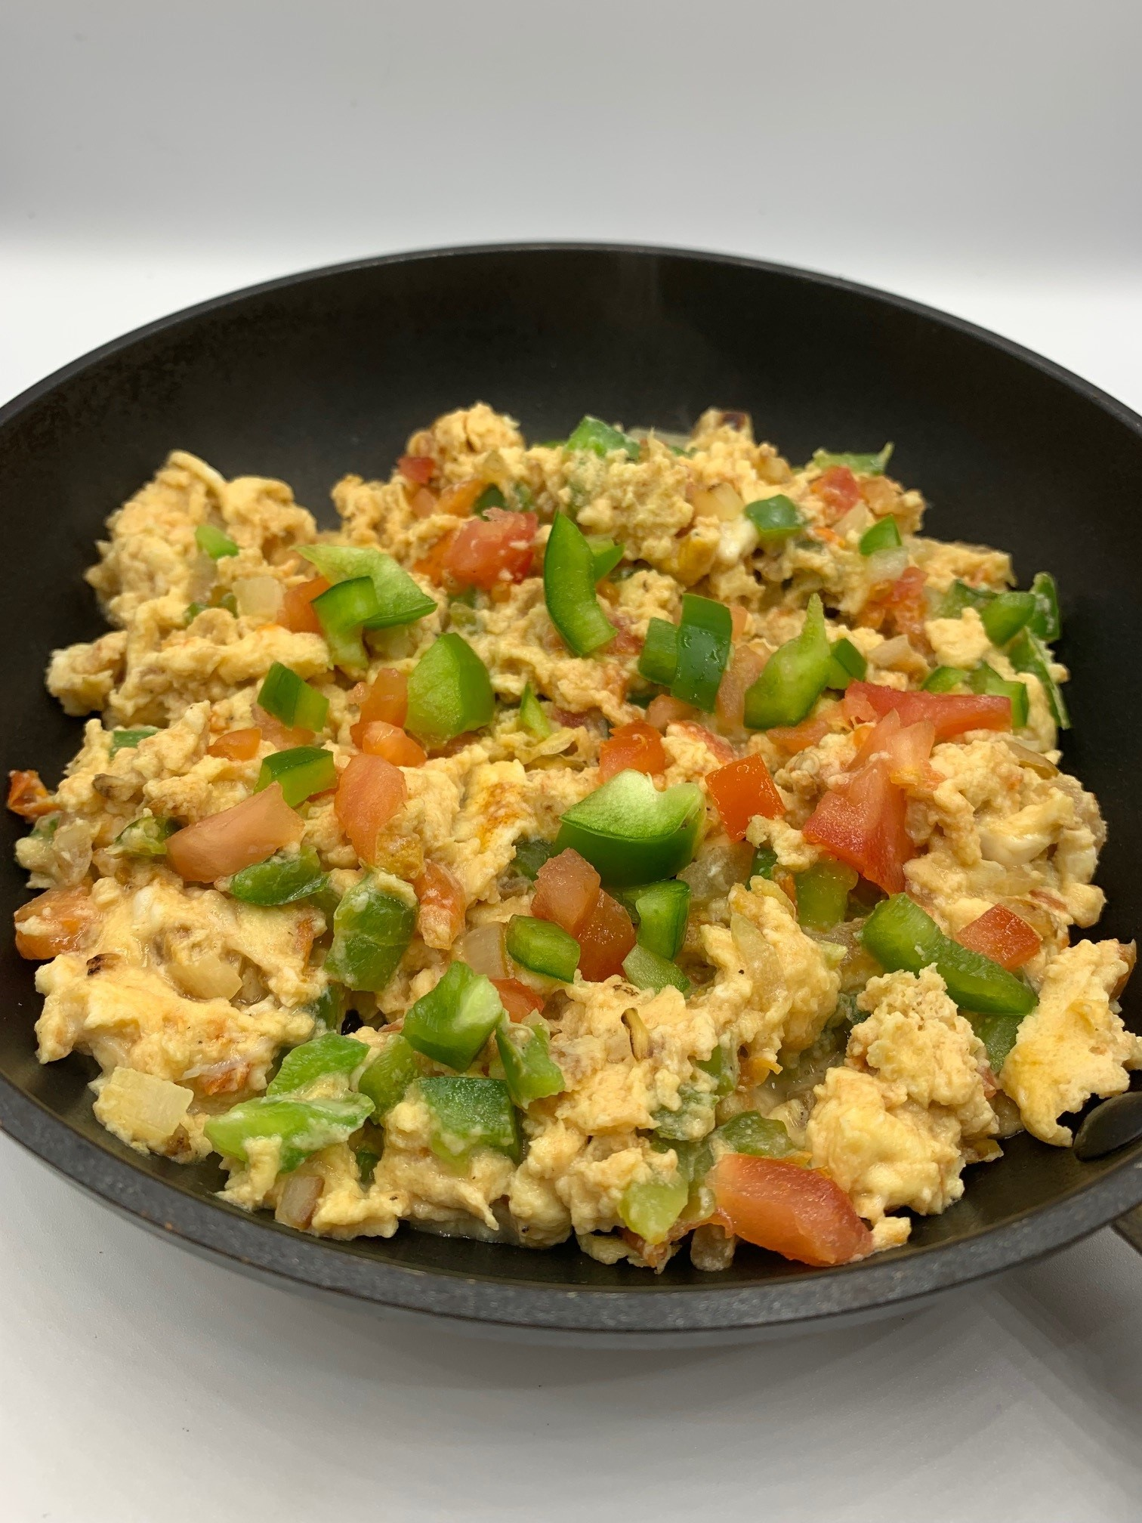
1 small onion
1 tomato
½ green pepper
3 eggs
1 x 15ml spoon milk
Freshly ground black pepper
Spray oil

Equipment
Chopping board, vegetable knife, small bowl, fork, measuring spoon, small frying pan, mixing spoon.

Method
- Prepare the ingredients:
- peel and chop the onion;
- chop the tomato;
- deseed and chop the green pepper.
- Crack the eggs into a small bowl and whisk with a fork.
- Add the milk and stir well.
- Season with black pepper.
- Spray the frying pan with oil and add the onion. Cook over a medium heat until they are soft, approximately 3-4 minutes.
- Add the tomato and pepper. Cook until soft, approximately 8-10 minutes.
- Pour the egg and milk mixture into the pan. Cook gently, stirring lightly.
- Cook until the egg is firm.

Top tips
- Add ¼ x 5ml spoon chilli flakes for a spicy kick!
- Add chopped coriander for extra colour and flavour.
- Serve on a toasted English muffin or with traditional cornbread.

Food skills
- Measure
- Cut
- Chop
- Mix
- Stir
- Fry/sauté

Did you know?
Perico is a popular dish in Columbia and Venezuela. The name comes from the bright colours of the onions, tomato, peppers and eggs, mimicking the colours of a parrot (perico). Spring onions are often substituted for the onions, especially in Colombia.

It can be regarded as a tropical version of scrambled eggs and can be eaten on its own or with bread at breakfast time. Alternatively, it can be used as a filling for arepa, a traditional bead made from maize flour that is grilled, baked, fried, boiled or steamed.

Why not try serving perico in toasted tortilla cones?

- Cut wholemeal tortilla wraps in half.
- Roll and shape each half into a cone and secure with a cocktail stick.
- Bake in the oven at 200°C until crisp and golden, approximately 5-6 minutes.

