Testing food for reducing sugars

Introduction
Some simple sugars, including glucose, can be made to reduce blue copper sulphate to red copper oxide. This reaction can be used as a test for some sugars.

Copper sulphate is mixed with other chemicals to be used as Benedict’s solution which is used in the test.

You will need
Equipment
Test tubes
Test tube rack
Glass rod
Spatula
Mechanical grinder or pestle and mortar
Dropping pipette
Conical flask (100cm³) or small beaker
Bunsen burner
Tripod
Gauze
Mat
Test tube holder
Eye protection

Materials
Food samples
Distilled water
Benedict’s solution
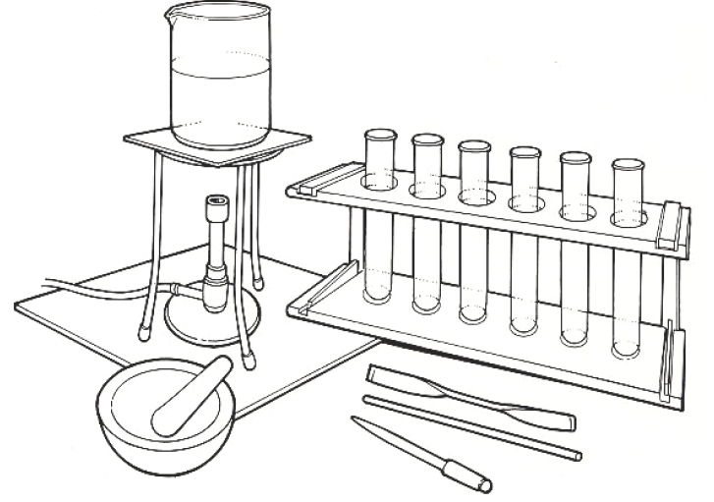

Note: Benedict’s solution is best heated in a water bath.





Some people are allergic or intolerant to a particular food or ingredient. Refer to the 14 allergens and check against student records before completing this experiment.

Care should be taken when heating the water and handling hot test tubes.
Wear eye protection.
Do not consume food in a laboratory, or any food used for experiments, because it may contaminated.

Method
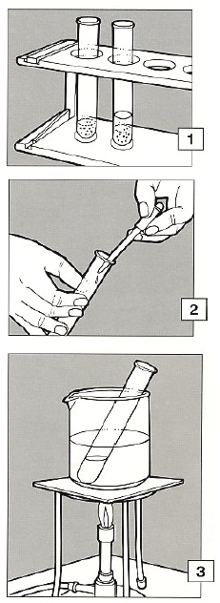
- If the food to be tested is liquid, go to 2. If the food to be tested is solid, make an extract. Grind, crush or chop a small amount and put it into a test tube to a depth of about 2cm. Add a similar amount of distilled water and stir with a glass rod. Allow to stand for a few minutes.

- Draw up about 1cm³ of the clear liquid into a pipette. Add it to a test tube containing about the same amount of benedict’s solution.

- Put the test tube into a beaker of boiling water and leave it for a few minutes so that the mixture is thoroughly heated.

- Remove the tube using a test tube holder. Place a rack and let it stand; look at the contents.

A change in colour from blue to yellow-red indicates the presence of reducing sugar.

Extension work
A sample of food which does not give a red colour may contain other, non-reducing sugars.

To test for these take a larger sample of the same food, crush or chop it finely and put into a small flask or beaker.

Add enough dilute hydrochloric acid* to cover the solid material completely. Boil gently for 10-20 minutes. If necessary add more acid to prevent it boiling dry.

Allow to cool and neutralise the acid by adding sodium carbonate, little by little, until there is no sign of any more reaction.

Use the liquid to repeat the test with Benedict’s solution starting at stage 2.
*Wear eye protection and use a fume cupboard where available

