Test 1 - Aroma / Flavour Recognition

Introduction – This activity will help you will explore how aroma influences the recognition of flavour in food.
Activity - Take a jelly bean and pinch your nostrils whilst chewing the jelly bean. Note down the flavours you identify. Then release your nose and make a note of the flavours you identify with your nostrils open.
- Identified flavour with nostrils pinched (there maybe more than one):
Write Your answer here:

- Identified flavour with nostrils open (name as many flavours as you can):
Write Your answer here:

Follow on questions:
- Did the flavours seem stronger or weaker when your nostrils were open? Explain why you think this happened.

- Why do you think aroma plays such an important role in how we perceive flavour?

- How would this activity help food developers and chefs improve the flavour experience of their products?

Test 2 - Identification of Tastes

Introduction – This activity will help you understand how to identify basic the five basic tastes which are Acidic, Bitter, Salty, Sweet and Umami.

Activity - Complete the table to describe the main tastes of the following samples:

Code Number | No Taste Identified | Acid | Bitter | Salty | Sweet | Umami
151
513
326
879
985
762

Follow on questions:
- Was there a taste you like the most or least? If so, try to explain why.

- What did you find most challenging about describing the Taste?

- How may the five basic tastes be an important part of Food preparation and choices?

Do you know what type of coding is used in this example? If so, why are these used in sensory testing?

Test 3 - Texture Description

Introduction – This activity will help you to understand how to describe and evaluate food based on textural differences between products.

Activity - Complete the table to describe the main textural properties of the following samples:

Code | Product | Descriptors
A | Oranges
B | Wine gums
C | Breakfast cereal
D | Celery
E | Cake
F | Marshmallows

Follow on questions:
- Was there a texture you like the most? If so, try to explain why.

- Was there a texture you like the least? If so, try to explain why.

- What did you find most challenging about describing the textures?

- How many food textures be an important part of food preparation and choices?

Test 4 – Odour Description

Introduction – This activity will help you to understand how to describe and identify different odours within food products using their sense of smell.
Activity - Complete the table to identify and describe the odour of the following samples:
Code | Identity | Description
A
B
C
D
E
F
G
H
I
J

Follow on questions:
- Did any smells remind you of a memory or place? If so, try to explain why.

- Was there an odour you liked the most? If so, try to explain why.

- Was there an odour you liked the least? If so, try to explain why.

- How might food odours be an important part of food production and consumer choices?

Test 5 – Taste Threshold

Introduction – This activity will help you explore how your taste buds detect different flavours at varying thresholds and how thresholds vary between people.
Activity - Taste the solutions in order 1 to 5 and mark the point at which you can first detect and identify the taste:

Sample number | Point of detection
1
2
3
4
5

What is the taste? - Write Your answer here:

Follow on activity -
- Work in a group of 4 to compare your threshold marks for each solution and discuss whether there are differences between your results.

- Why may some groups see differences in results?

- Why is it important for food scientists or chefs to understand taste thresholds?

Test 6 – Flavour Identification

Introduction – This activity will help you to identify the influence of Multi-Sensory Information
Activity - Complete the table to Identify the flavours and sweetness levels of following samples:

Sample | Colour | Flavours Identified | Level of Sweetness (Low 1 – 10 High)
1
2
3
4

- Was there a colour you associated with sweetness the most? If so, try to explain why you think this colour felt sweeter.

- Was there a colour you associated with sweetness the least? If so, try to explain why it seemed less sweet.

- Do any of the flavours match what you expected based on the drink’s colour?

- How might colour play an important role in the preparation and presentation of food and drinks?

Test 7 – Sensory Testing using JAR Scales

Introduction – This activity will help you understand how sensory testing is used to measure preferences and perceptions by using JAR (Just About Right) scales to evaluate different samples.
Activity – Taste each sample and mark your preference on the scale below:

Sample 891 | 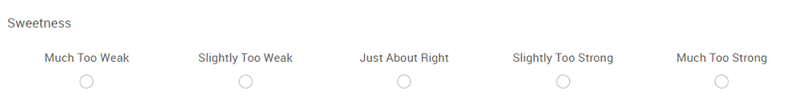  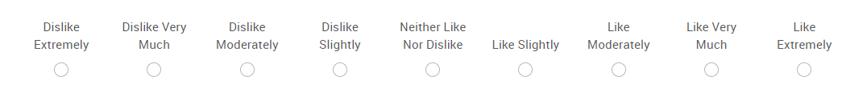
Sample 742

- Which sample do you prefer? Please explain Why.

- How might food scientists use JAR scales, and why do you think they are important in developing or improving food products?

Test 8 – Duo - Trio test (Cheese)

Introduction - This activity will help you identify the influence of sensory testing and how it is used to measure differences between samples by comparing two samples to the control.
Activity – Familiarise yourself with the control sample. Then taste the two samples and determine which one matches the control. Record your observations below:

Sample | Aroma | Colour | Texture | Taste
Control

481

693

Which sample matches the control: Circle your Answer

481 693

Follow on questions
- For the sample you selected please explain why you felt it was the same as the
control sample?

- What did you find most challenging about identifying the sample that matched the control? Explain why.

- Why might a food scientist use a duo-trio test to compare food products?

