Climate change pick and mix

  Detective, you’re hired! We need your help to investigate where food waste happens.  Investigate the kitchen, the fridge and the lunch hall in school or at home.  Check out these areas and consider, what gets thrown away? How is food stored? Does everyone finish all their lunch?  Write a report with your findings. Suggest ways to reduce food waste in the three areas. | 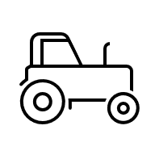  Sustainable farming practices help to reduce climate change and its impact of food production.  Design your own sustainable farm. You can draw the fields, water sources and the crops you will grow.  Think about sustainable farming methods such as; planting crops that use less water, using compost to help plants grow, rotating which crops grow in the fields to keep the soil healthy, and using solar energy from the sun to help power farming equipment. | 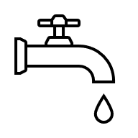  Water is a limited resource on Earth. Many countries have limited water to use due to changing climates and global warming.  Create a poster around the topic of a water conservation challenge to encourage children your age to reduce the amount of water they use.  Include actions which could be taken to help conserve water and spread the message!
  Draw or write a farm to fork journey.  Pick a food of your choice and research its journey from the farm to the fork.  Include each of the following stages: growing, rearing or catching, harvesting, processing, transporting, cooking, eating. A map or timeline can help support the journey. |   Create a climate change comic strip about the story of climate change.  Focus on the causes, effects and solutions to climate change issues.  You can create characters for your comic strip and describe how climate change has affected them maybe they live on a farm, by the sea, or in a city. Use drawings or computer graphics to bring your comic strip to life! | 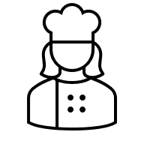  What’s in season today? Fruit and vegetables taste the best and are better for you when they grow in the right season. They are often cheaper too!  Create a seasonality calendar showing what’s in season month by month.  Consider what recipes could be made on each month of the calendar using seasonal foods.

