Planning sheet
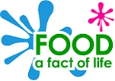
What are you making? _________________________________________

Who is it for? _________________________________________

When is it for? _________________________________________

Write a checklist to help you make sure your dish is suitable for the party and the people who will eat it.

My dish will:

- ______________________________________

- ______________________________________
- ______________________________________

What will it look like? | What ingredients will you need?

How will you make it? | What equipment will you need?

Fill in this part of your sheet after you have made your dish.

Does it look as you planned? | Does it taste as you planned?
What would you do differently next time?

