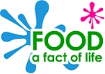

Salad planning sheet
This planner belongs to:
_____________________

Date: ________________________

Evaluating
Did your salad meet all your design criteria? _______

Explain what you did and anything that you did not manage to do.
_________________________________________________
_________________________________________________
_________________________________________________
_________________________________________________
Did your salad look like you expected? _________

Explain your answer.
________________________________________________
________________________________________________
________________________________________________
What did the person you made the salad for say about how it looked and tasted?
___________________________________________________________________________________________________________________________________________________
Explain how you would improve your salad.
________________________________________________
________________________________________________
________________________________________________

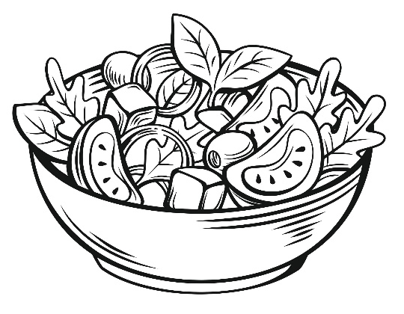

© Food – a fact of life 2023
Making
Here is the recipe for my salad and how it will look.
Ingredients:
____________________
____________________
____________________
____________________
____________________
____________________

Equipment:
_____________________________________________
_____________________________________________
_____________________________________________
Method:
_______________________________________________
_______________________________________________
_______________________________________________
_______________________________________________
_______________________________________________
_______________________________________________
_______________________________________________
_______________________________________________

Designing
My salad is for:

Here is the design criteria (checklist) of what I will do to make sure my salad is right for _______________ .

Design criteria
My salad will:
_______________________________________________
_______________________________________________
_______________________________________________
______________________________________________
_______________________________________________
_______________________________________________
______________________________________________________________________________________________
_______________________________________________
______________________________________________________________________________________________
_______________________________________________
______________________________________________________________________________________________
_______________________________________________

© Food – a fact of life 2023

