Cheese straws
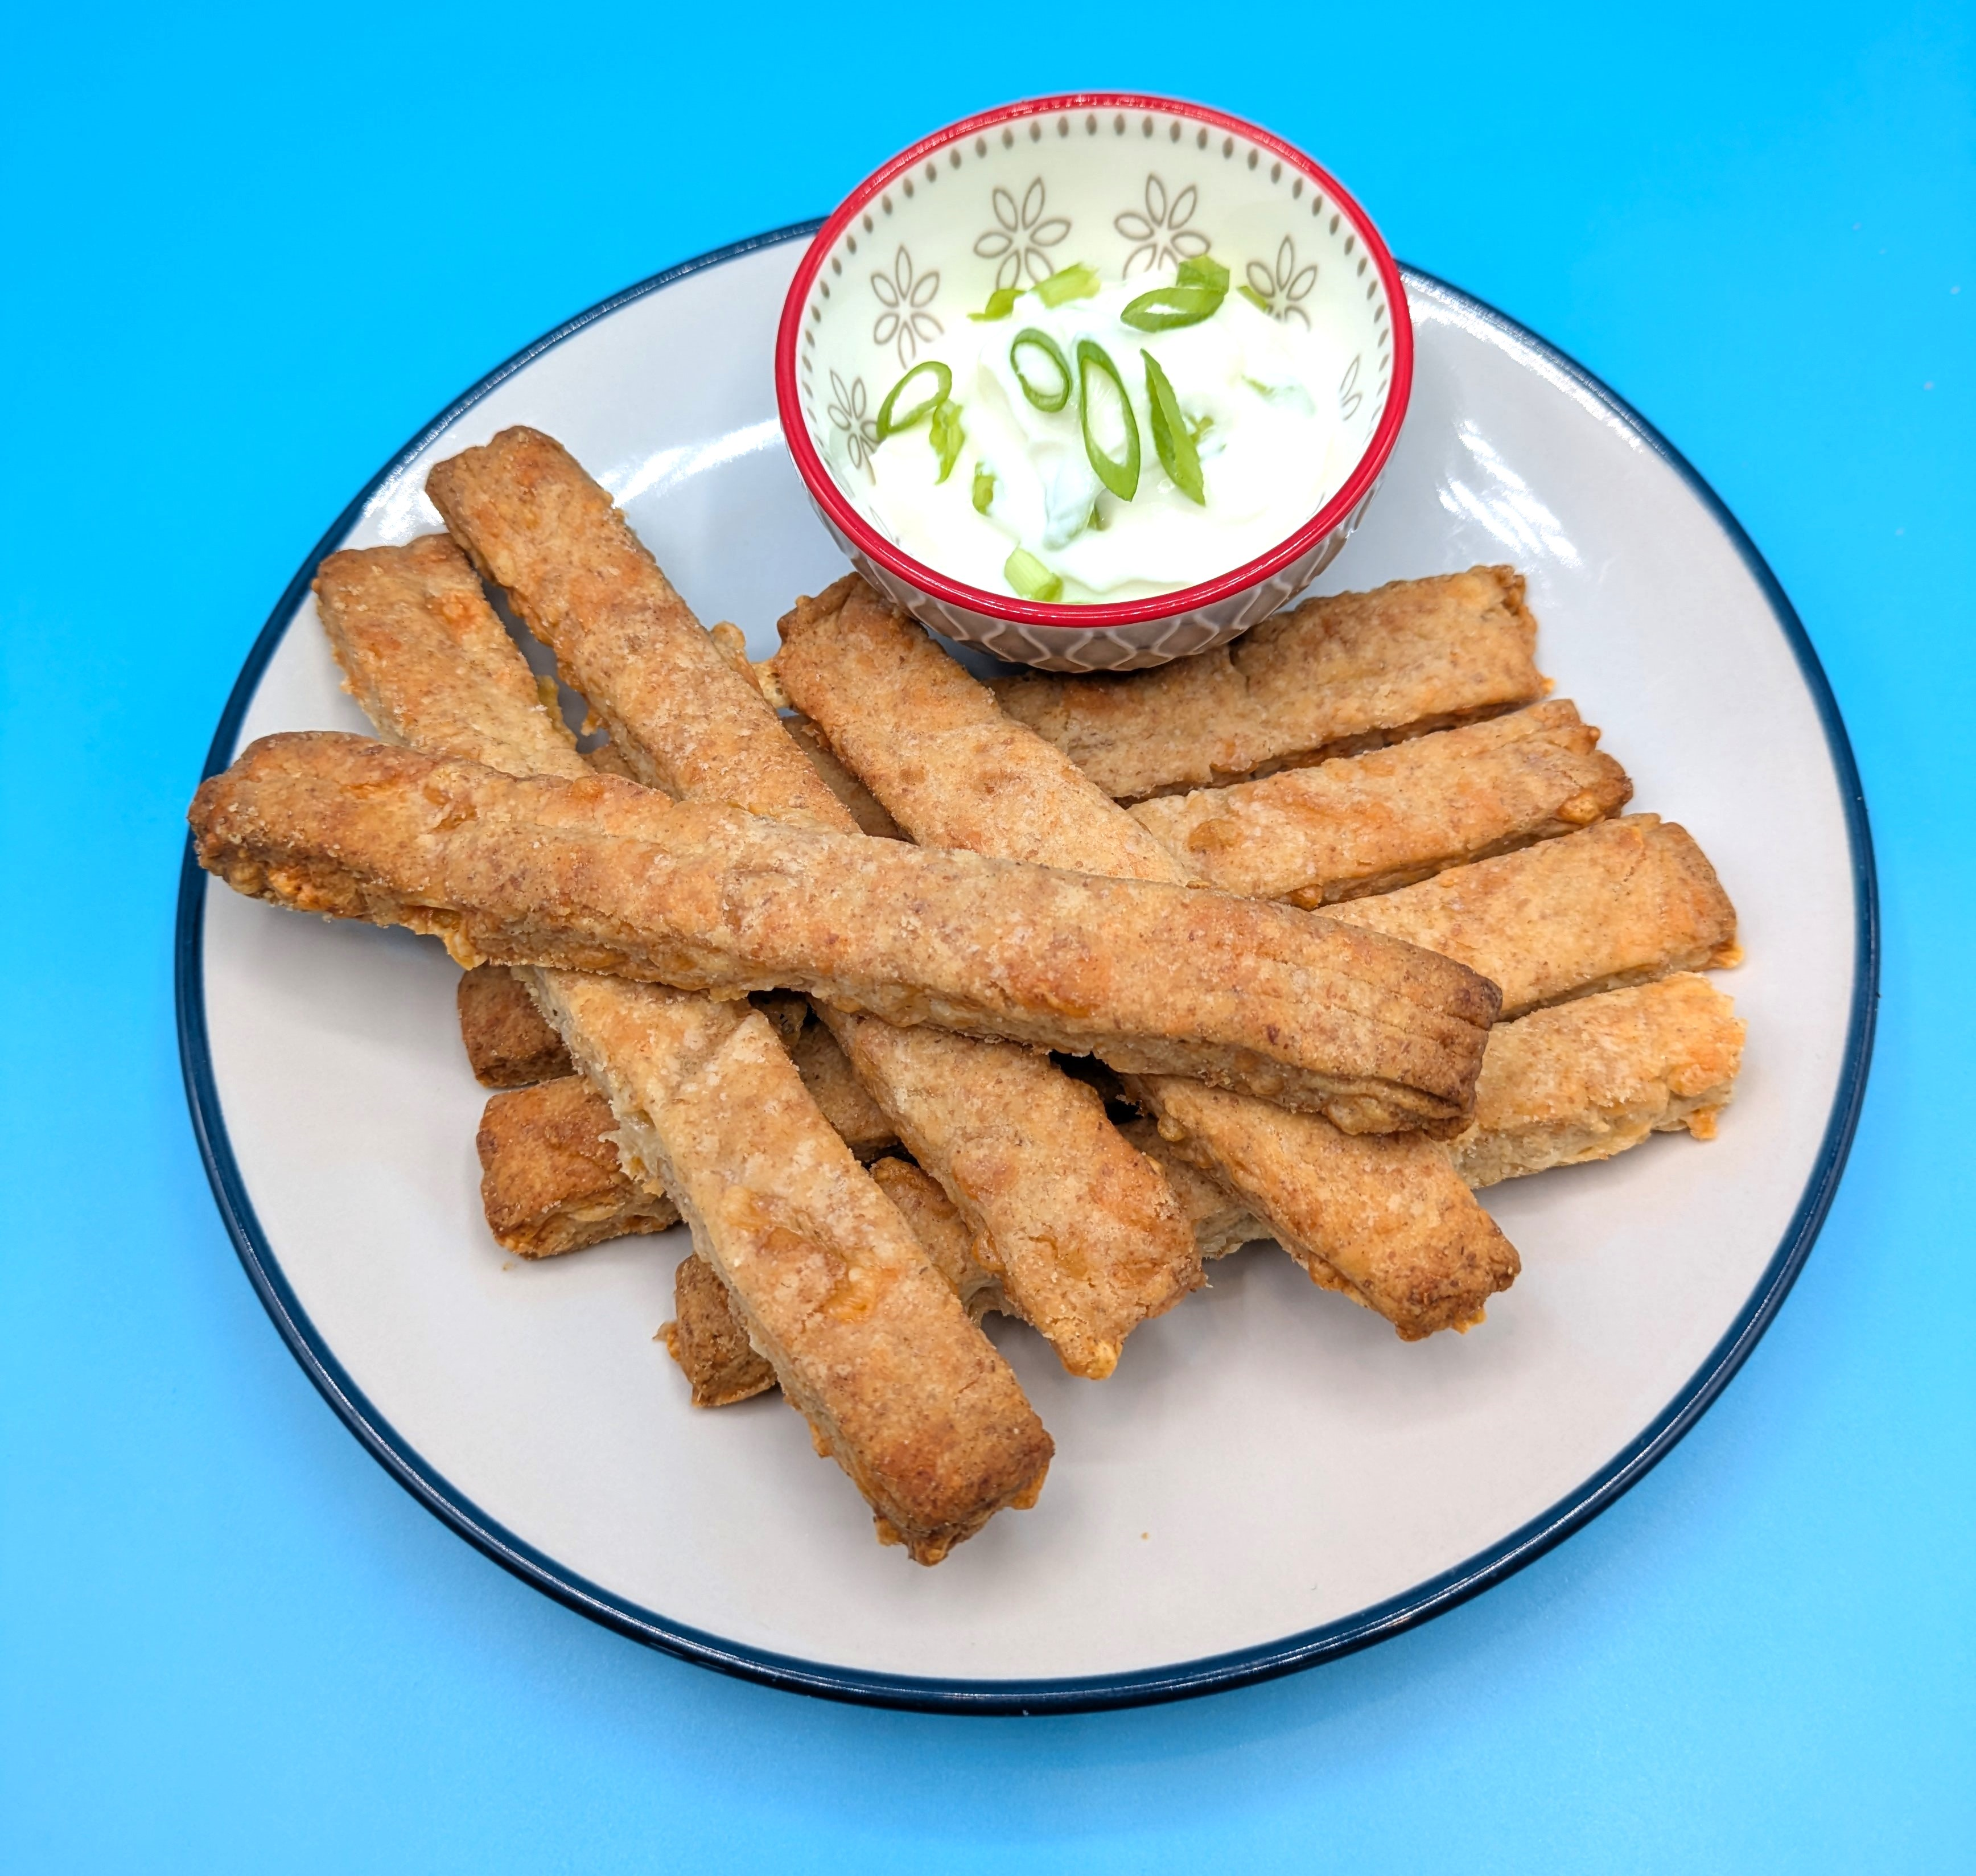
Complexity: low - medium
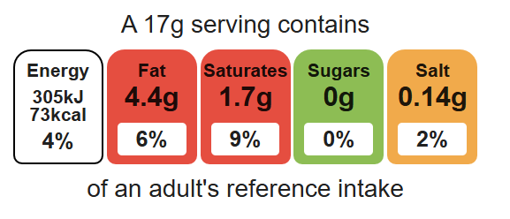

Ingredients (makes 12)

Equipment

Weighing scales

Baking tray

Grater

Chopping board

Sieve

Measuring spoons

Mixing bowl

Palette knife

Flour dredger

Rolling pin

Cooling rack

50g reduced-fat cheddar cheese

75g plain white flour

25g plain wholemeal flour

½ x 5ml spoon mustard powder

50g hard baking fat
2 x 15ml spoons cold water

Method
- Preheat the oven to 200ºC or gas mark 6.
- Grease or line the baking tray.
- Grate the cheese.
- Sift the flour and mustard powder into the mixing bowl.
- Using your fingertips, rub the fat into the flour until it resembles fine breadcrumbs.
- Stir the cheese into the flour mixture.
- Using a palette knife, mix to form a smooth dough, adding a little cold water gradually to help bind the mixture together.
- Roll out, on a lightly floured surface, to form a rectangle (20cm x 15cm) approximately 0.5cm deep.
- Trim away the edges and cut into thin strips, about 1.5cm x 7cm, using a palette knife.
- Place the straws on the baking tray.
- Bake for 10 minutes, until golden brown.

Top tips
- Serving suggestion: Serve with reduced-fat crème fraiche and spring onion dip.
- Turn up the flavour: Add mixed herbs, chilli flakes or a different type of cheese.
- Focus on fibre: Brush the straws with water and sprinkle with seeds before baking. Be ingredient aware!
- Use the rolling pin like a ruler, to help cut even strips.

Food skills
Weigh, measure, grate, sift, rub-in, mix, stir, combine, roll out, cut, chop slice, dice and trim, form and shape, bake.

