
Dietary needs case studies
Dietary needs are varied and often people need to change the foods that they eat, the recipes they make and the cooking methods used to meet their particular needs. Challenge the pupils to work through some of the Dietary needs case studies.

Lara is 3 years old and lives with her parents and older brother. Lara enjoys playing with her toys and would much rather do this than sit and eat at the table.



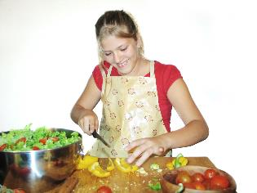



Ayesha is 13 years old and has begun to notice some changes in her body indicating that she is going through puberty. She walks to school each day but does not do much other exercise.

Thomas is 26 years old and has a very physical job on a building site. He also enjoys keeping fit and does at least two very hard training sessions a week.

Sue is 21 years old and in the final year of a university degree. Sue has recently become a vegetarian and is considering becoming a vegan. Sue is very busy with her university work but does try to find time to socialise with her friends.

Katie is 35 years old and is pregnant with her second child. Katie has a busy job as a teacher and enjoys yoga and Pilates to keep fit whilst she is pregnant.

James is 15 years old. He loves playing football with his friends but also spends a lot of time on his computer. James’ family are Jewish and so he strictly follows the religious practices of the Jewish faith.

Peter is 68 years old and lives with his wife Wendy. They have been married for 40 years and enjoy walking their dog Max every day. They live in a busy town but like to get out to the countryside when they can.

