Fibre line up answers

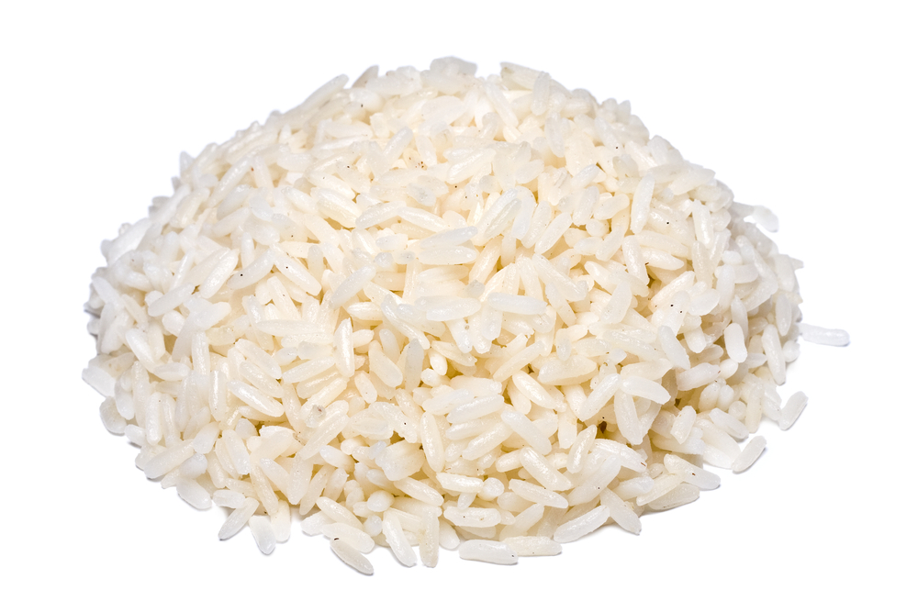
AOAC fibre content per 100g 1.6g
NSP content per 100g 1.0g

AOAC fibre content per 100g 0.5g
NSP content per 100g Trace

AOAC fibre content per 100g 1.6g
NSP content per 100g 1.0g

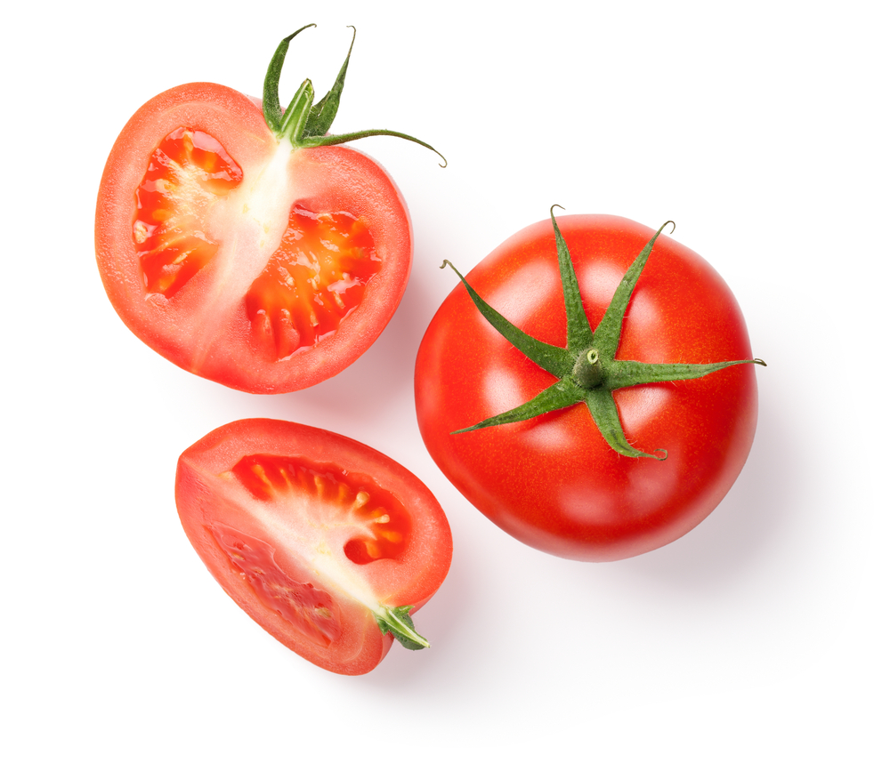

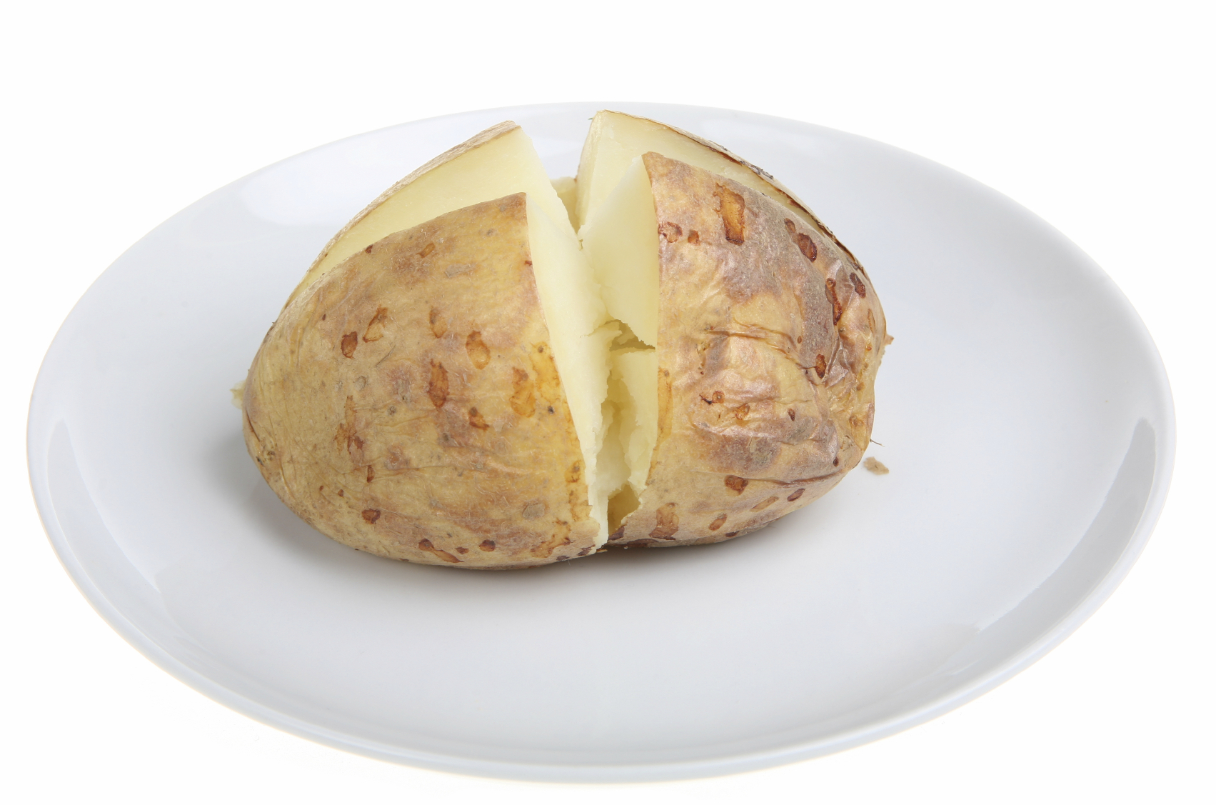

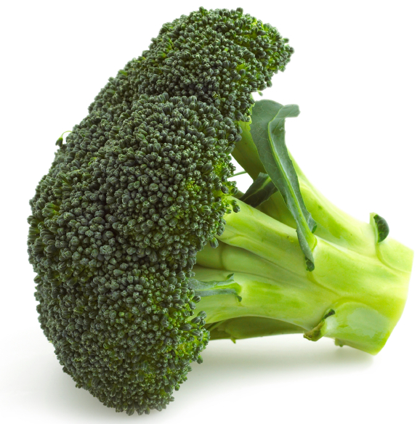
AOAC fibre content per 100g 1.7g
NSP content per 100g 1.5g

AOAC fibre content per 100g 1.8g
NSP content per 100g 0.9g

AOAC fibre content per 100g 2.6g
NSP content per 100g 1.4g

AOAC fibre content per 100g 2.7g
NSP content per 100g 1.6g

AOAC fibre content per 100g 2.8g
NSP content per 100g 2.3g

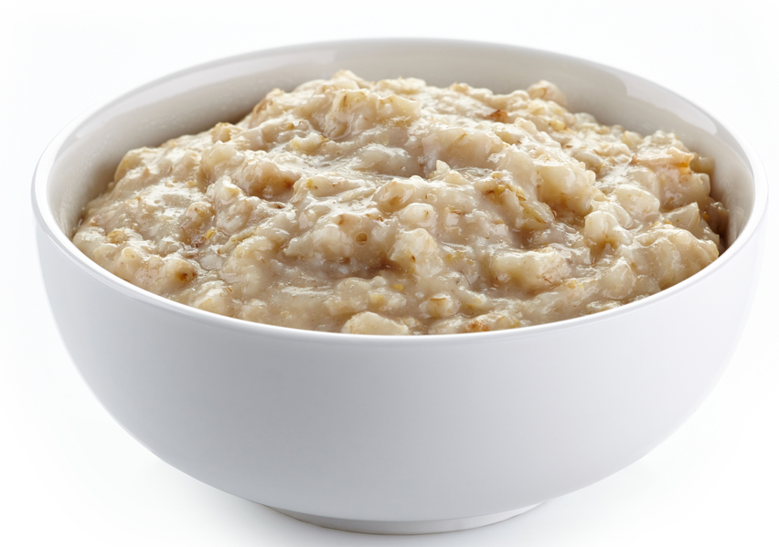


AOAC fibre content per 100g 1g
NSP content per 100g 1g

AOAC fibre content per 100g 1g
NSP content per 100g 0.9g

AOAC fibre content per 100g 1.2g
NSP content per 100g 1.3g

AOAC fibre content per 100g 1.4g
NSP content per 100g 0.8g

AOAC fibre content per 100g 1.5g
NSP content per 100g 0.9g

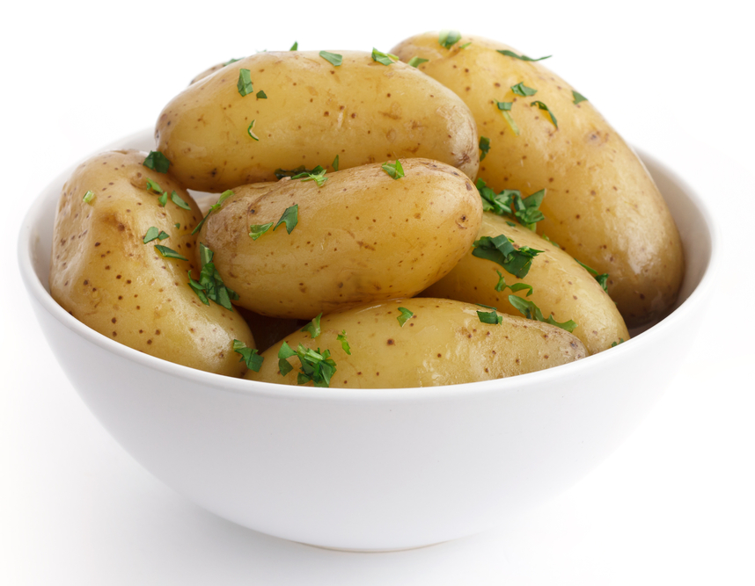

AOAC fibre content per 100g 1.6g
NSP content per 100g 1.0g

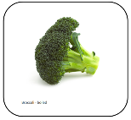
AOAC fibre content per 100g 2.8g
NSP content per 100g 2.3g

AOAC fibre content per 100g 2.8g
NSP content per 100g 2.3g

AOAC fibre content per 100g 2.8g
NSP content per 100g 2.3g

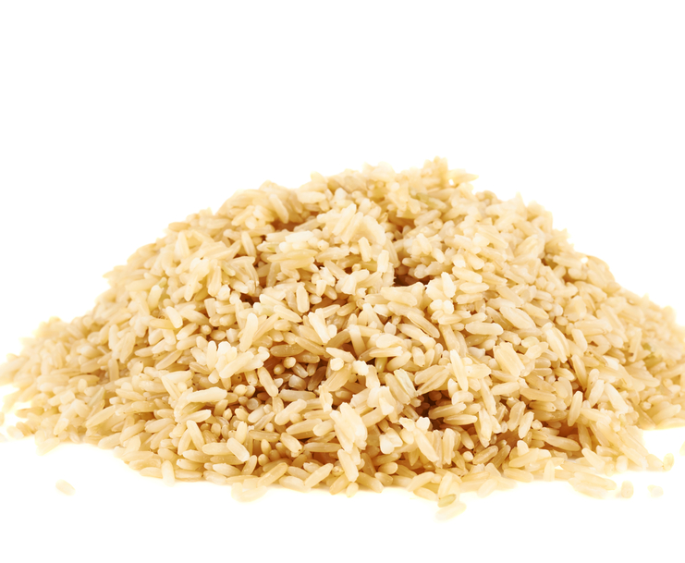


AOAC fibre content per 100g 4.2g
NSP content per 100g 4.4g

Dietary Fibre
Dietary fibre refers to a group of substances in plant foods which cannot be completely broken down by human digestive enzymes.

Association of Official Analytical Chemists (AOAC) is a method of food analysis and is the currently accepted method for determining dietary fibre in the UK, continental Europe and the United States. AOAC amounts include lignin and resistant starches as well as NSP.

Englyst is another method of testing which determines plant cell wall components of dietary fibre referred to as non-starch polysaccharide (NSP) amounts. This was the recommended UK method for nutrition and labelling purposes until 1999.
The AOAC amount for fibre is used for nutrition labelling.

Some nutritional analysis programmes used in schools, such as Explore Food, currently use NSP values.
To convert AOAC to NSP (estimated) divide by 1.33.

To convert NSP to AOAC (estimated) multiply by 1.33.

Previous recommendations were that adults should consume 18g of NSP a day.
Current recommendations from the SACN report (July 2015) are:
- The population should increase daily total fibre intake to 30g/day AOAC (adults) (NSP equivalent is 24g)
- 15g/day (2-5 year olds), 20g/day (5-11 year olds), 25g/day (11-16 year olds), 30g/day (16-18 year olds).

For more information on fibre go to the British Nutrition Foundation website:
http://bit.ly/1KSutYz

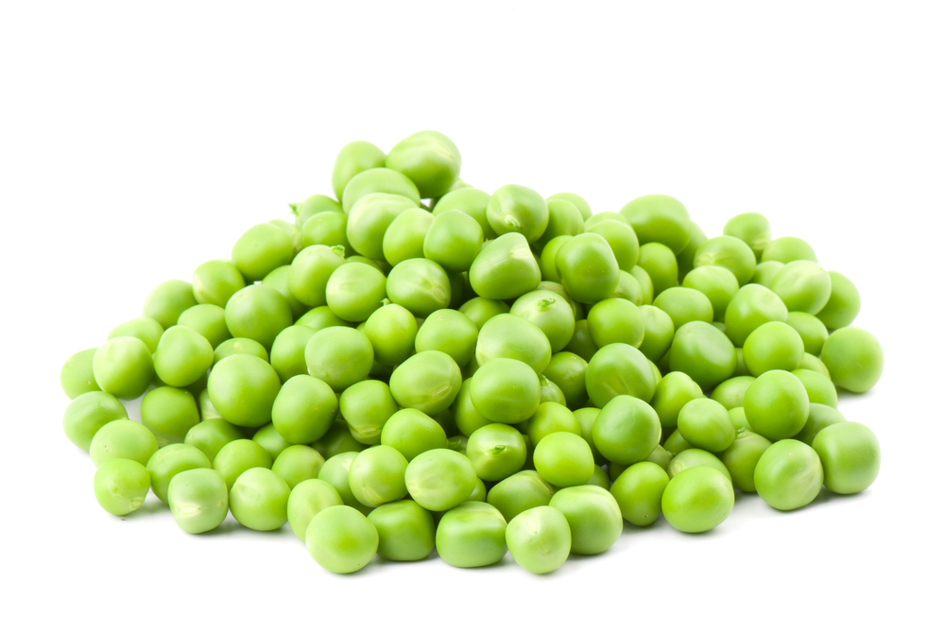
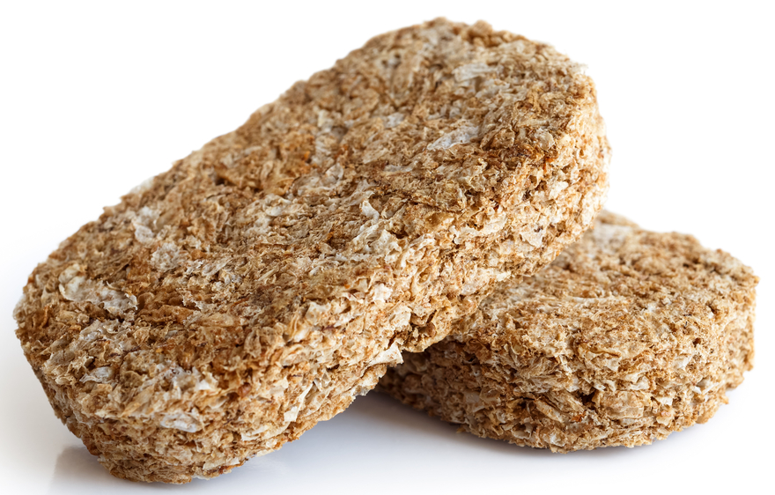

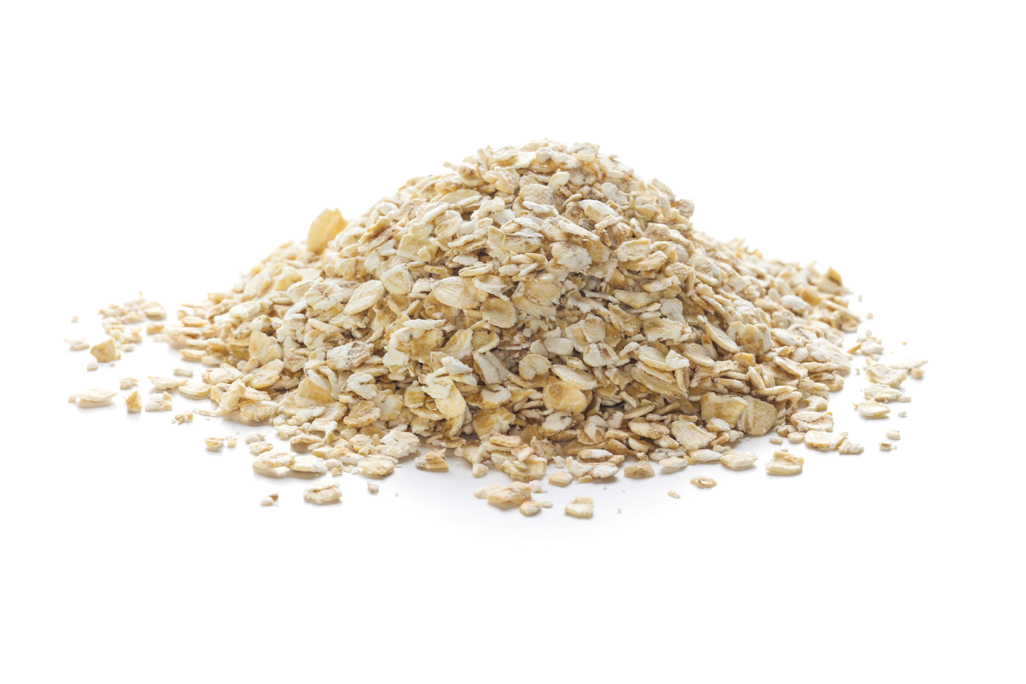
AOAC fibre content per 100g 5.6g
NSP content per 100g 4.5g

AOAC fibre content per 100g 0.5g
NSP content per 100g Trace

AOAC fibre content per 100g 9.7g
NSP content per 100g 7.3g

AOAC fibre content per 100g 8.2g
NSP content per 100g 5.9g

AOAC fibre content per 100g 7.8g
NSP content per 100g 7.2g

