Nutrition Manager

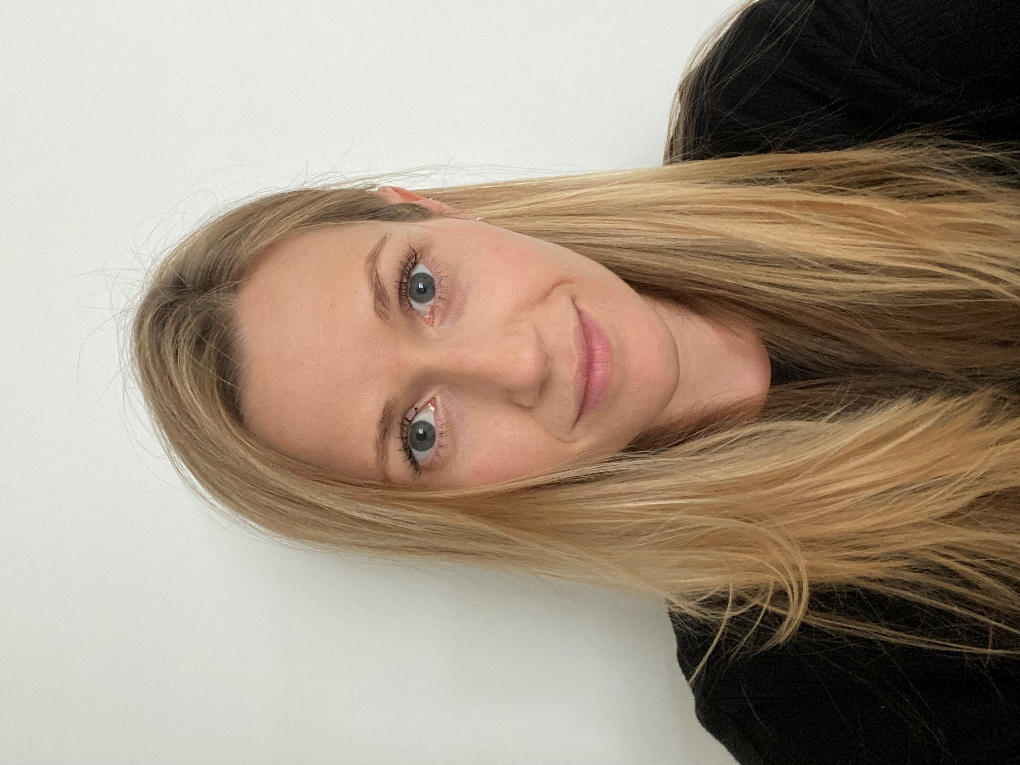
Name Beth Hooper

What qualifications do you have? Nutrition and Food Science Degree with Industrial Placement Year, University of Reading.

What does your job involve?
As a Nutrition Manager for Nestlé, my role is really varied working with lots of different teams. We’re a team of 5 nutritionists and a placement student. We work with the New Product Development teams to influence the nutritional profile of our products; the marketing and regulatory teams to review product communications; the culinary teams to develop recipes and the sales teams. We keep up to date with evolving science, trends, policies and regulation, engaging with different stakeholders and bringing that information back to our colleagues via nutrition updates and training. We work with the Public Affairs team to develop and report on our nutrition ambition, assessing our products against internal and external targets.

What, or who, inspired you to take your chosen career pathway?
I had wonderful Food Technology and Chemistry teachers who encouraged me to continue studying Food Science. I was really unclear about all the different roles out there but had great support and guidance from University.

What route did you take from leaving school to your current job?
My degree included a year placement as a quality technologist at Tate & Lyle. I loved working in industry but realised that my true passion was nutrition. After graduating, I joined the British Nutrition Foundation. I worked in the Science Team for five years working on industry, education and EU research projects. This was an incredible to start to my career, developing my nutrition science knowledge and building my communication skills while exposing me to how big the nutrition world was! From here, I moved to Nestlé as a Nutrition Manager.

What is the key knowledge, skills and experience needed for your job?
It’s essential that Nutritionists have a core understanding of nutrition, gained from studying an accredited Nutrition degree. Then – it’s communication! We work with LOTS of different colleagues and need to be able to communicate nutrition principles without getting too lost in the detail. It also helps to be pragmatic and solution focussed. Finally, we need to keep up to date so it’s essential that you’re curious and keen to keep learning!

What is the best thing about your job?
The great thing about nutrition is that the evolving external environment and science means the role is constantly changing too. The next best thing has to be the people and being able to talk about food all day! Although most companies only have a handful of nutritionists, there is an amazing, welcoming, network of nutritionists across the whole industry.

What questions are you often asked about your job?
I’m most frequently asked what I eat!!!

What advice would you offer to someone interested in doing what you do?
Get as much work experience as possible – there isn’t just one job for a Nutritionist so be open minded to help you find the right one for you! Stay curious

