Change for health
Task 1

Review this lasagne recipe. Indicate the changes you would make to reduce total fat and increase fibre content.

Annotate the recipe with your suggestions.
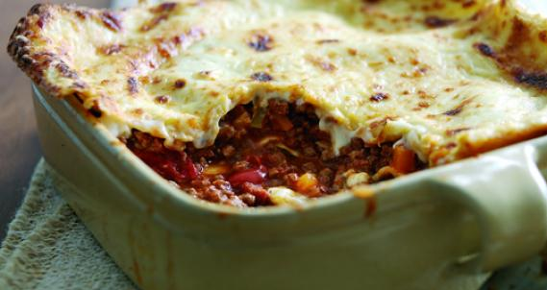

Ingredients
Think!
What changes can you make?
What could you add?
Can the cooking method be changed?
What other changes for health could be made to the recipe?
Ragu mixture
1 x 15ml spoon oil
450g beef mince
50g streaky bacon, finely chopped
1 red onion, peeled and chopped
2 large garlic cloves, peeled and crushed
1 small sprig fresh thyme
1 x 400g can chopped tomatoes
400ml beef stock
1 x 5ml spoon caster sugar
2 x 15ml spoon tomato purée
1 bay leaf
2 x 15ml spoon freshly chopped flat-leaf parsley
1 x 5ml spoon freshly grated nutmeg
Salt and freshly milled black pepper
Extension task
Explain the health benefits in reducing the total fat and increasing the fibre content of recipes.
Sauce
25g butter
25g plain flour
425ml whole milk
75g Cheddar, grated
25g Parmesan cheese, grated

1 x 250g fresh lasagne sheets
Method
- Heat a large non-stick pan and fry the mince in the oil with the bacon for 3-4 minutes until brown, breaking up any lumps with the back of a spoon. Transfer to a large bowl. Cook the onion, garlic in the same frying pan for 2 minutes.
- Add the remaining ragù ingredients to the pan with the meat, bring to the boil, reduce the heat, cover and simmer for 1 hour, stirring occasionally. Remove the bay leaf and thyme sprig.
- Meanwhile, make the cheese sauce; heat the butter in a non-stick pan until foaming then whisk in the flour. Remove the pan from the heat and slowly add the milk, return to the heat and cook until thickened, stirring continuously. Add the cheese and season.
- Preheat the oven to Gas Mark 5 or 190°C. Place a layer of lasagne sheets in the base of a 25cm/10inch square ovenproof dish. Spoon half the ragù mixture over the pasta then half the cheese sauce. Repeat with another layer of lasagne and ragù, then finish with a final layer of lasagne sheets and sauce. Sprinkle the Parmesan cheese on top.
- Bake in the oven for 30 minutes.

Task 2

Use a nutritional analysis programme such as Explore food to calculate the total fat and fibre content of the original and modified recipe.
What did you find? Has the fat been reduced? Has the fibre been increased?

