Bean and plantain stew

Ingredients
Complexity: medium-high
1 small onion
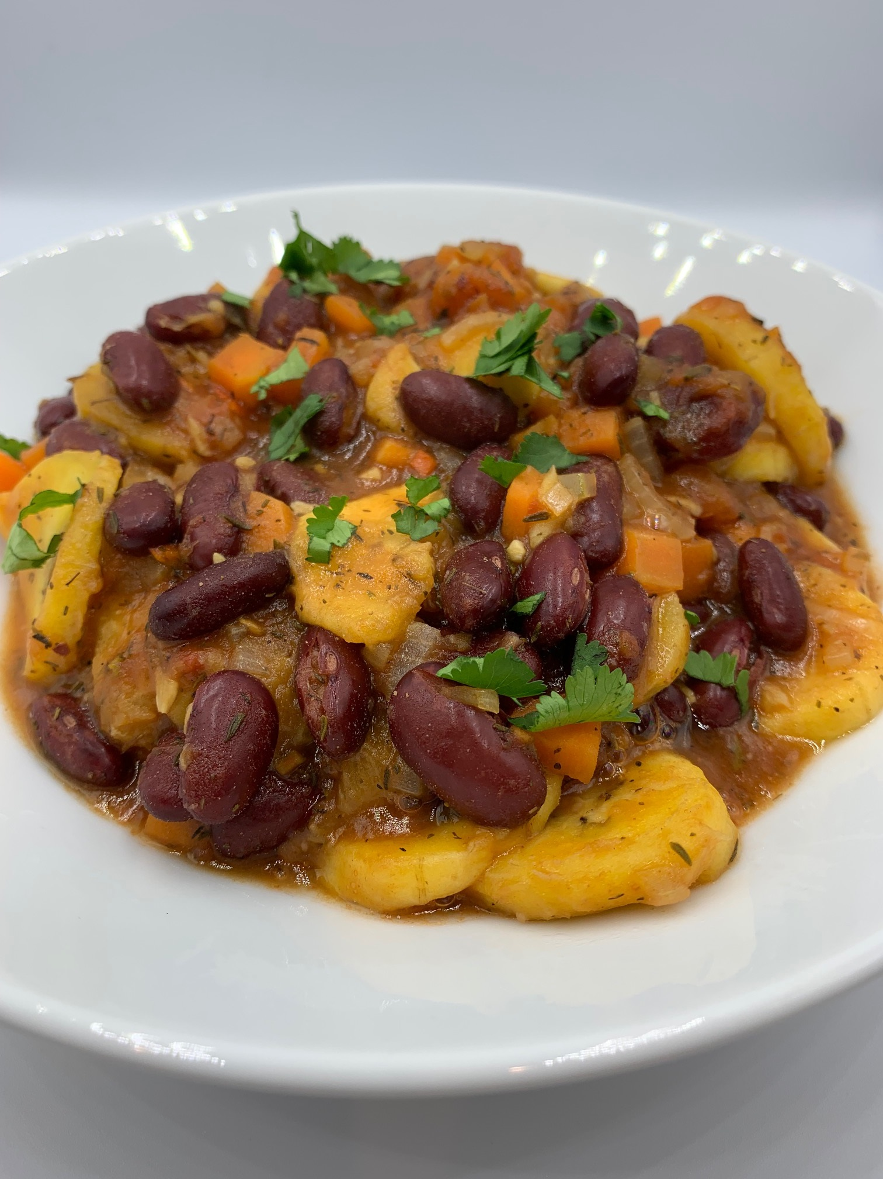
1 carrot
1 celery stick
1 clove garlic
1/8th scotch bonnet chilli or ½ x 5ml spoon chilli flakes
1 plantain
400g kidney beans
spray oil
200g canned chopped tomatoes
1 vegetable stock cube
125ml water
1 x 15ml spoon dried thyme
½ x 15ml spoon All purpose seasoning
Black pepper

Optional - garnish
25g parsley

Equipment
Chopping board, vegetable knife, garlic press, colander/sieve, large saucepan, mixing spoon, measuring jug, measuring spoons.

Method
- Prepare the ingredients:
  - peel and finely dice the onion;
  - peel and finely dice the carrot;
  - finely dice the celery;
  - peel and finely chop or crush the garlic;
  - deseed and finely chop the scotch bonnet, if using;
  - peel and slice the plantain;
  - drain and rinse the kidney beans;
  - roughly chop the parsley, if using.
- Spray the saucepan with oil and add the onion, carrot, celery, garlic and the fresh or dried chilli.
- Fry gently for 3-4 minutes.
- Add the plantain, kidney beans and chopped tomatoes.
- Crumble over the stock cube and add the water.
- Bring to the boil and add the dried thyme and All purpose seasoning. Season with black pepper.
- Reduce the heat and simmer for 10 minutes, until the plantain is soft.
- Serve sprinkled with chopped parsley, if using.

Top tips
- The plantain in this recipe can be replaced with a large unripe banana, a potato, yam, sweet potato or breadfruit, or canned jackfruit. Additional cooking time may be required, particularly if using potato or sweet potato.
- When preparing chilli peppers, do not to touch the eyes or similar areas that can be affected by the capsaicin (an irritant) that rubs off on hands. Wash your hands immediately after handling chilli peppers.
- To prepare remove the stem and slice the chilli pepper in half. With a teaspoon, carefully remove the ribs and seeds then slice or dice as needed.
- If Scotch Bonnet chillies are not available, they can be substituted with habanero peppers, serrano chillies, Thai red chillies, African bird’s eye peppers or dried chili flakes.

Food skills
- Weigh
- Measure
- Peel
- Dice
- Chop
- Slice
- Drain
- Fry
- Boil
- Simmer

Did you know?
Green plantains are starchy and bland while the fully ripened fruit is aromatic and tastes like an ordinary banana, but less sweet. Plantains can be replaced in savoury recipes with unripe bananas, yuca roots, potatoes, yams, breadfruits, jackfruits, or sweet potatoes. For sweet food, the best replacement for plantains is unripe green banana.

All purpose seasoning is a blend of salt, spices, dried herbs, and sugar that can be used in a range of recipes before cooking or as a seasoning in sauces and dressing. Any salt in the recipe should be omitted as it is included in the seasoning.

To make your own All purpose seasoning the following herbs and spices are used in the seasoning mix: salt, paprika, dried garlic, dried parsley, black pepper, minced onion, dried tarragon, onion powder, dried dill, dried oregano, celery seed, ground coriander, cayenne pepper and sugar.

