Testing food for glucose

Introduction
This is a simple test which shows whether food contains glucose. If glucose is present in the food there is a colour change in the test strip. Test strips are made to test urine for the presence of glucose.

They can be used for testing a restricted range of other dilute solutions for glucose but no other sugars or carbohydrates.

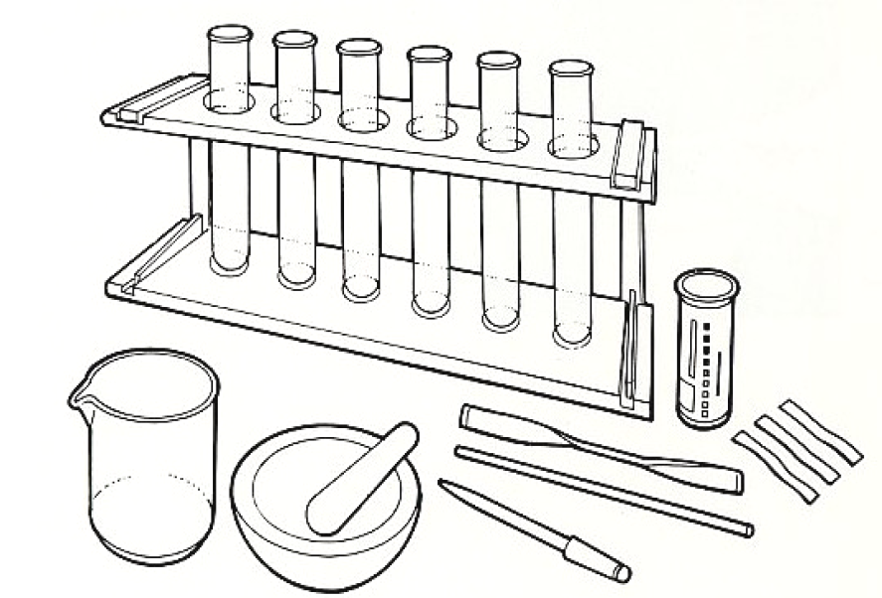
You will need
Equipment
Test tubes
Test tube racks
Glass rod
Spatula
Mechanical grinder or pestle and mortar
Dropping pipette
Beaker or dish

Materials
Food samples
Distilled water
Reagent strips
(in container with instructions)


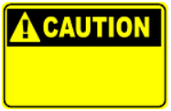

Some people are allergic or intolerant to a particular food or ingredient. Refer to the 14 allergens and check against student records before completing this experiment.

Do not consume food in a laboratory, or any food used for experiments, because it may contaminated.

Method
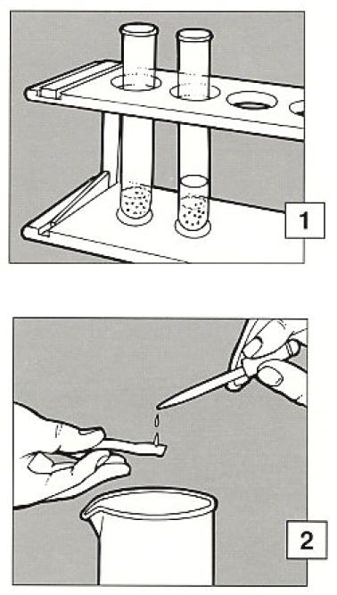
- If the food to be tested is liquid, go to 2. If the food to be tested is solid, make an extract. Grind, crush or chop a small amount and put it into a test tube to a depth of about 2cm. Add a similar amount of distilled water and stir with a glass rod. Allow to stand for a few minutes.

- Draw up some of the clear liquid into a pipette and then, holding a reagent strip horizontally over a dish, drop a little of the liquid over the strip to wet the coloured test area.

- Shake off any excess liquid. Wait for 10 seconds and compare the colour of the test area with the colours shown on the label of the container.

- Decide if the colour indicates that glucose is present in the sample.

Extension work
Dissolve a known (small) amount of glucose in a measured volume of water
Do not consume food in a laboratory, or any food used for experiments, because it may contaminated.
(e.g. 1g/litre).

Test this with the reagent strips. Compare the colour obtained with the result from the sample of food or drink.

