Fibre-boosted lamb korma
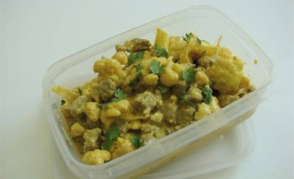
Introduction

In this activity, you’ll be using nutritional analysis to determine the fibre content of a meal and come up with different ways to boost the fibre content of the meal.

The task:
- Go to Explore Food http://explorefood.foodafactoflife.org.uk/

- Analyse the basic lamb korma recipe by inputting
each of the ingredients listed on the right, in the
correct quantities. When you’ve entered your
ingredients, click ‘view summary’, input the number of portions for the recipe and click ‘calculate’.
Basic lamb korma recipe
Serves 3
Ingredients
1 clove garlic (5g)
10ml oil
200g lean lamb leg steaks
½ green chilli
1 x 15ml spoon mixed curry spices
45ml plain yogurt
Black pepper
1 x 15ml spoon coriander
180g dried white basmati rice

- Print the results.

- Review how much fibre the dish provides. Your goal is to increase the amount of fibre provided, by replacing or adding ingredients.

- Analyse your modified recipe and print the results.
- Compare your two printouts and evaluate your success.

- Describe the changes that you made and give your reasons. Remember, the recipe needs to be familiar and taste good!

Challenges:

- Increase the fibre provided by this dish by at least 5 grams per portion.
- Add at least two different vegetables to the dish and determine how much extra fibre these provide.
- Choose at least one portion of either nuts, seeds or pulses to add to this dish and determine how much extra fibre this provides.

Bonus activity:

Suggest a side-dish that could complement this main dish. Describe the side-dish, detailing the ingredients it would contain. When you have listed your ingredients, calculate how much fibre your dish provides and write it below:

Description of dish: ______________________________________________________________________
______________________________________________________________________
______________________________________________________________________
______________________________________________________________________

Quantities and ingredients:

- _____________________________________
- _____________________________________
- _____________________________________
- _____________________________________
- _____________________________________
- _____________________________________
- _____________________________________
- _____________________________________
- _____________________________________
- _____________________________________

Total fibre provided by my side-dish: _________ grams

