Mealie Bread

Ingredients
Complexity: low-medium
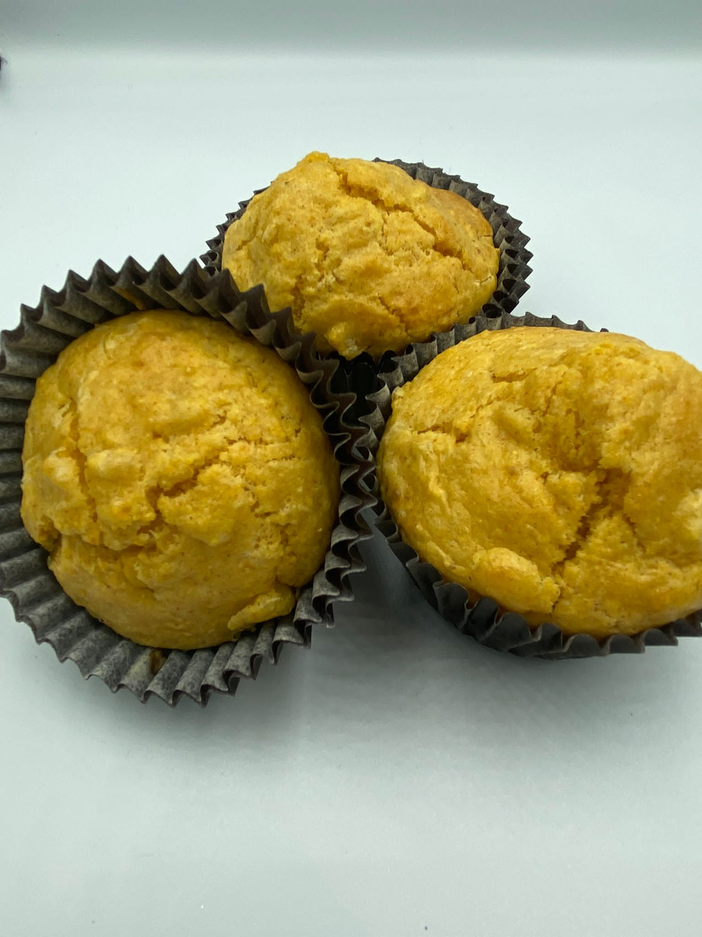

30g butter or reduced fat spread

2 eggs

340g can sweetcorn

120ml milk

180g plain flour

30g cornmeal

2 x 5ml spoons baking powder

30g sugar

½ x 5ml spoon salt

½ x 5ml spoon paprika

Equipment

900g (2lb) loaf tin or muffin tray, greaseproof paper or muffin cases, small saucepan or microwaveable bowl, small bowl, fork, sieve/colander, blender/food processor, large bowl, mixing spoon.

Method
- Preheat the oven to 180°C or Gas mark 4. Grease the loaf tin, or line with greaseproof paper, or place 8 muffin cases in a muffin tray.
- Prepare the ingredients:
- melt the butter or spread;
- crack eggs and lightly beat with a fork;
- drain the canned sweetcorn.
- Place half the corn and milk in a blender or food processor and blitz until a coarse mixture is formed.
- Add the remaining corn and pulse the mixture 1 or 2 more times to leave most of the corn kernels whole.
- Place flour, cornmeal, baking powder, sugar, salt and paprika into the mixing bowl and mix together.
- Add the sweetcorn mix, melted butter/spread and beaten eggs to the flour mix and combine until a thick mixture is formed.
- Place the mixture in the loaf tin or divide evenly between the muffin cases.
- Bake the loaf for 30-35 minutes or the muffins for 20-25 minutes.

Top tips
- Polenta can be used as an alternative to cornmeal.
- The sweetcorn can be mashed with a fork or a potato masher, if a blender/food processor isn’t available.
- Try adding different spices to the bread to enhance the flavour of the corn.
- Let your bread cool slightly before slicing it, as this helps the slices hold together better.

Food skills
- Weigh
- Measure
- Melt
- Blitz
- Mix
- Divide
- Bake

Did you know?
Mealie bread is a traditional South African quick bread made from mealie, known in other parts of the world as maize, or corn. Maize was first grown for food in Mexico, and it is thought that the Portuguese were the first to bring maize from the Americas to Africa.

Mealie bread was traditionally made by steaming rather than baking. A large pot of boiling water would have been put on the stove (or campfire) with something inside to act as a platform for the bread tin. Then, the loaf tin with the bread batter was placed into the boiling water so the water came about halfway up the sides of the tin. The pot was then covered, and the bread steamed.

