Tuna and broccoli pasta
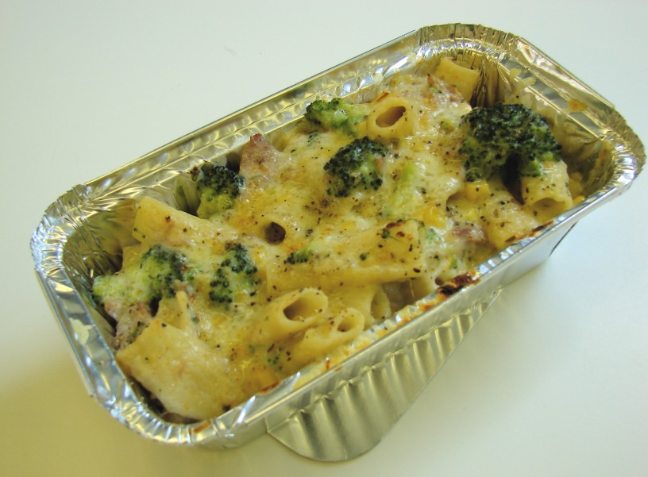
Complexity: low - medium
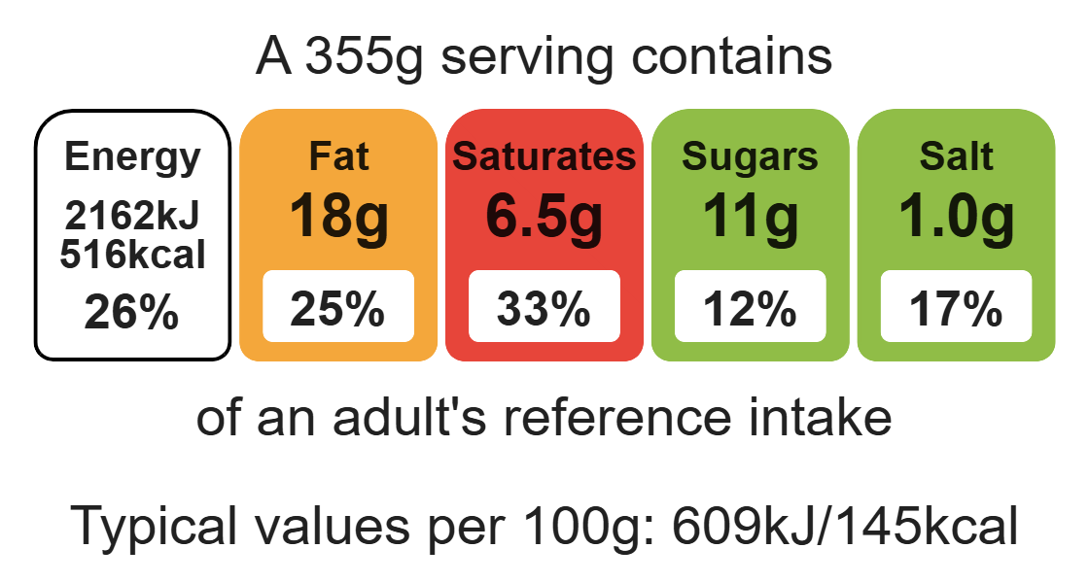

Ingredients (serves 2)
100g wholemeal pasta

Equipment

weighing scales

2 saucepans

grater

chopping board

sharp knife

colander

measuring jug

heat-resistant spoon

measuring spoons

whisk

ovenproof dish

40g reduced-fat Cheddar cheese
100g broccoli
100g canned tuna (in water) drained
25g baking fat/block
25g plain flour
250ml semi-skimmed milk
1x5ml spoon dried oregano
50g sweetcorn (canned or frozen)
Black pepper

Method
1. Bring a saucepan of water to the boil and then add the pasta. Simmer for about 10-12 minutes, until al dente.
2. Grate the cheese and cut the broccoli into small pieces.
3. While the pasta is cooking, make the sauce:
- place the fat, flour and milk into a small saucepan;
- bring the sauce to a simmer, whisking it all the time until it has thickened;
- reduce the heat, stir in the oregano, and allow to simmer for 2 minutes.
4. During the last 2 minutes of the pasta boiling, add the sweetcorn and broccoli to the saucepan.
5. Preheat the grill.
6. Drain the boiling hot water away from the pasta and vegetables into a colander in the sink.
7. Pour the drained pasta and vegetables into the sauce.
8. Stir in the canned tuna.
9. Pour the mixture into an ovenproof dish or foil tray.
10. Sprinkle the cheese over the top and add a few twists of black pepper.
11. Place under a hot grill until the cheese is bubbling and golden brown.

Top tips
- Reduce food waste: Use up any leftover vegetables such as leeks, peppers or mushrooms.
- Turn up the flavour: Add 1 x5ml spoon of pesto, mustard or tomato puree to the sauce for extra flavour.
- Vary your protein: Swap the tuna for cooked chicken or beans e.g. chickpeas.

Food skills
Weigh, measure, melt, simmer, boil, grate, cut, chop, slice, dice and trim, whisk, drain, grill.

