Pizza wheels (yeast dough)
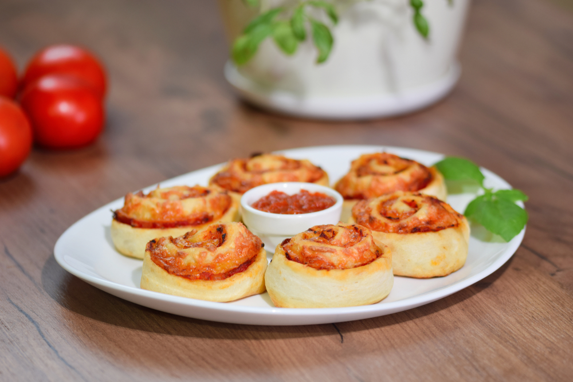

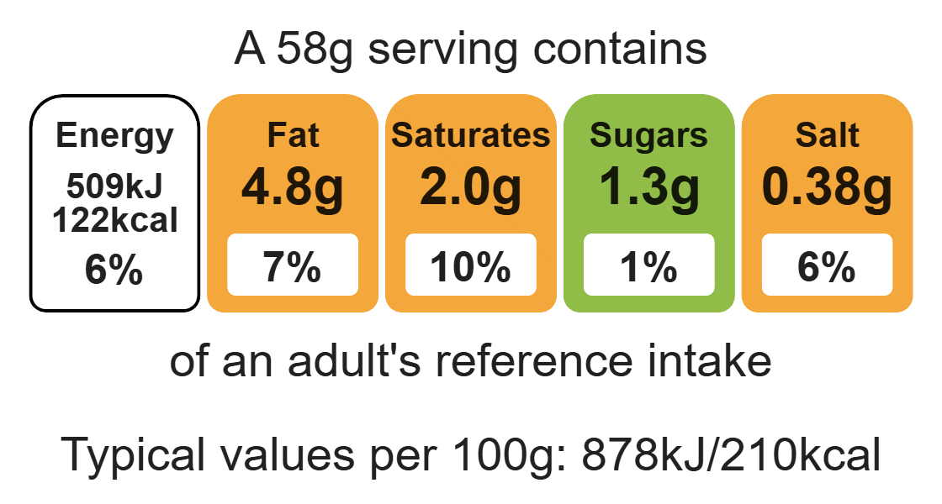

Ingredients (makes 8)
250g strong wholemeal flour
Complexity: medium- high
1 x 5ml spoon salt
1 x 5ml spoon sugar

Equipment

Baking tray

Weighing scales

Grater

Sharp knife

Chopping board

Mixing bowl

Sieve

Measuring spoons

Mixing spoon

Measuring jug

Flour dredger

Rolling pin

Palette knife

1 x 7g packet fast action dried yeast
150ml warm water
1 x 15ml spoon vegetable oil
1 ball mozzarella cheese or 50g reduced-fat Cheddar cheese
1 onion
3 mushrooms
1 tomato
A handful of fresh basil
1 jar tomato pizza sauce or 2-3 x 15ml spoons tomato purée

Method
1. Preheat the oven to 200 ºC or gas mark 6.
2. Grease or line baking trays.
3. Prepare the pizza topping ingredients:
- grate the Cheddar cheese (if using);
- peel and dice the onion;
- wipe, or peel, and finely chop the mushroom;
- chop the tomato;
- roughly chop the basil.
4. Sift together the flour, salt and sugar into a mixing bowl.
5. Stir in the yeast.
6. Add the oil and enough warm water to mix into a soft dough.
7. Knead the dough for 5-10 minutes on a lightly floured work surface.
8. Roll out the dough into a rectangle.
9. Spread the pizza sauce, or tomato purée, over the base.
10. Sprinkle the filling ingredients over the pizza base.
11. Roll up from the long end sealing the filling inside.
12. Cut into 4cm slices.
13. Place flat on the baking tray. Cover and allow to prove for 20 minutes.
14. Bake for 15-20 minutes, until golden brown.
15. After baking, place on a cooling rack.

Top tips
- Turn up the flavour: Why not add some different fillings? Try slices of ham, spinach, chopped black and green olives, capers, tuna or sweetcorn.
- Reduce food waste: Use up leftover vegetables as toppings for the pizza wheels e.g. sweetcorn, spinach, peppers.
- You may wish to make a calzone, which is a folded pizza.

Food skills
Weigh, measure, cut, chop, slice, dice and trim, grate, sift, mix, stir and combine, knead, roll out, spread, prove, bake.

