Proteins and their functional
properties in food products

- Name the four chemical elements that are contained in all amino acids.
  - _______________________
  - _______________________
  - _______________________
  - _______________________

- Describe the process of denaturation.

______________________________________________________________________

______________________________________________________________________

______________________________________________________________________

______________________________________________________________________

- Give four examples of cooked foods which require coagulation.
  - _______________________
  - _______________________
  - _______________________
  - _______________________
- Using one of your four examples, explain how coagulation acts to change the food.
______________________________________________________________________

______________________________________________________________________

______________________________________________________________________

______________________________________________________________________

- Complete the sentence below, using the terms provided:
‘Coagulation occurs in the production of cheese. ____________ (which contains the enzyme rennin) is added to milk, causing the protein ______________ to clot, producing ___________ (solid) and ___________ (liquid).’
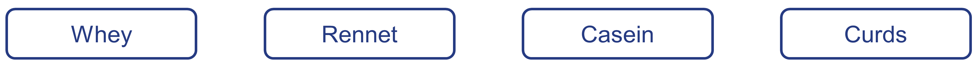

- a. Describe the process of gluten formation.
______________________________________________________________________

______________________________________________________________________

______________________________________________________________________

- b. Explain the function of gluten in bread.
______________________________________________________________________

______________________________________________________________________

______________________________________________________________________
- Explain what would happen to bread if you made it with plain flour rather than strong flour.
______________________________________________________________________

______________________________________________________________________

______________________________________________________________________

______________________________________________________________________

- Describe the process of gelation, using gelatine as an example.

______________________________________________________________________

______________________________________________________________________

______________________________________________________________________

______________________________________________________________________

- Complete the table below, describing the functional properties of proteins. Give at least one example of a food that uses each property.

Functional property | Description | Examples in food
Denaturation
Coagulation
Gluten formation
Gelation

