West African Jollof rice with chicken

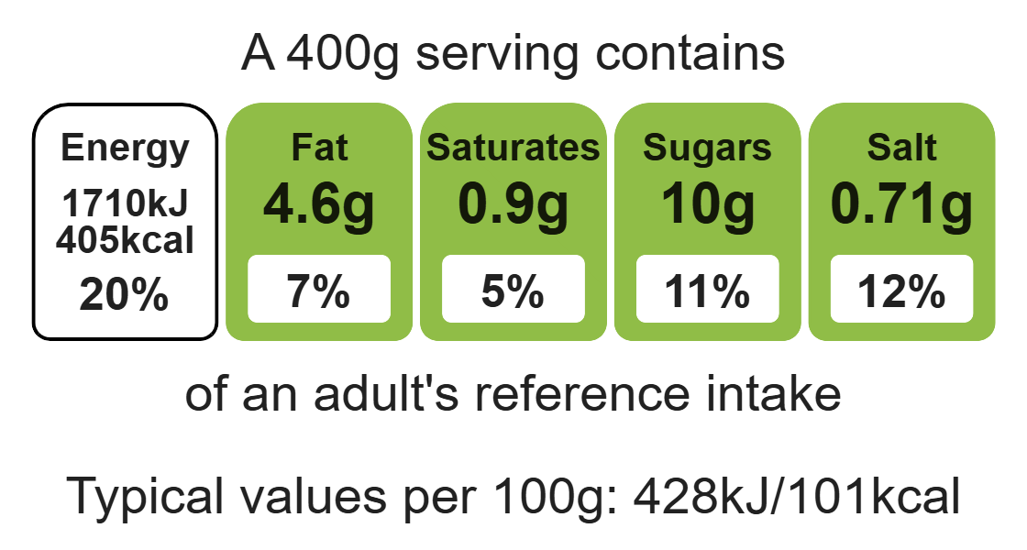
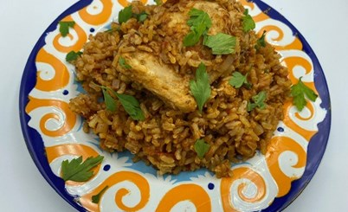

Ingredients (serves 2)

1 onion
Complexity: medium-high

Spray oil

2 chicken thigh fillets
Equipment
Chopping board
Sharp knife
Large saucepan with lid
Mixing spoon
Fish slice or tongs
Small plate
Measuring spoons
Can opener
Measuring jug

½ x 5ml spoon ground ginger

½ x 5ml spoon cinnamon

½ x 5ml dried thyme

¼ x 5ml cayenne pepper

Black pepper

150g brown rice

1 x 400g can chopped tomatoes

1 x reduced-salt chicken stock cube

200ml boiling water

1 bay leaf (optional)

Optional
Top tips
- Vegetarian alternative: Substitute the chicken with a vegetarian alternative.
- Turn up the flavour: Use ground chilli as an alternative to cayenne pepper.
- Focus on fibre: Use brown rice for added fibre – cook for 20-25 minutes as it will need longer to cook.
- Reduce food waste: Additional vegetables can be added to the rice mixture such as diced peppers or sliced okra. Use up any leftover vegetables. Try using chopped fresh tomatoes when they are in season.

1 x 15ml spoon parsley – garnish

Method
- Prepare the ingredients on a clean chopping board:
- peel and chop the onion;
- chop the parsley (if using fresh).
2. Add the spray oil to a large saucepan and gently fry the onions and chicken fillets for 5-6 minutes until the onions are soft and the chicken browned.
- Remove the chicken and place on a plate.
- Add the ground ginger, cinnamon, thyme and cayenne pepper to the pan. Season with black pepper. Stir well and cook for 1 minute.
- Add the rice and stir.
- Add the canned tomatoes.
- Crumble in the stock cube and add 200ml boiling water. Stir well.
- Return the chicken to the pan.
- Add the bay leaf, if using.
- Bring to the boil and then reduce to a simmer.
- Cook for 15 minutes until the rice is tender and the chicken cooked. Add more boiling water if need be.
- Remove the bay leaf.
- Garnish with chopped parsley, if using, and serve.

Food skills
Weigh, measure, peel, cut, chop, slice, dice and trim, fry and sauté, mix, stir and combine, melt, simmer and boil.

