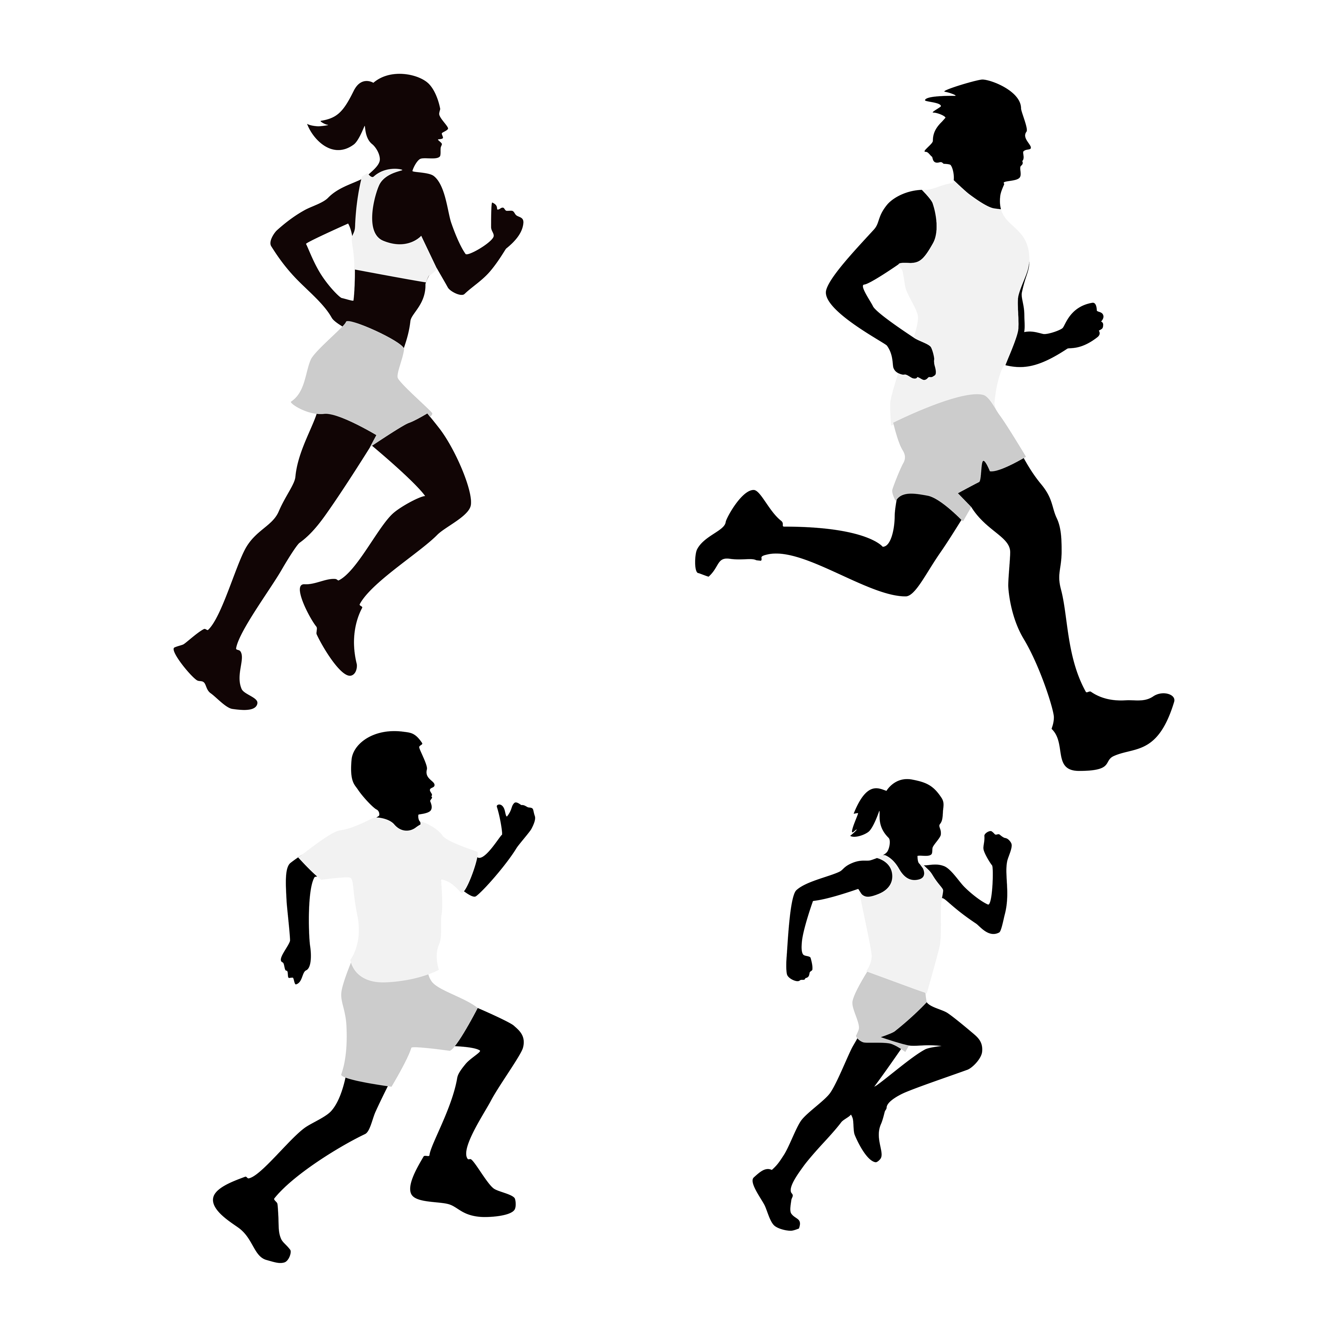
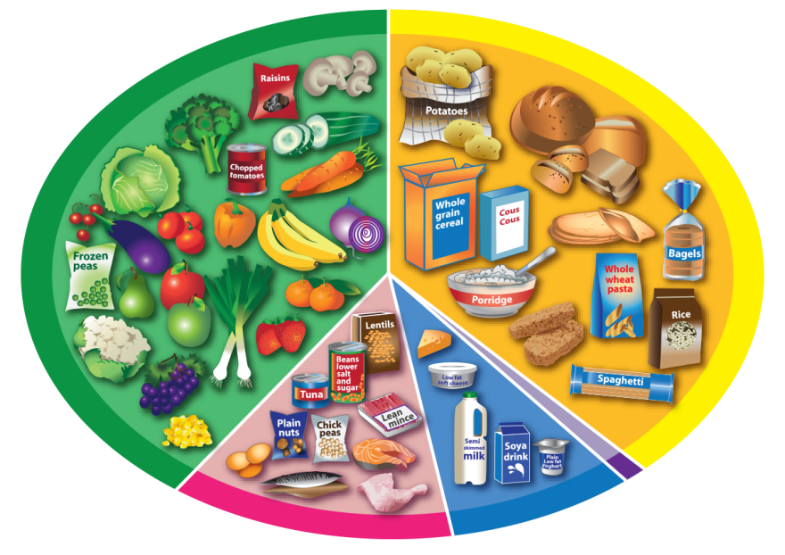
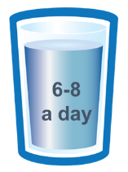
www.foodafactoflife.org.uk
© Food – a fact of life 2018
[Date]
Completing the Be healthy be active Challenge
[Name]

