Small change BIG difference
Identify ways to reduce the saturated fat content of cauliflower cheese.

How would this reduce the saturated fat content?

Explain the health benefits of reducing the saturated fat in our diet?


Identify ways to increase the fibre content of spaghetti Bolognese.

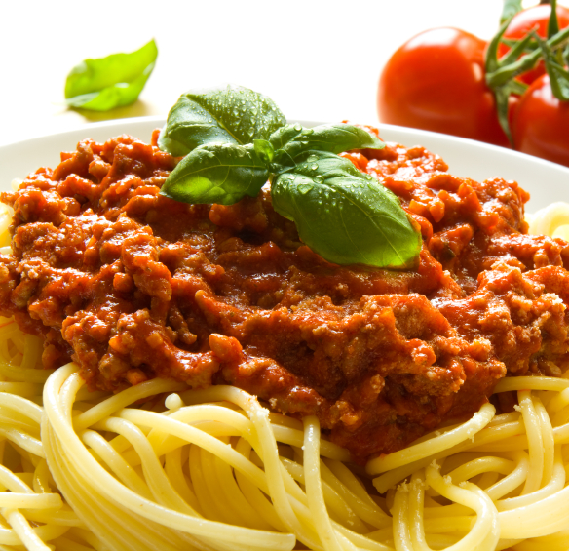
How would this increase the fibre content?

Explain the health benefits of increasing the fibre in our diets.


Identify ways to increase the fruit and vegetable content of Thai green chicken curry.

Explain the health benefits of increasing the amount of fruit and vegetables in our diet
How would this increase the fruit and vegetable content?
Identify ways to reduce the salt content of sausages, mash, peas and onion gravy.

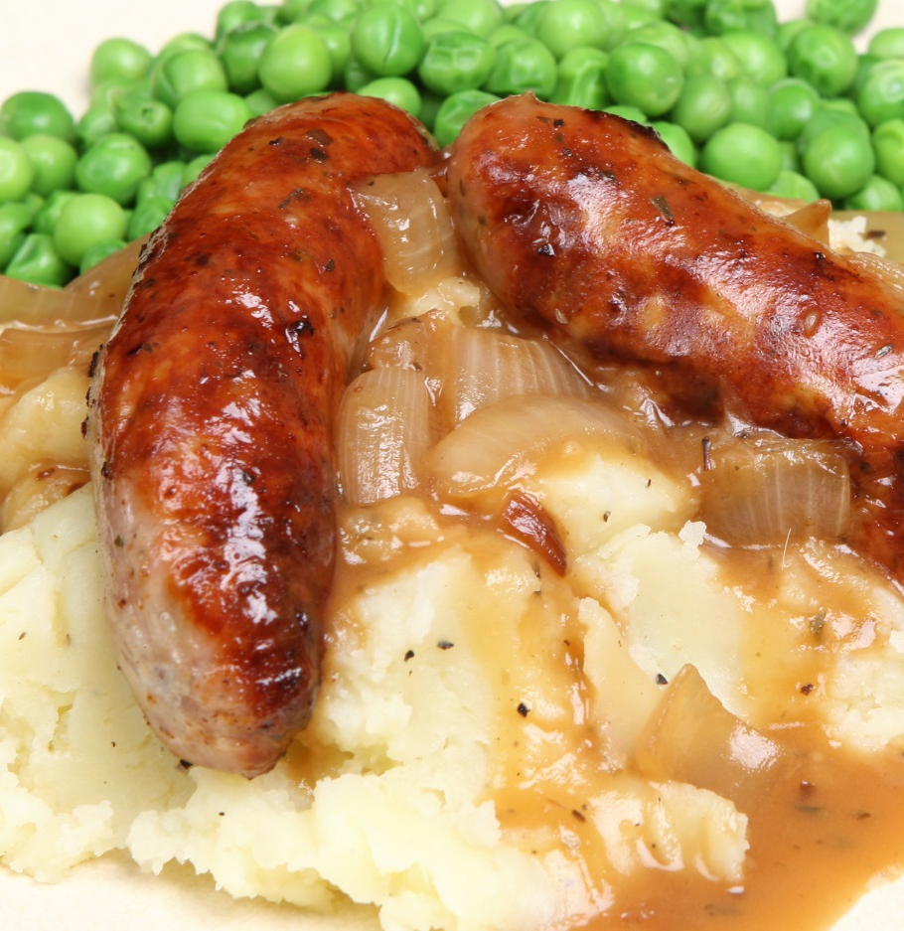

How would this reduce the salt content?

Explain the health benefits of reducing the amount of salt in our diets.

The definition of free sugars includes: all added sugars in any form; all sugars naturally present in fruit and vegetable juices, purées and pastes and similar products in which the structure has been broken down; all sugars in drinks (except for dairy-based drinks); and lactose and galactose added as ingredients.
Identify ways to modify a recipe for apple crumble to reduce the amount of free sugars


How would this reduce the amount of free sugars?

Explain the health benefits reducing the free sugars in our diets.

