Session 14: Rice

Welcome
This session is about cooking with rice to make a delicious meal or side dish. As with other sessions, students will revisit many skills and techniques, therefore making them more confident cooks. Linking to the theme of this block of sessions, it is the Idea of students making dishes at school that they can easily make at home now, and in the future. It also provides you with the opportunity to assess students' practical capability. You could use the practical observation sheet to help.

During this session, students will make either a mushroom risotto or savoury rice. These have been selected as they show the versatility of rice in cooking, and how it can be used in different types of tasty, but inexpensive dishes. Knife techniques are demonstrated, along with safe use of the hob in cooking the rice to perfection.

There is lots of room for students to be creative, selecting different types of ingredients that could be combined into the dishes. You could get your students to use the mushroom risotto or savoury rice recipe writing frames before cooking to develop their own ideas. The students' own recipe creations could then be used in this session.

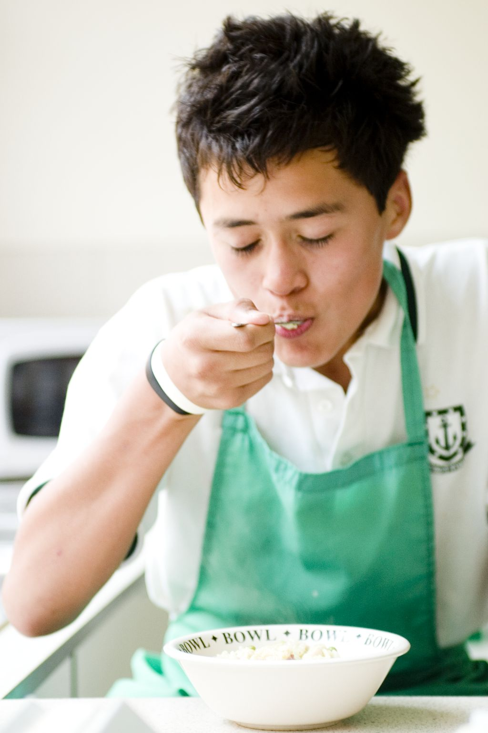
If you have an established lesson plan and/or recipe, which supports the aims and objectives of this session, feel free to use it instead. Look at the support materials provided within this session as they support this activity and may well be useful in your own lessons, e.g. worksheets, PowerPoint presentations.

This session can act as a stand-alone lesson, focusing on rice based dishes and the safe use of the hob. Alternatively, it could be integrated into a series of lessons, e.g. exploring the use of rice as a staple food in different cultures.

Aims and objectives

Aim
For students to:
- demonstrate competence in cooking a rice based dish, using minimal pieces of equipment.

Objectives
Students should be able to:
- prepare an onion;
- prepare a range of vegetables, e.g. peeling, slicing, dicing;
- use the hob safely;
- make a rice based dish, e.g. mushroom risotto or savoury rice.

Cooking session
Two cooking session plans, based on the Licence to Cook recipes are supplied within this session.

If you have your own tried and tested risotto or savoury rice recipe, feel free to use it instead. In addition, you may wish to make other types of dishes, such as a simple paella or pilaf.

Each plan refers to aspects of healthy eating, wise food shopping and food safety and hygiene which are theme which run through each session.

Before the cooking session

There are a number of factors that you need to consider before the cooking session. More detailed guidance is available in the Cooking session guide.

You will need to consider:
- Ingredients: who will be providing the ingredients and where will they be stored? The recipes call for a little oil, vegetable stock and curry powder. It may be easier for the school to provide these for students to share.
- Recipe: are pupils going to use a printed-out copy or follow instructions on an interactive whiteboard?
- Equipment: is all the equipment needed for the session available, clean and in good working order? Check that all the hobs are in good working order and clean. Students will require the use of a saucepan - check that there are enough. Students will require boiling water - ensure that there are kettles around the room.
- Aprons: do you have enough and are they clean?
- Hair: do you have ties/bands for hair?
- Containers: will students be able to take away the rice dish they make? If so, in what?
- Waste: do you have adequate disposal facilities, including recycling or composting?
- Cooking area: is it clean and ready to use?

Differentiation and inclusion
Before this practical session, you will need to consider the age, ability, previous experience and any special requirements of your students. This will determine recipe selection, any advanced ingredient preparation and equipment used.

Do any of your students need:
- partly-prepared ingredients, e.g. sliced mushrooms?
- assistance boiling and pouring water from the kettle?
- to follow different recipes? The savoury rice recipe is easier than the mushroom risotto.
- challenging, by using different types of ingredients in their rice dish or making a side dish?

Demonstration
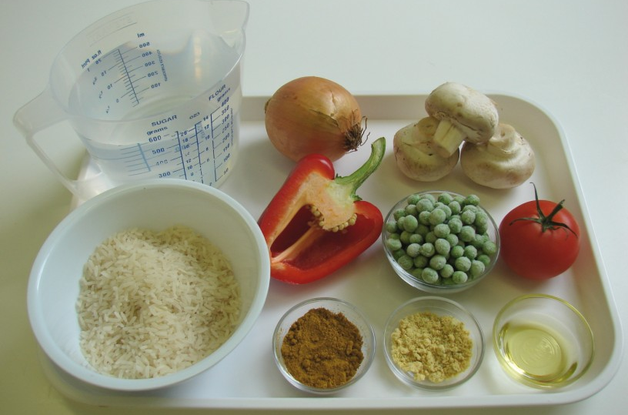
Although the two recipes suggested vary in the way in which the rice is cooked, go through the main stages of the cooking and checking process with the students. You will probably not need to demonstrate any knife skills or hob use again at this stage. However, do remind students to prepare ingredients and cook safely.

Ensure that you have all the ingredients and equipment you need before the session, perhaps on trays for ease, for your demonstration.

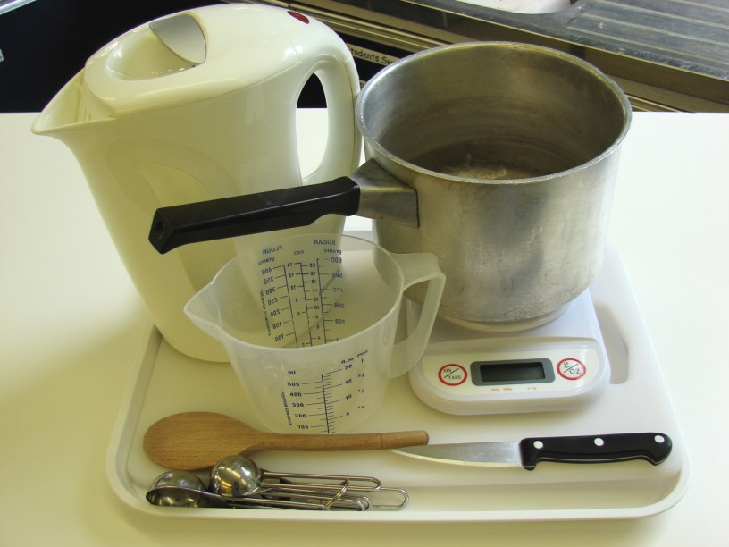
Think about:
- describing the ingredients and equipment used;
- highlighting how to use the kettle safely to boil water;
- showing how to cook rice;
- ensuring that students have followed and understood the method.

More detailed guidance is available in the Demonstrating guide.
Risk assessment

The two cooking session plans and recipes highlight a number of different hygiene and safety issues which need to be considered before, during and after the cooking session.

Before the cooking session, you will need to assess these risks in relation to the number of students being taught, as well as their experience, and consider measures that can be put into place to manage the risk. Below are examples of potential risks, along with preventative measures.

Mushroom risotto
Potential risk | Measure | Likelihood
Cuts from using a knife unsafely | Demonstrate safe use of knives and monitor students’ use | Low
Incorrect storage of rice could cause food poisoning | Cool quickly and store in the fridge after cooking and use the next day | Low/Med

Savoury rice
Potential risk | Measure | Likelihood
Dirt or food poisoning bacteria present on raw food, causing cross contamination | Wash vegetables | Low
Incorrect storage of rice could cause food poisoning | Cool quickly and store in the fridge after cooking and use the next day | Low/Med

Time
The session plans are based on a 60 minute session.

If you have less time available, you will need to modify the session plan to better suit your circumstances. For example, within this session you might:
- demonstrate the safe use of the hob and kettle at another time;
- demonstrate key aspects from the recipe, rather than every stage;
- have ingredients pre-measured;
- allow students to work with a partner.
During the lesson
Time (mins) | Activity: Mushroom risotto | Equipment/ resources
0 | Registration.  Explain to the students that they will be making mushroom risotto. Go through the aims and objectives for the lesson. | PowerPoint Mushroom risotto  recipe
5 | Gather the students around a demonstration area, with your tray of ingredients and equipment. Ensure that all students have their apron on, hair tied back, and hands washed.  Briefly talk through the recipe – note your expectations, for example:  * preparing the ingredients carefully and accurately;  * frying the onion and garlic;  * cooking the rice, stirring constantly;  * using the kettle and hob safely;  * being hygienic and safe when preparing food. | Aprons  Demonstration ingredient and equipment tray
Demonstration
* Place out the chopping board and vegetable knife. Have a small bowl or plate handy for peelings and other waste.
* Check whether any students need to be reminded how to prepare an onion. Use the Claw grip to cut away one end of the onion (not the root). Then use the Bridge hold to cut the onion in half. Peel away the outer skin. Next, cut length ways into the onion – but do not cut through the root. The root will keep the onion together. Next, use the Claw grip to slice across the onion.
* Check that all students remember how to slice mushrooms using the Claw grip. You may need to recap crushing garlic.
* Remind students about using the kettle safely to boil water to make up the stock. Kettles should not be over filled, as they could boil over. Students should share the kettles in the room. Kettles should be disconnected from the electrical point when filling up and pouring. Pouring boiling water from the kettle should be done slowly and safely. The water should be measured in a measuring jug which is on a flat surface for an accurate reading.
* If time, you may wish to prepare the risotto. If not, explain to the students that when the risotto rice is cooking, it needs to be stirred constantly as the stock is added. The stirring action helps the dish to develop its creamy texture. The rice should not become too dry, as it will easily burn on the bottom of the pan.

 | * Remind students that they should be careful when using the hob, with the saucepan (or frying pan) handle turned away from the edge.
15 | Ensure that all students wash their hands. Allow them to start making their mushroom risotto.  During this time, circulate the room to ensure that students are preparing ingredients and using the kettle and hob safely. In this time, students should:  * prepare the vegetables;  * use the hob safely to cook the risotto rice;  * stir in the parmesan cheese and thyme.
25 | All risottos should be cooking on the hob - they take at least 25 minutes. The risotto is cooked when the rice is tender to eat. During the remaining time students should be washing up, cleaning work surfaces and putting away equipment.
50 | Give a 5 minute time warning.  Remind students that all washing up should be completed, work surfaces should be clean, and their mushroom risotto should be placed in a container.  Circulate the room, ensuring that sinks are clean, and equipment is put away properly.
55 | Plenary  Pose the following questions to the students:  * What were the main skills demonstrated today?  * Name 3 different combinations of ingredients that could be added to risotto.  * How could you make this a complete, balanced meal?
60 | Finish

After the session
Check that the room is clean and tidy. Students should leave the room as they find it.

The mushroom risottos may need to be refrigerated until the end of the school day, if so, ensure that each container is covered and clearly labelled with the student’s name and group. The refrigerator should be between 0-5ºC.

Students may wish to reheat the rice dish at home. To microwave, place the risotto in a suitable container and cover loosely. Cook for full power for 3-4 minutes. Alternatively, reheat the risotto in a saucepan – you may need to add a little water.

Remind the students that rice dishes should be eaten within 24 hours of being made.

If the same students are with you for another cooking session in the next few days or week, remind them of the ingredients and/or containers they need to bring, if appropriate. You may wish to provide students with recipes or writing frames

During the lesson
Time (mins) | Activity: Savoury rice | Equipment/ resources
0 | Registration.  Explain to the students that they will be making savoury rice. Go through the aims and objectives for the lesson. | PowerPoint Savoury rice recipe
5 | Gather the students around a demonstration area, with your tray of ingredients and equipment. Ensure that all students have their apron on, hair tied back, and hands washed.  Briefly talk through the recipe – note your expectations, for example:  * preparing the ingredients carefully and accurately;  * frying the onion and other vegetables;  * cooking the rice until tender;  * using the kettle and hob safely;  * being hygienic and safe when preparing food. | Aprons  Demonstration ingredient and equipment tray
Demonstration
* Place out the chopping board and vegetable knife. Have a small bowl or plate handy for peelings and other waste.
* Check whether any students need to be reminded how to prepare an onion. Use the Claw grip to cut away one end of the onion (not the root). Then use the Bridge hold to cut the onion in half. Peel away the outer skin. Next, cut length ways into the onion – but do not cut through the root. The root will keep the onion together. Next, use the Claw grip to slice across the onion.
* Check that all students remember how to slice the mushrooms, dice the pepper and chop the tomato.
* Remind students about using the kettle safely to boil water to make up the stock. Kettles should not be over filled, as they could boil over. Students should share the kettles in the room. Kettles should be disconnected from the electrical point when filling up and pouring. Pouring boiling water from the kettle should be done slowly and safely. The water should be measured in a measuring jug which is on a flat surface for an accurate reading.
* If time, you may wish to prepare the savoury rice. If not, explain to the students that when the rice is simmering, it needs to be stirred occasionally.
* Remind students that they should be careful when using the hob, with the saucepan handle turned away from the edge.

15 | Ensure that students all wash their hands. Allow them to start making their savoury rice.  During this time, circulate the room to ensure that students are preparing ingredients and using the kettle and oven safely. In this time, students should:  * prepare the vegetables;  * fry the onion and other vegetables;  * cook the rice;  * use the kettle and hob safely. | Basic equipment  Saucepans  Ingredients
35 | All rice dishes should be being cooked on the hob - they take around 15-20 minutes. During the remaining time students should be washing up, cleaning work surfaces and putting away equipment.
50 | Give a 5 minute time warning.  Remind students that all washing up should be completed, work surfaces should be clean, and their savoury rice should be placed in a container.  Circulate the room, ensuring that sinks are clean, and equipment is put away properly.
55 | Plenary  Pose the following questions to the students:  * What were the main skills demonstrated today?  * Name 3 different combinations of ingredients that could be added to the savoury rice.  * How could you make this a complete, balanced meal?
60 | Finish

After the session
Check that the room is clean and tidy. Students should leave the room as they find it.

The savoury rice may need to be refrigerated until the end of the school day, if so, ensure that each container is loosely covered and clearly labelled with the student’s name and group. The refrigerator should be between 0-5ºC.

Students may wish to reheat the rice dish at home. To microwave, place the rice in a suitable container and cover loosely. Cook for full power for 3-4 minutes. Alternatively, reheat the rice in a saucepan – you may need to add a little water.

Remind the students that rice dishes should be eaten within 24 hours of being made.

If the same students are with you for another cooking session in the next few days or week, remind them of the ingredients and/or containers they need to bring, if appropriate. You may wish to provide students with recipes or writing frames.

Areas of learning

Healthy eating
- Try brown rice, or mixes of white and brown, for extra fibre and to add variety to the diet.
- Stir-in chopped tomatoes, dried fruits and almonds at the end of cooking.

Wise food shopping
- Buy large packets of rice and store in a cool, dry place ready to use in lots of different recipes.
- Rice is relatively inexpensive, so go for large portions.
- A small pot of spice, like curry powder, or dried herbs, like thyme, goes a long way and is a useful store cupboard ingredient.

Food safety and hygiene
- When getting ready to cook, always wear an apron, tie back long hair, roll up long sleeves, remove any jewellery and wash your hands.
- Wash fruit and vegetables before use.

Extending this activity
This session provides a great opportunity to be integrated into existing lessons or be developed into a mini-scheme of work.

For example, students could:
- explore the use of rice as a staple food in different cultures;
- plan, generate, model and create different types of rice based dishes, perhaps based on a particular cuisine from around the world;
- evaluate different types of rice by making a selection of dishes and taste testing the dishes, using comments to help plan and create their own recipes.

Appropriate aspects of ICT could also be integrated, including:
- recording how the dish is made using a digital camera;
- creating a recipe plan or flow-chart;
- modelling the sensory data from different class mates tasting sessions;
- exploring the internet for traditional recipes and techniques, which can be used in their own cooking sessions.

Shopping list

Mushroom risotto
Ingredient | x 1 | x 10 | x 20
Chestnut mushrooms | 150g | 1.5kg | 3kg
Onion | 1 | 10 | 20
Garlic (cloves) | 2 | 20 | 40
Oil | 1 x 15ml spoons | 150ml | 600ml
Risotto rice | 250g | 2.5kg | 5kg
Stock powder | 1 x 5ml spoon | 1 tub | 1 tub
Parmesan | 1 x 15ml spoon | small block | medium block
Thyme, fresh | 1 x 10ml spoon | handful of sprigs | handful of sprigs

Savoury rice
Ingredient | x 1 | x 10 | x 20
Onion | 1 | 10 | 20
Red pepper | 1/2 | 5 | 10
Oil | 1 x 10ml spoon | 100ml | 200ml
Rice, long grain | 150g | 1.5kg | 3kg
Vegetable stock powder | 1 x 5ml spoon | 1 tub | 1 tub
Peas, frozen | 25g | 250g | 500g
Curry powder | 1 x 10ml spoon | 1 jar | 1 jar
Tomato (each) | 1 | 10 | 20

Equipment list

Mushroom risotto

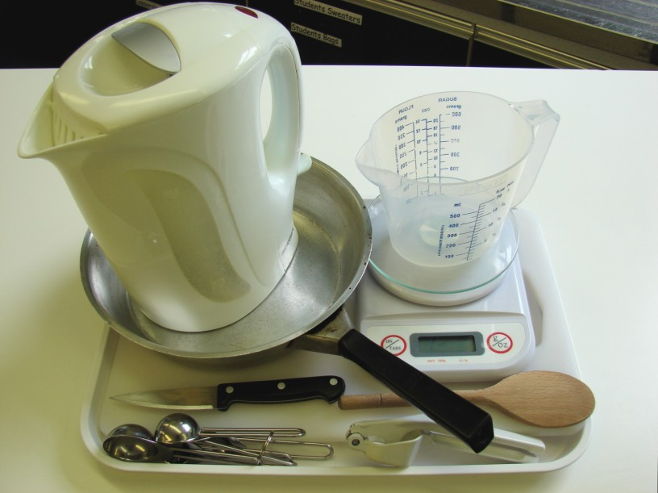
Chopping board, knife, garlic press, weighing scales, measuring spoons, frying pan, wooden spoon, kettle, measuring jug.

Savoury rice

Chopping board, knife, saucepan, wooden spoon, weighing scales, measuring jug, measuring spoons.

Containers

If students take their dishes, they will need to bring (or be provided with by the school) a suitable container, such as a foil container with a lid.

