Nutrient treasure hunt

The table below is partially completed. Use your treasure hunting skills (around the room) and nutrition knowledge to fill in the gaps.
Nutrient | Function | Product or source | Nutrient content per 100g | Fortified? (yes/no) | Extension – are intakes in UK adolescents low*?
 | 
Vitamin C

 | 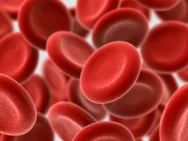
 |  | 
 | Helps to release energy from carbohydrate. It is also involved in the nervous system and the heart.
Iodine

*Low’ defined as intakes less than the Lower Reference Nutrient Intake (LRNI)

