Chimichurri fish traybake

Ingredients
Complexity: medium
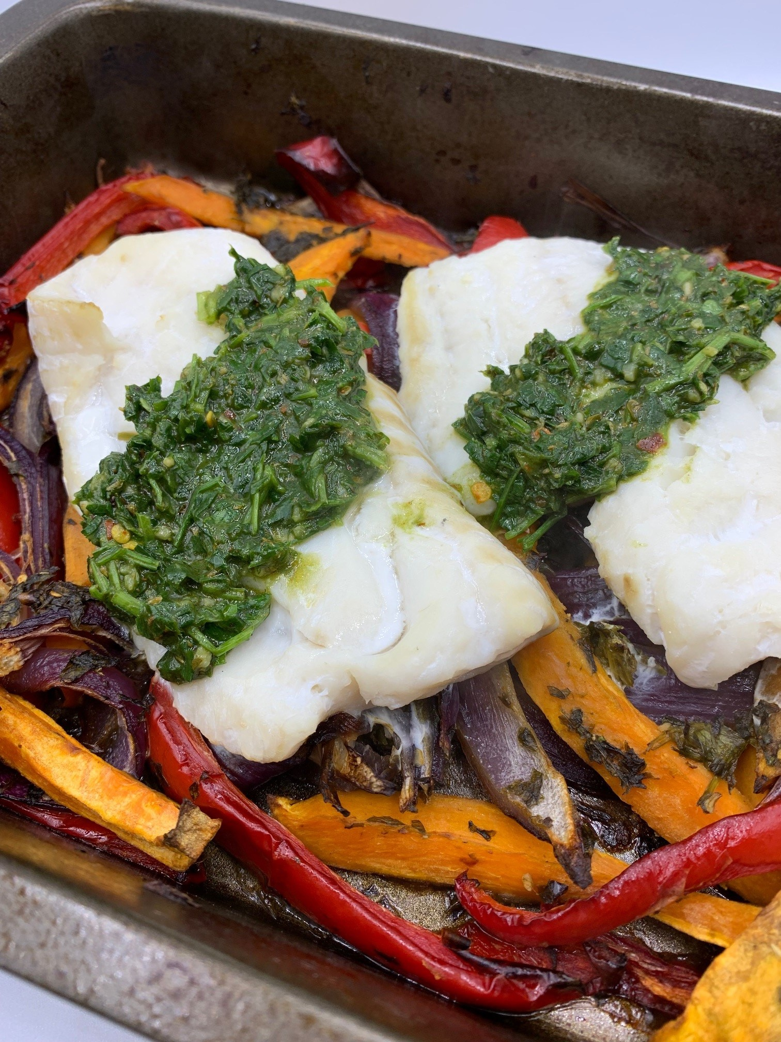
2 small sweet potatoes (about 350g)
1 medium red onion
1 red pepper
1 garlic clove
25g fresh flat-leaf parsley
1 x 15ml spoon olive oil
1 x 15ml spoon red wine vinegar
¼ x 5ml spoon crushed chillies
¼ x 5ml spoon smoked paprika
1 x 5ml spoon dried oregano
Black pepper
250g skinless white fish fillets, e.g. basa

Equipment
Chopping board, vegetable knife, garlic press, large roasting tin, measuring spoons, food processor or hand blender.

Method
- Preheat the oven to gas 6, 200°C, fan 180°C.
- Prepare the ingredients:
  - peel and slice the sweet potatoes into wedges;
  - peel and slice the red onion into wedges;
  - deseed and slice the red pepper;
  - peel and crush or chop the garlic.
- Put the sweet potato, onion and peppers in a large roasting tin.
- To make the chimichurri dressing, put the parsley, oil, vinegar, garlic, crushed chillies, paprika and ½ x 5ml spoon oregano into a food processor. Alternatively, use a hand-held blender.
- Blitz until the parsley is finely chopped and you have a thick sauce. Season with black pepper.
- Add 1 x 15ml spoon of the sauce to the vegetables in the tin and toss together. Scatter over the remaining oregano, then roast for 25-30 minutes until the vegetables are just tender.
- Top with the fish fillets and return to the oven for 5-10 minutes until the fish is cooked through.
- Add 1-2 x 15ml spoons cold water to the remaining sauce and stir well to make a pourable dressing.
- Spoon over the roasted vegetables and fish to serve.

Top tips
- For a vegetarian or vegan dish, try sliced halloumi, tofu, paneer or ready-made polenta instead of fish. Alternatively, add more vegetables such as broccoli and cauliflower florets, diced aubergine, sliced mushrooms, sliced carrots and green, orange or yellow peppers.
- Currently, one third of global fish stocks are overfished, so choose fish labelled as sustainably sourced (e.g. the blue Marine Stewardship Council (MSC) label) and check the Marine Conservation Society’s Good Fish Guide for more sustainable options.

Food skills
- Weigh
- Measure
- Peel
- Slice
- Chop
- Crush
- Blitz
- Stir
- Roast

Did you know?
Chimichurri is an Argentinian uncooked herb sauce and is available as red or green chimichurri. Red chimichurri, is spicier and also includes smoked paprika and dried red chili, cayenne pepper, or pepper flakes. Some recipes also add red peppers.

In Argentina, chimichurri is used both as a marinade and a sauce for grilled meat, but it can also be used with fish, chicken, lamb, or pasta.

To avoid waste, store any unused sauce covered in the refrigerator - the vinegar will help to preserve the herbs.

This recipe was adapted from a recipe for Chimichuri fish traybake, which was kindly donated by Tesco plc.

