Pizza toast
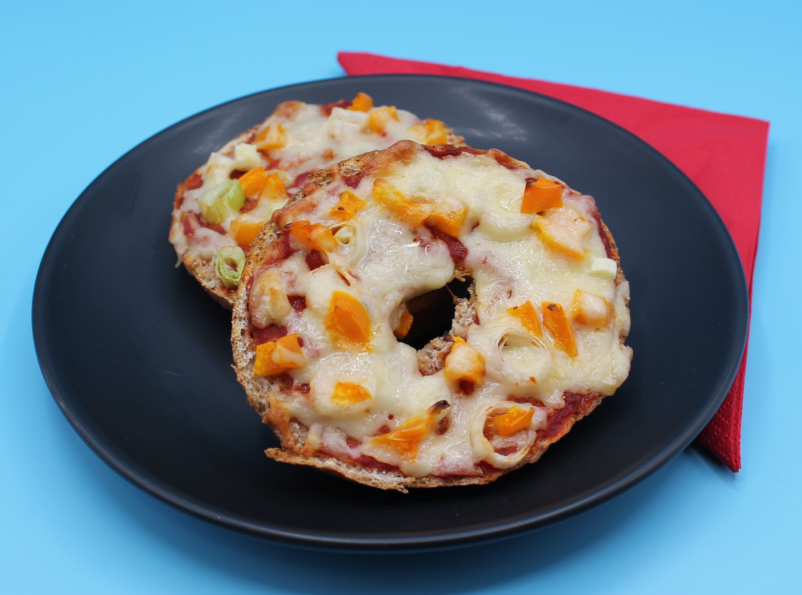
Complexity: medium- high
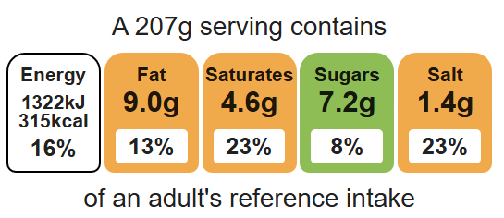

Ingredients (serves 1)
½ pepper

Equipment

Chopping board

Sharp knife

Grater

Fish slice

Measuring spoons

1 spring onion
1 mushroom
30g reduced-fat hard cheese, e.g. cheddar, Edam, Gruyere
2 slices wholemeal bread, bagel, piece of French stick sliced in half, or a crumpet
2 x 15ml spoons tomato pizza sauce or passata
½ x 5ml spoon mixed herbs

Method
Top tips
- Turn up the flavour: Add cooked chicken, canned tuna or canned sweetcorn.
- Reduce food waste: Add leftover vegetables such as sweetcorn, tomatoes, olives.
- Tomato purée could be used instead of pizza sauce or passata.

1. Preheat the grill.
2. Prepare the pizza toppings:
- deseed and dice the pepper;
- slice the spring onion into rings;
- slice the mushroom;
- grate the cheese.
4. Place the bread under the grill and toast on one side.
5. Carefully remove the bread from the grill and place on the chopping board uncooked side-up.
6. Spread the tomato sauce over the bread using the back of the spoon.
7. Arrange the pepper, mushroom and onion over the bread.
8. Sprinkle the grated cheese on top.
9. Place under the grill until the cheese melts.

Food skills
Weigh, measure, cut, chop, slice, dice and trim, grate, spread, grill.

