Marble pear traybake
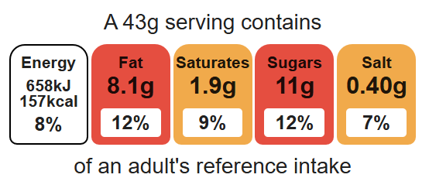
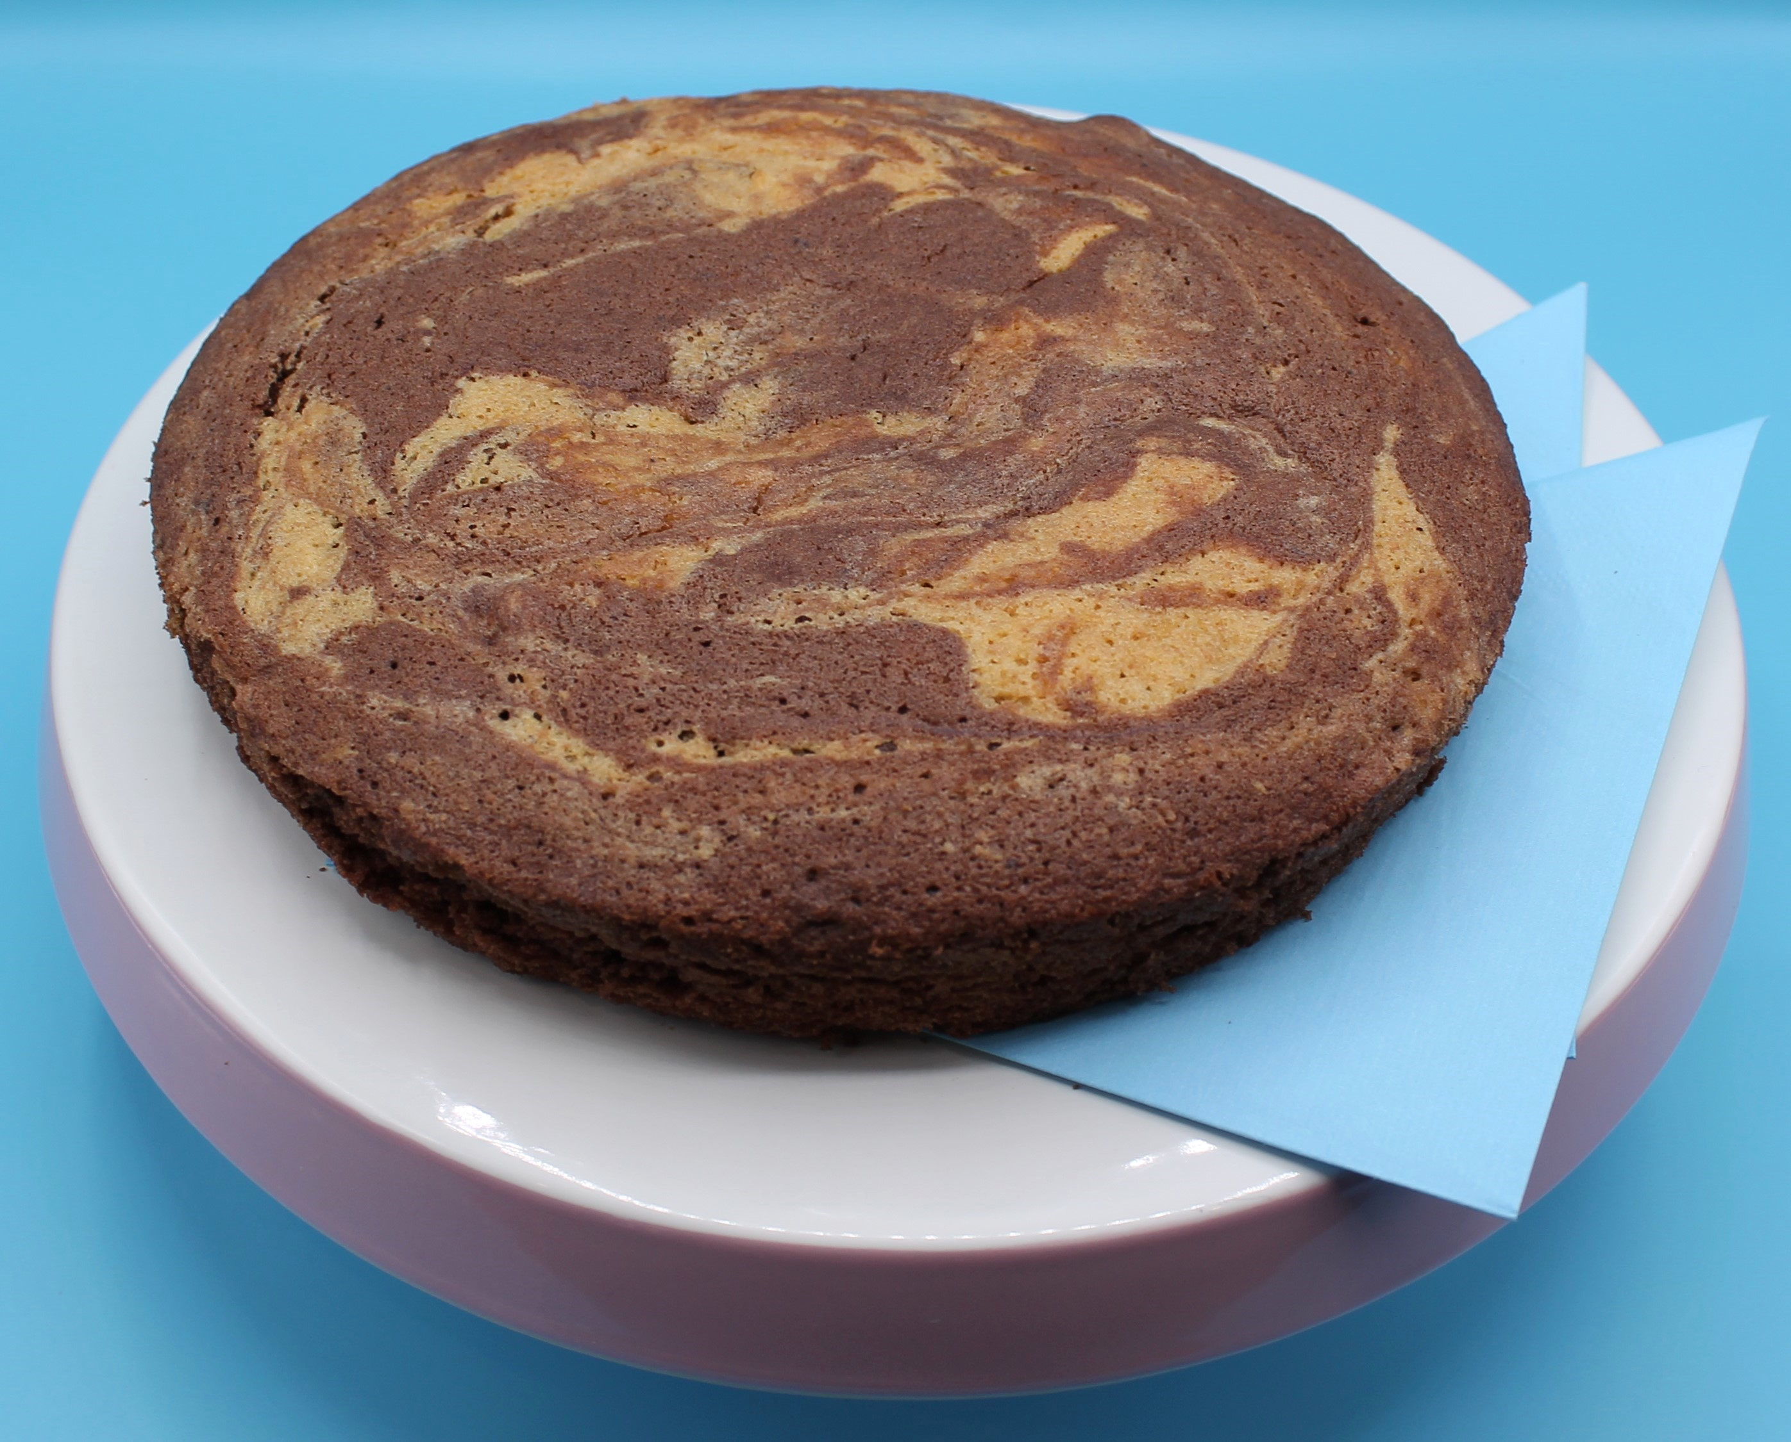
Complexity: medium

Equipment

Baking tin or foil tray (20cm)

Weighing scales

Chopping board

Sharp knife

Mixing bowl

Electric hand whisk

Measuring spoons

Small bowl

Sieve

Mixing spoon

Fork

Spatula

Cooling rack

Ingredients (serves 10)
½ pear
100g caster sugar
100g reduced-fat spread
2 eggs
50g self-raising white flour
50g self-raising wholemeal flour
1 x 5ml spoon baking powder
1 x 15ml spoon cocoa powder

Method
- Preheat the oven to 180ºC or gas mark 4.
- Grease and line the baking tin or foil tray.
- Core and chop the pear into small pieces. There is no need to peel the pear. Place the chopped pear into the lined baking tin.
- Cream the sugar and fat together in a large bowl, ideally using an electric hand whisk, until light and fluffy.
- In a small bowl, beat the eggs with a fork.
- Add the beaten egg, a little at a time, to the fat and sugar.
- Sift the flour and baking powder into a bowl.
- Fold the flour and baking powder into the mixture, a spoonful at a time.
- Spoon half of the plain cake mixture into the tin on top of the pear (do not spread it across the pear).
- Stir-in the cocoa to the cake mixture remaining in the bowl.
- Spoon the chocolate mixture into the baking tin and then swirl the two mixtures together to create a marble effect.
- Place in the oven and bake for 25 minutes, until golden brown and springy to the touch.
- Remove from the oven and allow to cool.

Top tips
- Turn up the flavour: Instead of cocoa powder, try spices and fruit, e.g. mixed spice or ginger and apricots.
- Focus on fibre: Replace the white flour with 50g wholemeal flour for an extra fibre boost.
- When lining the baking tin, it is only necessary to line the bottom. The sides can be greased with oil and pastry brush

Food skills
Weigh, measure, core, cut, chop, slice, dice and trim, cream, beat, sift, fold, mix, stir and combine, bake.

