Polish potato dumplings

Ingredients
Complexity: medium-high
350g potatoes
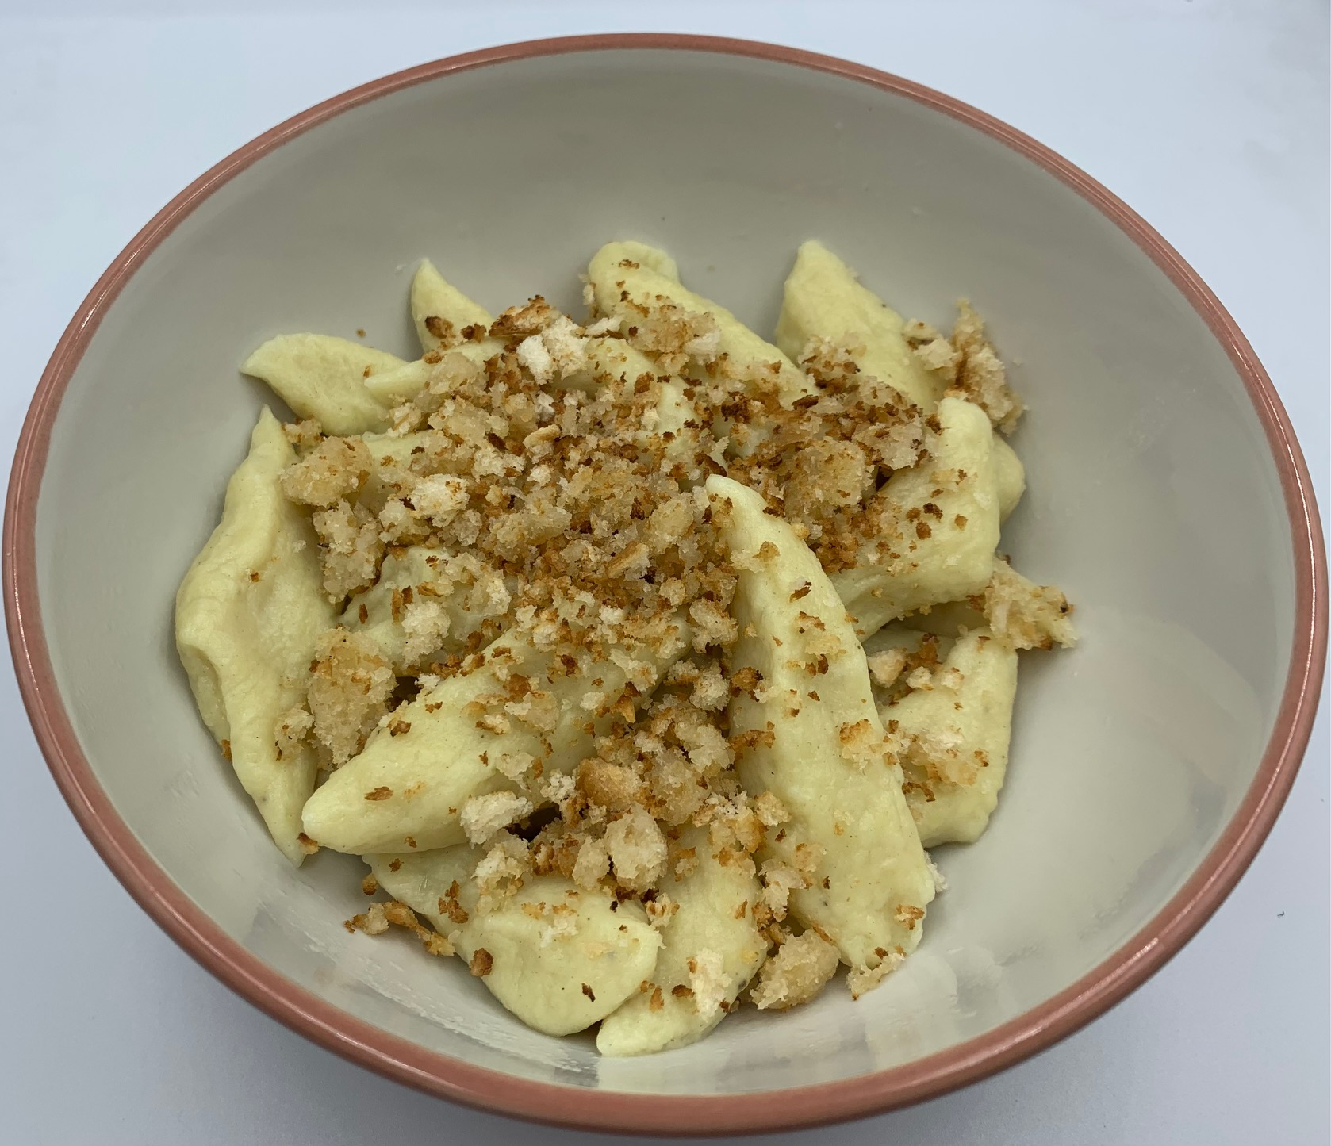
1 egg
¼ x 5ml spoon salt
130g plain flour

For the polonaise topping - optional
1 x 5ml spoon reduced fat spread
2 x 15ml spoons fresh breadcrumbs

Equipment

Vegetable peeler, chopping board, vegetable knife, large saucepan x 2, colander, fine mesh sieve or potato masher, large mixing bowl, spoon, small bowl, fork, slotted spoon, small frying pan, mixing spoon.

Method
- Peel the potatoes and cut into cubes.
- Place the potatoes in a pan of cold water and bring to the boil. Reduce the heat and simmer until the potatoes are soft.
- Drain the potatoes using a colander and transfer to a fine mesh sieve or a potato ricer.
- If using a sieve, place it over a large mixing bowl and push the cooked potato through the sieve with the back of a spoon.
- Crack the egg into a small bowl and mix with a fork.
- Add the egg, salt and three quarters of the flour into the bowl with the potato and mix to form a smooth dough. Add more flour if necessary. Don’t overwork the dough as it will become tough.
- Put a large saucepan of water on to boil.
- On a lightly floured surface and with lightly floured hands, roll pieces of dough into 1.5cm thick cylinders. Cut at an angle into 3-4cm pieces. Repeat until all the dough is cut into pieces.
- Carefully place the dumplings into the boiling water and return to the boil. Depending on the size of the saucepan, this may need to be done in batches.
- Reduce the heat and simmer for 3-5 minutes. Remove a dumpling with a slotted spoon and carefully test to see if cooked. The dumpling should be firm and hot in the centre.
- Once cooked, remove the dumplings with a slotted spoon and drain in a colander.
- If serving with the polonaise topping, melt the reduced fat spread in a small saucepan. Add the breadcrumbs and gently fry until golden brown.
- Serve the dumplings with a sprinkling of the topping.

Top tips
- Potatoes baked or microwaved in their skins can be used instead of boiled potatoes. Leftover mashed potato can also be used.
- Serve with the polonaise topping as a side dish or with the pan juices or gravy from roasted meats or poultry.
- Uncooked dumplings can be frozen. Place in a single layer on a baking tray and freeze. Once frozen place in a container or freezer bag and store for up to three months. Defrost before cooking.

Food skills
- Weigh
- Measure
- Peel
- Cut
- Boil
- Simmer
- Drain
- Mash
- Mix
- Form and shape
- Melt
- Fry

Did you know?
Potato dumplings are known as kopytka (koh-pit-kah) in Poland. Their name means ‘little hooves’ because of their shape.

Many people consider these dumplings the Polish equivalent of gnocchi.

An alternative recipe for Polish potato dumplings is pyzy which uses a combination of raw, grated and cooked potato in the dough.

