The effects of cooking on food

- Identify five reasons why food may be cooked.

- ___________________________________________________________
- ___________________________________________________________
- ___________________________________________________________
- ___________________________________________________________
- ___________________________________________________________

- Describe how cooking a food may make it safer to eat. Name an example of a food that is unsafe to eat raw.
______________________________________________________________________

______________________________________________________________________

______________________________________________________________________

- Name the main reaction that causes browning in both baked goods and meats.
_________________________________

- Suggest three different ways that you could incorporate tomatoes into dishes.

- ___________________________________________________________
___________________________________________________________
- ___________________________________________________________
___________________________________________________________
- ___________________________________________________________
___________________________________________________________

- Give an example of a food that is easier to digest after cooking. Explain what has happened to the food to make this possible.
______________________________________________________________________

______________________________________________________________________

______________________________________________________________________

- Name the three ways that heat can be transferred to food.
  - _________________________
  - _________________________
  - _________________________
- Which method of heat transfer is illustrated by the diagram below?

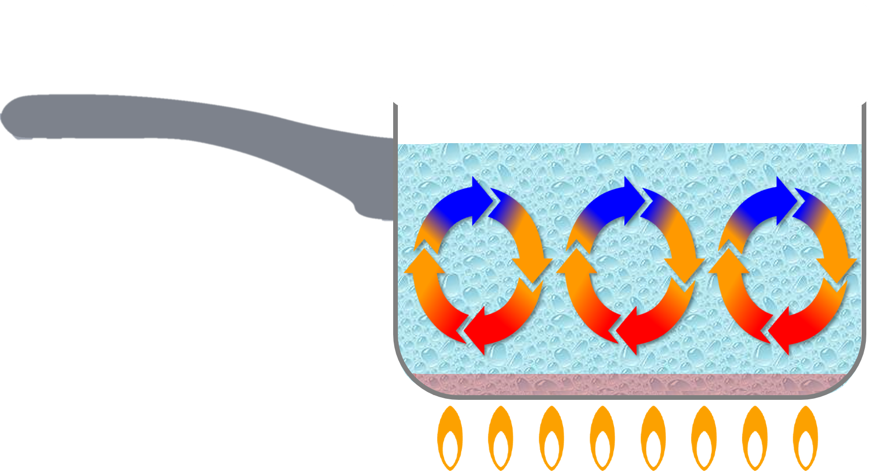
______________________________

- Explain how a microwave heats food.
______________________________________________________________________

______________________________________________________________________

______________________________________________________________________

______________________________________________________________________
- Name the two cooking methods that work together when a potato is baked in the oven.
  - _____________________
  - _____________________
- Match the cooking methods (right) to indicate whether they are moist methods, dry methods or fat-based methods.
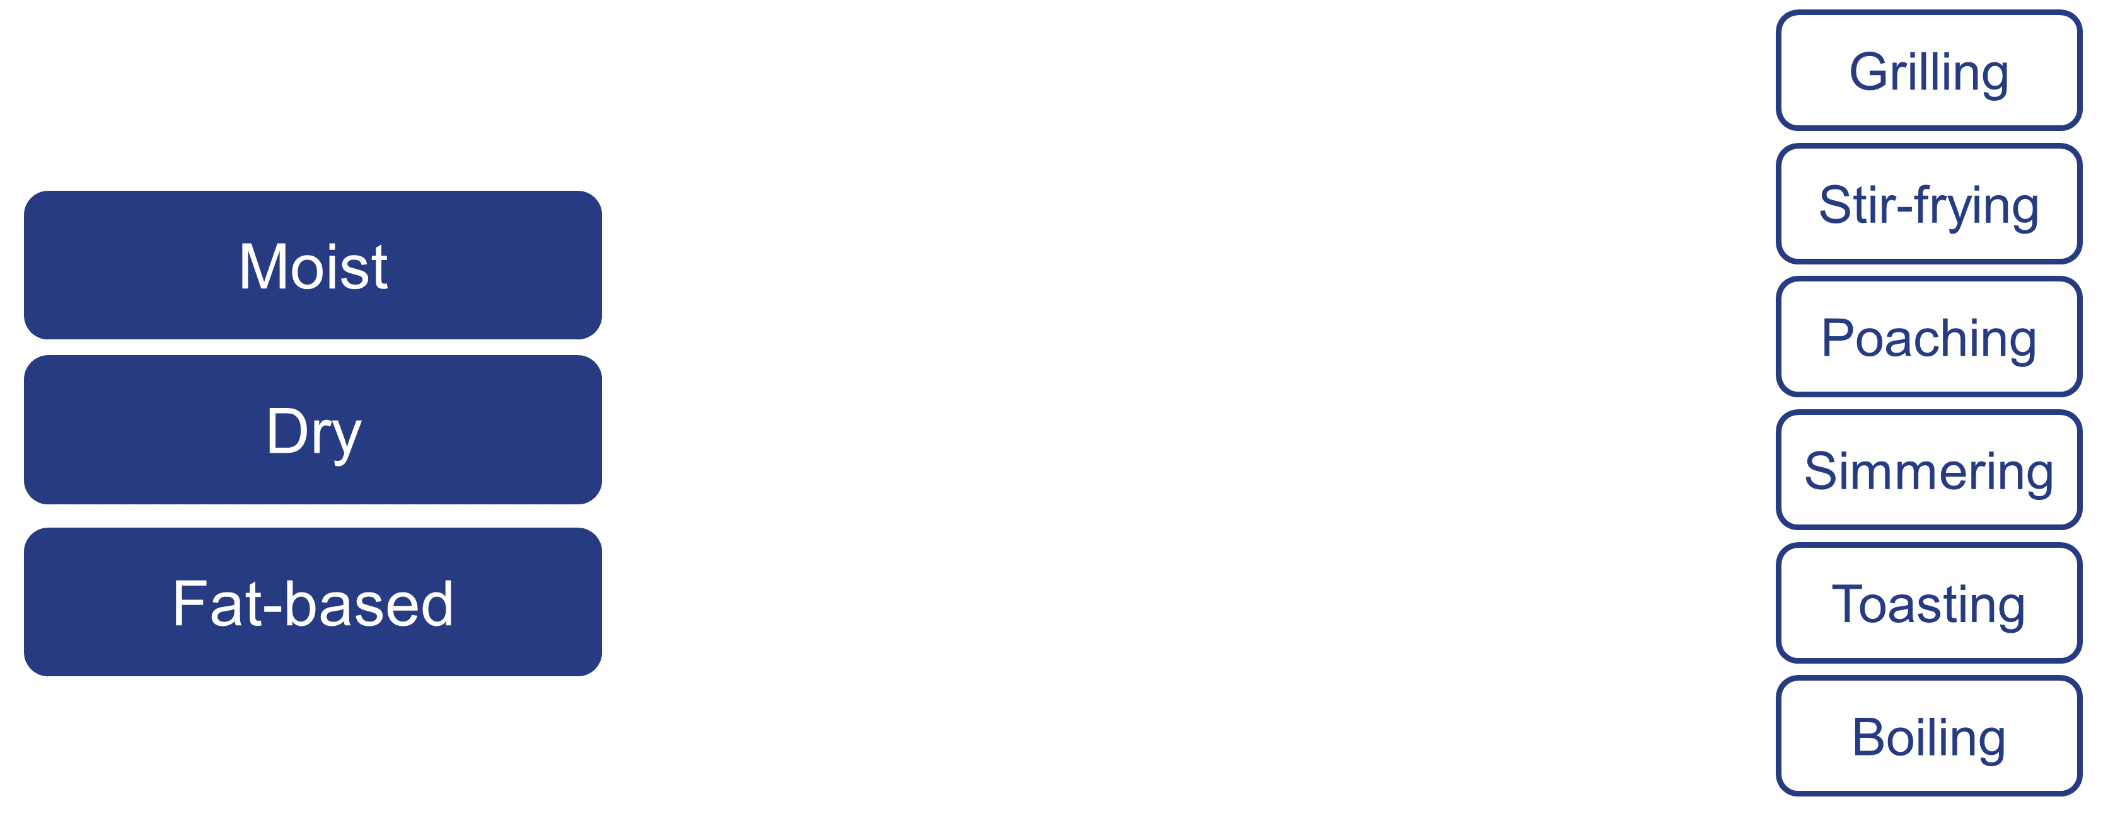

- Think about a dish you cooked recently. What changes occurred when the raw ingredients were cooked together? Describe the changes in texture, smell, taste and looks of the raw ingredients and the finished dish.
______________________________________________________________________

______________________________________________________________________

______________________________________________________________________

______________________________________________________________________
______________________________________________________________________

______________________________________________________________________
______________________________________________________________________

