Around the world – dishes using starchy carbohydrates
Bulgar wheat
Couscous
Wild rice
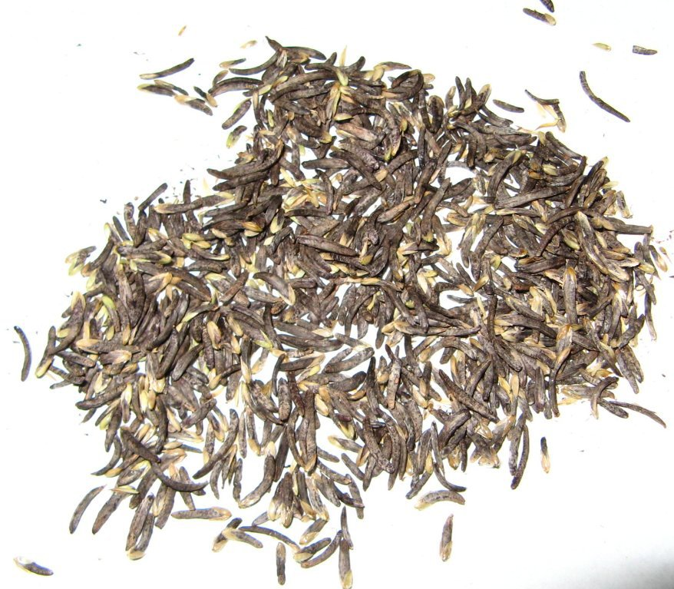

Pasta
Quinoa

1. What cereal crop are these ingredients made from?

- Bulgar wheat………………………………………
- Couscous …………………………………………
- Wild rice……………………………………………
- Quinoa ……………………………………………..
- Pasta………………………………………………..

2. Research how they are cooked and give two examples of dishes that are made using the ingredient.
Pasta recipes
Quinoa recipes
Brown rice recipes
Bulgar wheat recipes
Couscous recipes

3. Name two other starchy carbohydrates that are used in dishes around the world.

