Mini carrot cakes
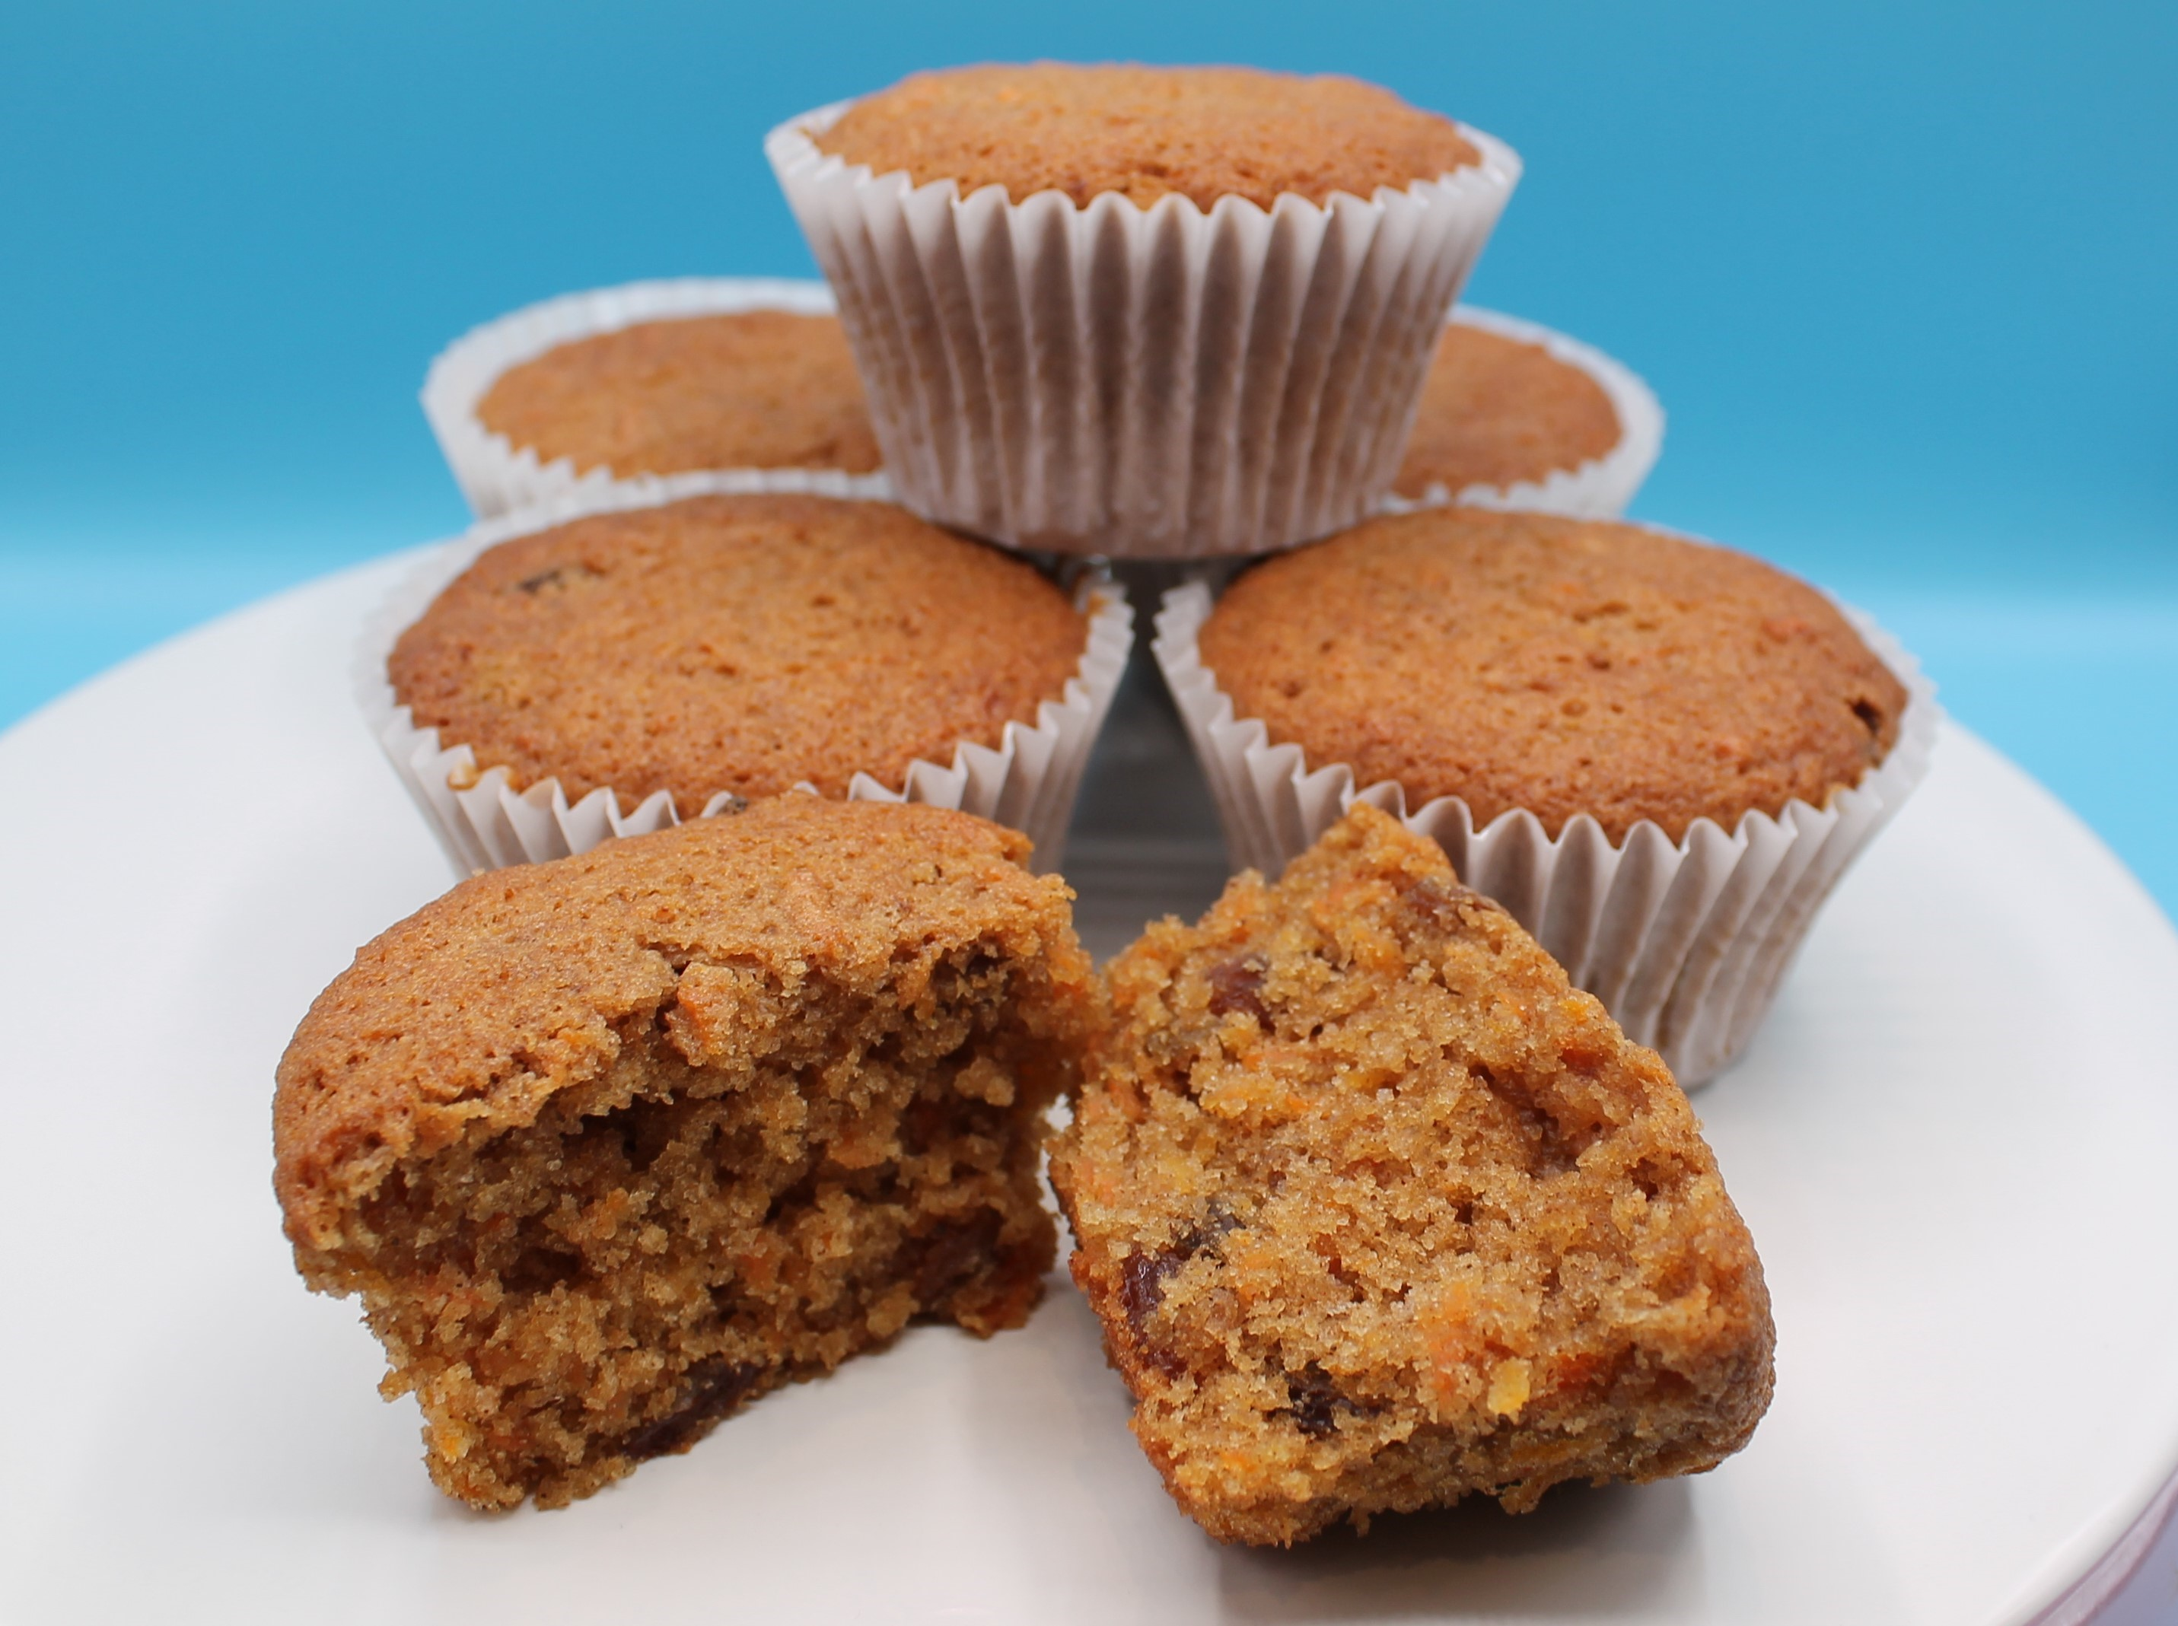
Complexity: medium
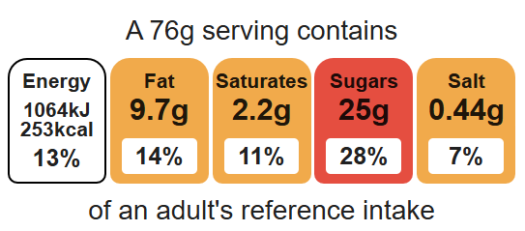

Equipment
Muffin tray
12 muffin cases
Weighing scales
Chopping board
Vegetable peeler
Sharp knife
Grater
Measuring spoons
Small bowl
Mixing bowl
Mixing spoon
Sieve
2 metal spoons
Fork
Cooling rack

Ingredients (makes 12)
150g reduced-fat spread
250g carrots
200g caster sugar
100g plain white flour
100g plain wholemeal flour
2 x 5ml spoons cinnamon
2 x 5ml spoon baking powder
2 eggs
125g sultanas
50g nuts (optional)

Method
- Preheat oven to 200°C or gas mark 6.
- Place the muffin cases in the muffin tin.
- Melt the fat in the microwave or in a small saucepan.
- Peel, top and tail, and grate the carrots.
- Combine the grated carrots, sugar and melted fat in the mixing bowl.
- Sift in the flour, cinnamon and baking powder.
- Beat the eggs in a small bowl and then add to the mixture.
- Mix in the sultanas and nuts (optional).
- Mix all the ingredients together to form a smooth batter.
- Divide the mixture equally between the muffin cases using 2 spoons.
- Bake for 20 minutes, until golden.
- Allow to cool on a cooling rack.

Top tips
- Focus on fibre: Replace the white flour with 100g wholemeal flour.
- Reduce food waste: Add leftover canned pineapple or grated apple.
- Serving suggestion: Combine 50g reduced-fat cream cheese and 25g of icing sugar for a cream cheese topping. Place on top of the mini carrot cakes once they have cooled.

Food skills
Weigh, measure, melt, simmer and boil, peel, cut, chop slice, dice and trim, grate, mix, stir and combine, sift, portion/ divide, bake.

