Spicy bean burger

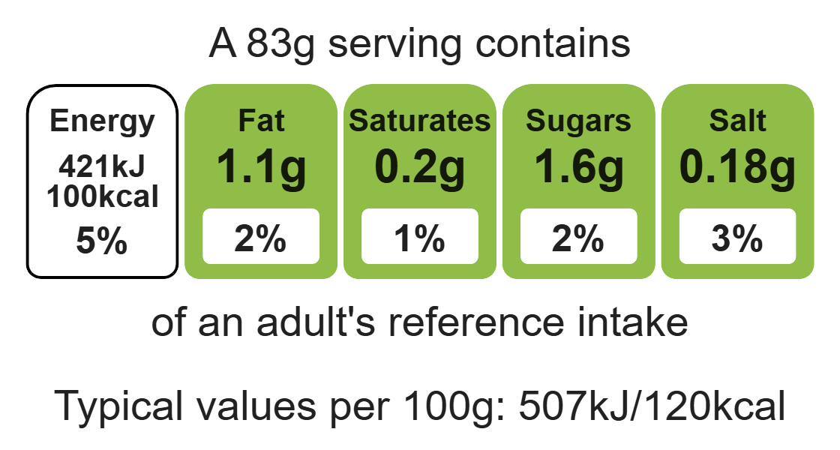

Ingredients (serves 4)
Complexity: medium
1 slice of wholemeal bread
½ onion

Equipment

Food processor

Mixing bowl

Chopping board

Sharp knife

Can opener

Measuring spoons

Spatula

Flour dredger (optional)

Fish slice

1 chilli
1 x 400g can red kidney beans
1 x 5ml spoon ground chilli powder
1 x 5ml spoon dried mixed herbs

Method
- Preheat the grill.
- Put the bread in the food processor and blitz until it resembles breadcrumbs. Pour these crumbs into the mixing bowl.
- Cut the top of the chilli off, and then de-seed.
- Peel the onion.
- Drain the red kidney beans.
- Place the red kidney beans, onion, chilli, chilli powder and dried herbs into the food processor. Blitz together to form a thick paste-like mixture.
- Place the bean mixture into the mixing bowl with the breadcrumbs. Mix everything together thoroughly using the spatula.
- On a lightly floured chopping board, divide and shape the bean mixture into 8 small patties.
- Grill the patties for 8 minutes, turning over after 4 minutes.
- Serve in a pitta with salad.

Top tips
- Vary your protein: Try different types of beans or pulses.
- Turn up the flavour: Use other herbs, spices and or lemon instead of chilli.
- Serving suggestion: Eat with a range of different fillings e.g. tomato salsa or tzatziki.
- Reduce food waste: Add vegetables to the mix e.g. sweetcorn, green pepper or grated carrot.
- The grill gets hot so remember to wear oven gloves.

Food skills
Weigh, measure, cut, chop, slice, dice and trim, peel, drain, blitz, puree and blend, mix, stir and combine, grill.

