Session 10: Mini meals

Welcome
This is the final unit in this module, i.e. sessions 6 – 10. By this stage students should be confident in the cooking area, know the use of many different types of equipment and becoming more creative in their cooking. During this unit, students consolidate their understanding by cooking a main meal component.

You may wish to observe students’ practical work using the practical observation sheet. The result of this observation, along with their previous practical work, goes towards their ‘licence to cook’.

During this unit, students will make either Koftas, spicy bean burgers or a fish & veg stack. These have been chosen as they allow students to demonstrate previous skills and understand of ingredient preparation. It also provides the opportunity for students to use a food processor to prepare ingredients. Students will need to share the food processor in groups, wait their turn or work in small groups. Alternatively, students could prepare the vegetables by hand, practicing their knife skills, or make breadcrumbs using a grater. You will need to decide what is best for your school. The spicy bean burgers recipe is vegan.

There is lots of room for students to be creative, selecting different types of ingredients that could be combined into the dishes. You could get your students to use the Koftas, spicy bean burgers or fish & veg stack recipe writing frames before cooking to develop their own ideas. The students’ own recipe creations could then be used in this session.

If you have an established lesson plan and/or recipe, which supports the aims and objectives of this session, feel free to use it instead. Look at the support materials provided within this unit as they support this activity and may well be useful in your own lessons, e.g. worksheets, PowerPoint presentations.

This session can act as a stand-alone lesson, focusing on the safe use of the food processor. Alternatively, it could be integrated into a series of lessons, e.g. exploring different types of fish and vegetables that could be used to promote oily fish in the diet.

Aims and objectives

Aim
For students to:
- become more confident by extending their competence in more complex dishes.

Objectives
Students should be able to:
- measure ingredients;
- prepare a range of ingredients for fillings, e.g. peeling;
- handle ingredients safely, e.g. meat and fish preparation;
- combine ingredients uniformly to the correct consistency;
- use a food processor to prepare ingredients;
- shape and form ingredients, e.g. Kofta balls, spicy bean burgers;
- use the oven or grill safely;
- make a savoury dish, e.g. Koftas, fish and veg stack or spicy bean burgers.

Cooking session
Two cooking plans, based on Licence to Cook recipes are supplied within this session.

If you have your own tried and tested recipes, feel free to use them instead. In addition, you may wish to make other types of dishes, such as fish cakes, chicken nuggets, lentil bake.

Each plan refers to aspects of healthy eating, wise food shopping and food safety and hygiene that are themes which run through each session.

Before the cooking session
There are a number of factors that you need to consider before the cooking session. More detailed guidance is available in the Cooking session guide.

You will need to consider:
- Ingredients: who will be providing the ingredients and where will they be stored?
- Recipe: are pupils going to use a printed-out copy or follow instructions on an interactive whiteboard?
- Equipment: is all the equipment needed for the session available, clean and in good working order? Check that all the ovens have two shelves available or that grill pans are available, plus oven gloves are at hand. Weighing scales should also be provided for students use. Recipes include the use of food processors – do you have these? Do you have enough? Students may need to share, work together or prepare ingredients by hand, e.g. using a knife and/or grater.
- Aprons: do you have enough and are they clean?
- Hair: do you have ties/bands for long hair?
- Containers: will students be able to take what they make? If so, in what?
- Waste: do you have adequate disposal facilities, including recycling or composting?
- Cooking area: is it clean and ready to use?

Differentiation and inclusion
Before this practical session, you will need to consider the age, ability, previous experience and any special requirements of your students. This will determine recipe selection, any advanced ingredient preparation and equipment used.

Do any of your students need:
- ingredients pre-measured or prepared, e.g. carrot peeled, cans opened?
- pre-prepared breadcrumbs, due to mobility issues?
- support using the food processor?
- to follow different recipes? The spicy bean burgers are easier to prepare than the Koftas and fish & veg stack.
- an extended range of ingredients to challenge their preparation skills, or accompaniments to the main meal dishes?

Demonstration
During the session you will be demonstrating how to use the food processor, as well as shaping and forming the dish. In addition, it will be important to remind students about how to prepare some of the ingredients, e.g. carrot, onion. You may wish to remind students about the safe use of the oven or grill.

Ensure that you have all the ingredients and equipment you need before the session, perhaps on trays for ease, for your demonstration.
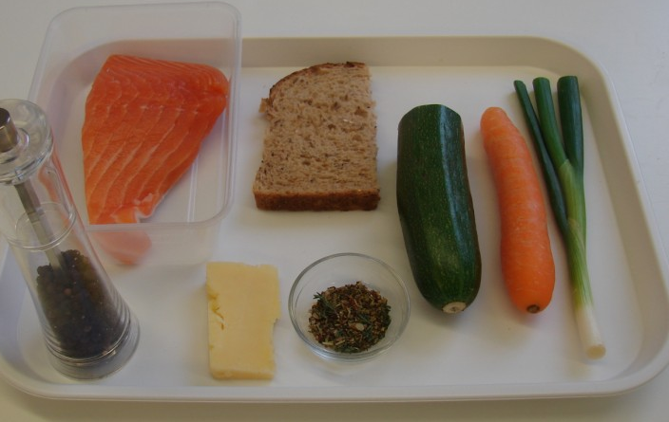
Think about:
- describing the ingredients and equipment used;
- highlighting the safe use of the food processor;
- showing how to shape and form ingredients;
- ensuring that students have followed and understood the method.
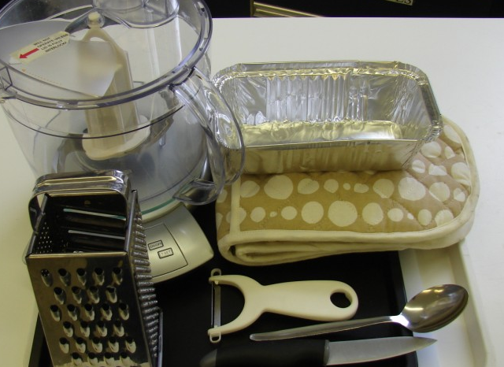

More detailed guidance is available in the Demonstrating guide.

Risk assessment

The two cooking session plans and recipes highlight a number of different hygiene and safety issues which need to be considered before, during and after the cooking session.

Before the cooking session, you will need to assess these risks in relation to the number of students being taught, as well as their experience, and consider measures that can be put into place to manage the risk. Below are examples of potential risks, along with preventative measures.

Koftas
Potential risk | Measure | Likelihood
 |  | Low
Cuts from using a knife unsafely | Demonstrate safe use of knives and monitor students’ use | Med
Cross contamination of raw meat | Use a clean separate chopping board, ideally a red one  Thoroughly wash and dry hands after touching the raw meat | Low/Med
Meat is not cooked properly | Ensure meat is not pink and that food is piping hot | Med

Spicy bean burgers
Potential risk | Measure | Likelihood
 |  | Low
Accidental cuts from the can lid or edge. | Demonstrate safe use of opening a can or have contents already emptied from can before session. | Low/Med

Fish & veg stack
Potential risk | Measure | Likelihood
 |  | Low
Cross contamination of raw fish | Use a clean separate chopping board  Thoroughly wash and dry hands after touching the raw fish | Low/Med

Time
The session plans are based on a 60 minute session.

If you have less time available, you will need to modify the session plan to better suit your circumstances. For example, within this unit you might:
- demonstrate key aspects from the recipe, rather than every stage;
- have ingredients pre-measured and/or pre-prepared, e.g. carrots, breadcrumbs;
- use canned or frozen vegetables;
- use pre-prepared garlic and/or chilli, e.g. in tubes, jars or frozen;
- allow students to work with a partner.

During the lesson: Koftas
Time (mins) | Activity | Equipment/ Resources
0 | Registration.  Explain to the students that they will be making Koftas. Go through the aims and objectives for the lesson. | PowerPoint Koftas recipe
5 | Gather the students around a demonstration area, with your tray of ingredients and equipment. Ensure that all students have their apron on, hair tied back and hands washed.  Briefly talk through the recipe – note your expectations, for example:  * measuring accurately;  * peeling and deseeding, i.e. onion, chilli and garlic;  * using the food processor safely;  * shaping mixture into 8 even sized balls;  * using the grill safely to cook the Koftas;  * being hygienic and safe when preparing food. | Aprons  Demonstration ingredient and equipment tray
 | Demonstration  * Place out the chopping board, knife, food processor and measuring spoons.  * Remind students about pre-heating the grill. Remind students that when placing and removing items from the grill they may wish to wear oven gloves, as the grill pan handle can become hot.  * Demonstrate the preparation of the onion, chilli and garlic. Highlight the different ways in which the chilli can be prepared – the seeds can be very hot. You may wish to use gloves, or get students to hold the chilli with a fork with removing the seeds.  * Ensure that the blade is in the food processor bowl – highlight that the blade edge is extremely sharp. Place the onion, chilli and garlic in the food processor. Show how the lid fixes over the bowl and locks into place. Next, plug in the food processor and blitz until the onion is in small pieces. Unplug the food processor and remove the lid. | Aprons  Demonstration ingredient and equipment tray
* Use a spatula to scrap the onion from the edges. Add all of the remaining ingredients. Fix on the lid, plug in the food processor and blitz until everything is uniformly mixed together. Unplug the food processor and take off the lid. Using a spatula, scrap the mixture away from the blade – then remove the blade. Again, remind the group that the blade is extremely sharp.
* Sprinkle some flour on a chopping board and place the mixture on top. Divide equally into 8 and thread onto skewers.
* Explain that the Koftas need to be grilled for 10-15 minutes, being turned occasionally. The skewers may become hot – so use an oven glove.
15  30 | Ensure that all students wash their hands. Allow them to start making their Koftas.  During this time, circulate the room to ensure that students are preparing ingredients and using the oven safely. In this time, students should:  * preheat grills;  * measure their ingredients;  * make, form and cook their Koftas.  At this stage most students should have prepared the onion, chilli and garlic. Then, students should:  * add the mince, herbs and spice;  * blitz the mixture together in a food processor;  * form the mixture into 8 even sized balls;  * place the Koftas in the grill, using oven gloves. | Basic equipment  Ingredients
40 | All Koftas should be cooking. During this time students should be washing up, cleaning work surfaces and putting away equipment.
50 | Give a 5 minute time warning.  Remind students that all washing up should be completed, work surfaces should be clean and their Koftas should be ready to go in their containers. Koftas should not have any sign of blood and must be cooked thoroughly throughout.  Circulate the room, ensuring that sinks are clean, and equipment is put away properly.
55 | Plenary  Pose the following questions to the students:  * What were the main skills demonstrated today?  * Name 3 accompanying dishes that could be served with the Koftas?
60 | Finish

Note: You may wish to cook the Koftas in a pre-heated oven (200ºC or gas mark 6). If so, students will require baking trays/dishes.

After the session
Check that the room is clean and tidy. Students should leave the room as they find it.

The koftas may need to be refrigerated until the end of the school day, if so, ensure that each container is covered and clearly labelled with the student’s name and group. The refrigerator should be between 0-5ºC. Only place in the refrigerator when cool.

Students may wish to reheat the koftas at home. To microwave, place the koftas in a suitable container and cover loosely. Cook for full power for 2-3 minutes. Alternatively, place in a preheated oven (200ºC or gas mark 6) for 15-20 minutes. Ensure that the dish is piping hot before eating.

If the same students are with you for another cooking session in the next few days or week, remind them of the ingredients and/or containers they need to bring, if appropriate. You may wish to provide students with recipes or writing frames.

During the lesson
Time (mins) | Activity: Fish & veg stack | Equipment/ Resources
0 | Registration.  Explain to the students that they will be making Fish & veg stack. Go through the aims and objectives for the lesson. | PowerPoint Fish and veg stack recipe
5 | Gather the students around a demonstration area, with your tray of ingredients and equipment. Ensure that all students have their apron on, hair tied back and hands washed.  Briefly talk through the recipe – note your expectations, for example:  * measuring accurately;  * preparing vegetables as ribbons;  * handling fish safely;  * using a food processor to make a breadcrumb topping;  * assembling ‘stack’;  * using the oven safely to cook the ‘stack’;  * being hygienic and safe when preparing food. | Aprons  Demonstration ingredient and equipment tray
 | Demonstration  * Place out the chopping board, knife, vegetable peeler and oven proof dish/foil tray on a baking tray.  * Remind students about pre-heating the oven. Remind students that when placing and removing items from the oven they must always wear oven gloves.  * Demonstrate how to prepare the ribbon vegetables. Top and tail the carrot and courgette. Peel the carrot – stress that the peeling action should be away from them. Next, take the vegetable peeler and run it length ways down the carrot and courgette to make thin ribbons of vegetable. When you get about half way down, turn the vegetable over and start again.  * Next, arrange these ribbons in the ovenproof dish. Carefully lay the piece of fish on top. | Aprons  Demonstration ingredient and equipment tray
* Ensure that the blade is in the food processor bowl – highlight that the blade edge is extremely sharp. Place the bread and spring onion in the food processor. Show how the lid fixes over the bowl and locks into place. Next, plug in the food processor and blitz until the bread and onion are in small pieces. Unplug the food processor and remove the lid.
* Use a spatula to scrape the bread and onion from the edges, and then remove the blade. Again, remind the group that the blade is extremely sharp. Add all the remaining ingredients and mix together.
* Spoon the bread mixture of the fish.
* Remind students to use oven gloves to place the ‘stack’ into the pre-heated oven
15  25 | Ensure that students all wash their hands. Allow them to start making their Fish & veg stack.  During this time, circulate the room to ensure that students are preparing ingredients and using the oven safely. In this time, students should:  * preheat ovens;  * measure their ingredients;  * prepare the vegetables, fish and topping.  At this stage most students should prepare the ribbon vegetables and placed the fish on top. Then, students should:  * prepare the topping in the food processor;  * spoon the topping over the fish;  * place the ‘stack’ in the oven, using oven gloves. | Recipe  Equipment  Ingredients  Baking trays
40 | All ‘stacks’ should be in the oven, as they need 20 minutes cooking. During this time students should be washing up, cleaning work surfaces and putting away equipment.
50 | Give a 5 minute time warning.  Remind students that all washing-up should be completed, work surfaces should be clean and their ‘stacks’ should be cooling down, ready to go into a container. The fish should be cooked throughout and be piping hot (the flesh should be a bright pink colour).  Circulate the room, ensuring that sinks are clean, and equipment is put away properly.
55 | Plenary  Pose the following questions to the students:  * What were the main skills demonstrated today?  * Name 3 other types of fish that could be used.  * What other vegetables could be used?
60 | Finish

After the session
Check that the room is clean and tidy. Students should leave the room as they find it.

The fish and vegetable stack may need to be refrigerated until the end of the school day, if so, ensure that each container is covered and clearly labelled with the student’s name and group. The refrigerator should be between 0-5ºC. Only place in the refrigerator when cool.

Students may wish to reheat the fish and vegetable stack at home. To microwave, place in a suitable container and cover loosely. Cook for full power for 2-3 minutes. Alternatively, place in a preheated oven (200ºC or gas mark 6) for 15-20 minutes. Ensure that the dish is piping hot before eating.

If the same students are with you for another cooking session in the next few days or week, remind them of the ingredients and/or containers they need to bring, if appropriate. You may wish to provide students with recipes or writing frames.

Areas of learning
These three areas of learning link to the face-to-face lessons and online tutorials for students. Where appropriate, these key messages could be integrated into the activity.

Healthy eating
- Serve the Koftas or spicy bean burgers with a large salad, as well as a glass of fruit juice.
- We should all eat more fish – at least 2 portions a week, one of which should be oily.

Wise food shopping
- Canned red kidney beans are available in economy ranges. They are very versatile in cooking.
- Different types of frozen fish can be purchased. Allowing you to use what you need, when you need it.

Food safety and hygiene
- When getting ready to cook, always wear an apron, tie back long hair, roll up long sleeves, remove any jewellery and wash your hands.
- Ensure that the meat and fish is thoroughly cooked (it is piping hot and there is no trace of blood).

Extending this activity
This unit provides a great opportunity to be integrated into existing lessons or be developed into a mini-scheme of work.

For example, you could:
- Explore different types of accompanying dishes that could be made;
- plan and create dishes which can be cooked for a school barbecue or other celebration event;
- evaluate different ways of shaping and forming the koftas and spicy bean burgers.

Appropriate aspects of ICT could also be integrated, including:
- recording sensory data;
- creating a recipe plan or flow-chart;
- modelling recipe costs, looking at the consequences of changing ingredients;
- exploring the internet for additional recipes.

Shopping list

Koftas
Ingredient | x 1 | x 10 | x 20
Onion (small) | 1 | 10 | 20
Fresh red chilli | 1/2 | 5 | 10
Lamb mince | 200g | 1kg | 2kg
Garlic (cloves) | 1 | 10 | 20
Fresh parsley, mint and coriander | A few sprigs of each | Packet of each | 2 packets of each
Cumin | 1 x 5ml spoon | 10 x 5ml spoon | 20 x 5ml spoon

Spicy bean burgers
Ingredient | x 1 | x 10 | x 20
Bread (slice) | 1 | 10 | 20
Canned red kidney beans (400g) | 1 | 10 | 20
Onion | 1/2 | 5 | 10
Green chilli (medium) | 1 | 10 | 20
Ground chilli powder | 1 x 5ml spoon | 10 x 5ml spoon | 20 x 5ml spoon
Dried herbs | 1 x 5ml spoon | 10 x 5ml spoon | 20 x 5ml spoon

Fish & veg stack
Ingredient | x 1 | x 10 | x 20
Carrot | 1 | 10 | 20
Courgette | 1/2 | 5 | 10
Piece of fish, e.g salmon (approx 200g) | 1 | 10 | 20
Granary bread (slice) | 1/2 | 5 | 10
Spring onion | 1 | 10 | 20
Cheddar cheese | 25g | 250g | 500g
Dried mixed herbs | 1 x 5ml spoon | 10 x 5ml spoon | 20 x 5ml spoon
Black pepper | a few twists | a few twists | a few twists

Equipment list

Koftas

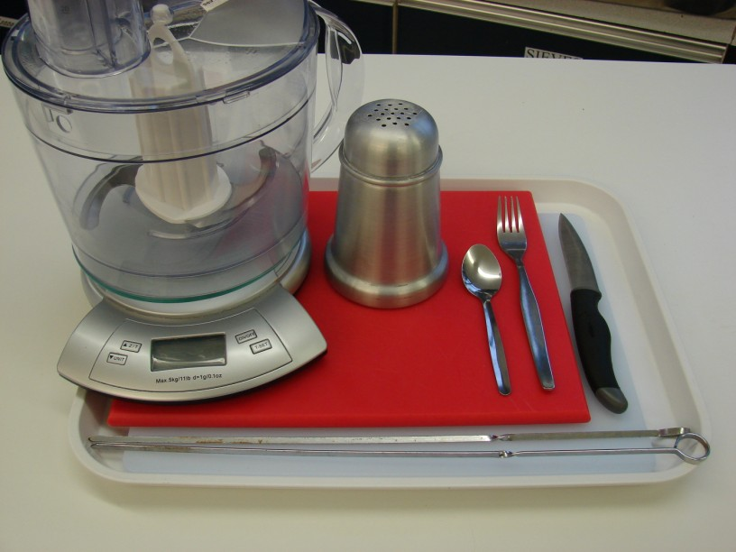
Chopping boards, knife, fork, food processor, flour dredger, skewers

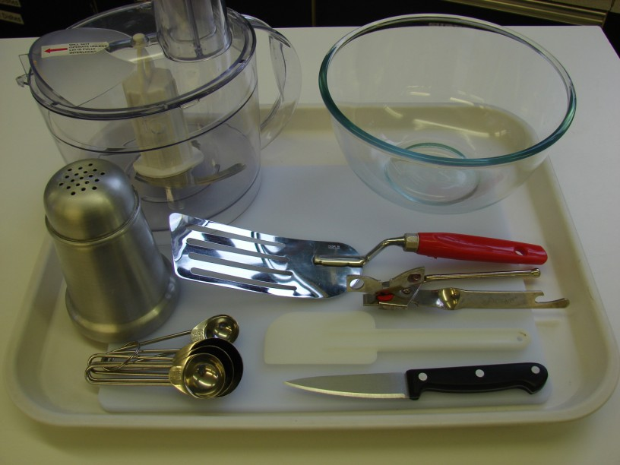
Spicy bean burgers

Chopping board, knife, can opener, food processor, bowl, measuring spoons, spatula, flour dredger, fish slice

Fish & veg stack
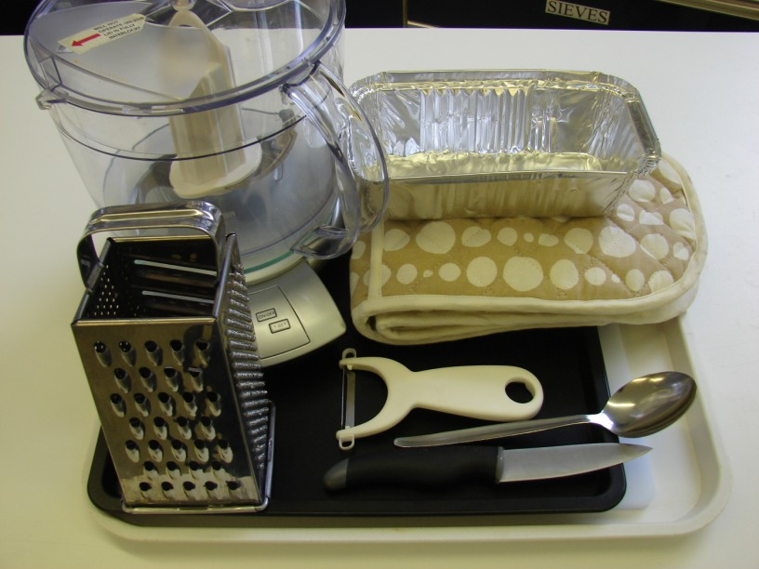
Chopping board, knife, vegetable peeler, oven proof/foil dish, food processor, grater, metal spoon, oven gloves

Containers

If students take their koftas, burgers or fish and vegetables stacks home, they will need to bring (or be provided with by the school) a suitable container, such as a plastic or foil container with a lid.

