Homemade burgers
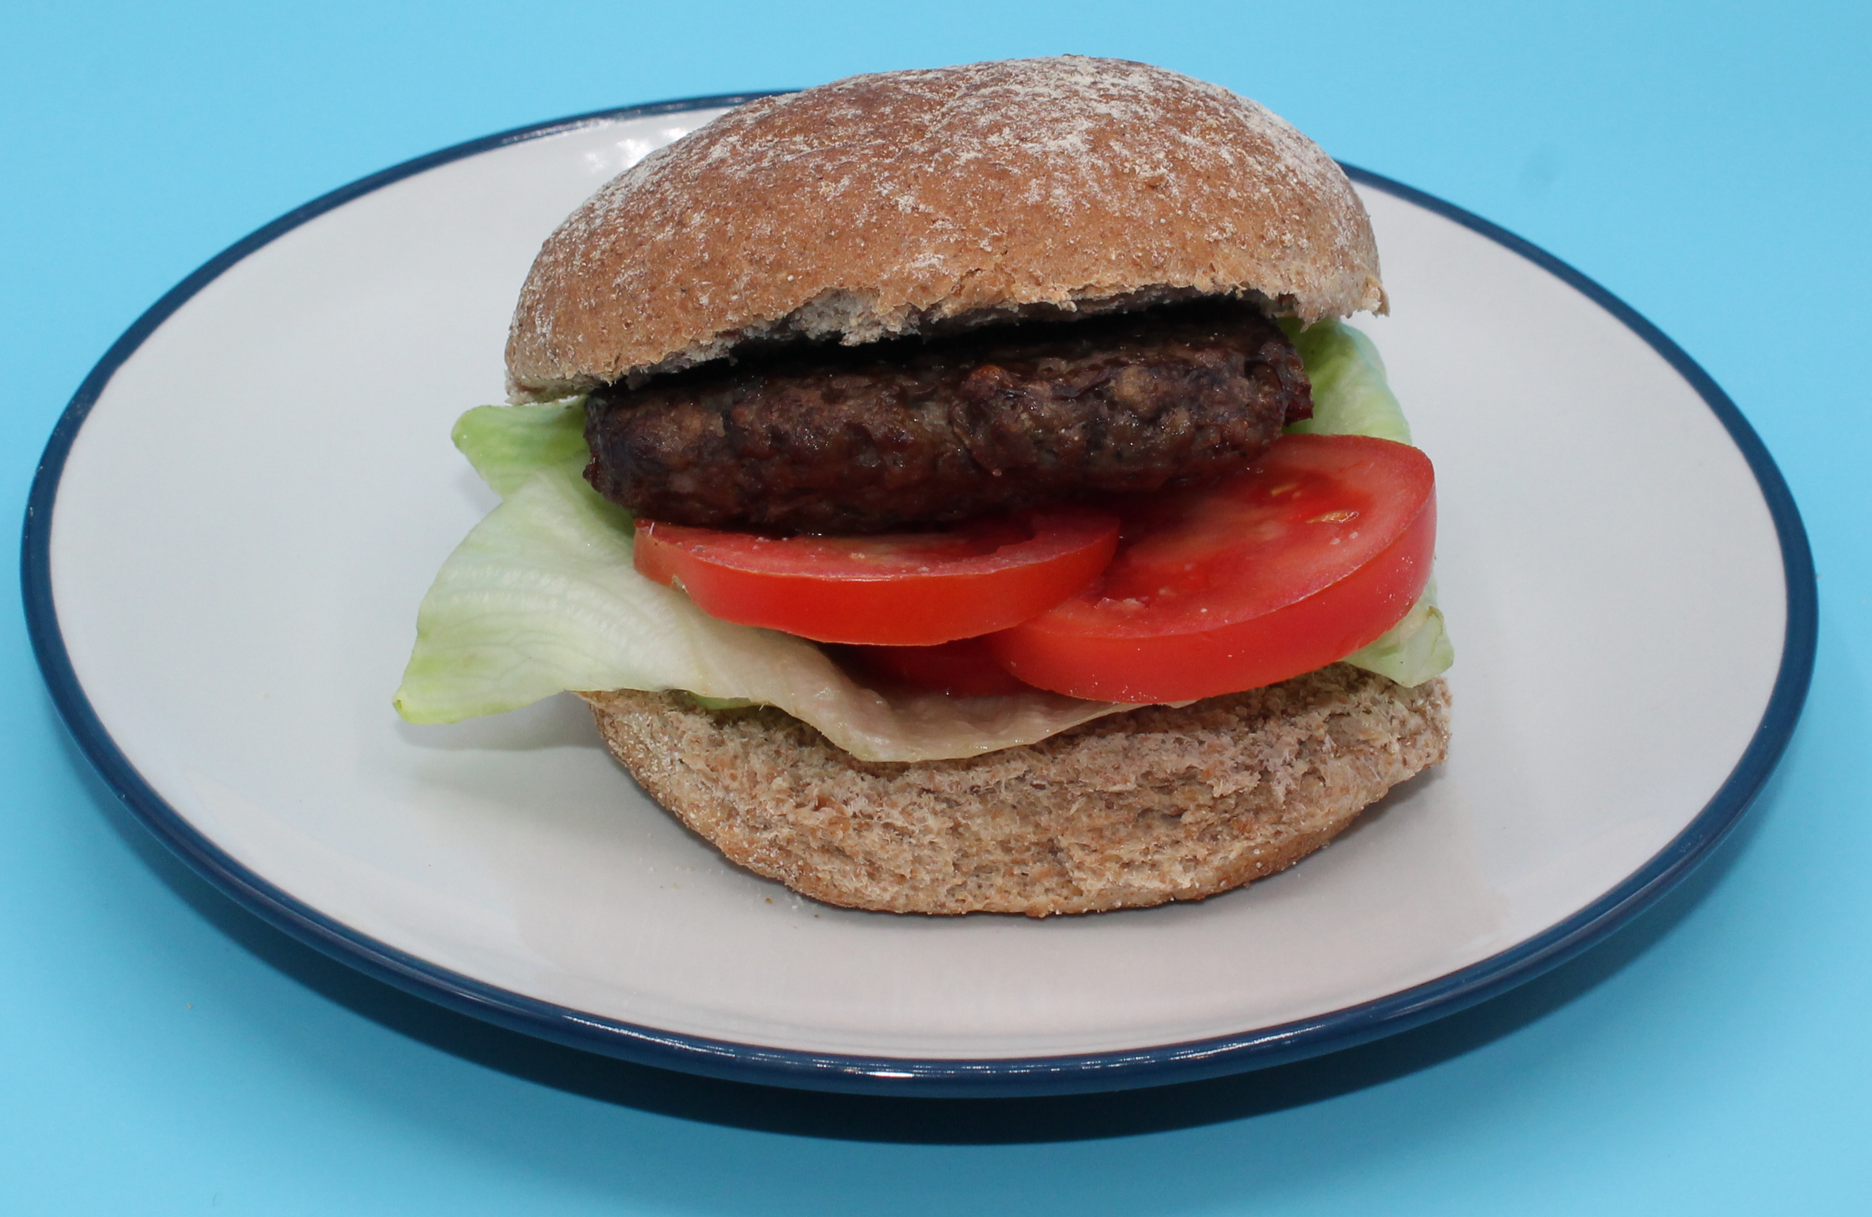

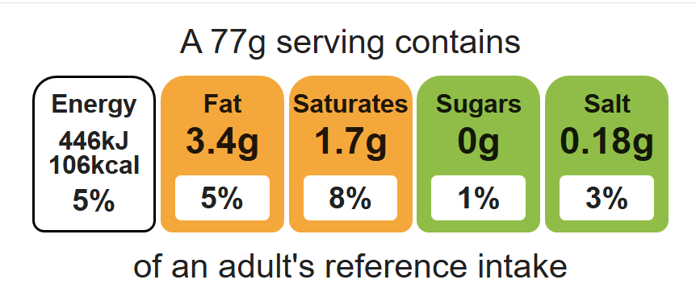
Complexity: low - medium

Ingredients (makes 5)

400g lean beef mince

1 red onion

Equipment

Weighing scales

Mixing bowl

2 Chopping boards

Sharp knife

Fish slice

Black pepper
Flour, for dusting

Method
- Peel and finely dice the onion.
- Mix the minced beef with the diced onions and black pepper.
- Divide mixture into 5 balls. Dust hands in flour and flatten each ball into a burger shape. Thoroughly wash and dry hands after touching the raw meat.
- Cook on the barbeque or under the grill until cooked throughout, about 5 minutes each side. Ensure no pink meat remains.

Top tips
- Turn up the flavour: Try combining 1 chopped chilli, grated 3cm piece fresh ginger, 1 x 10ml spoon Worchester sauce and 1 x 10ml spoon curry powder for a blazing burger.
- Vary your protein: Why not try lamb, pork or turkey mince?
- For a vegetarian alternative:
- Serving suggestion- serve with a wholemeal bun and salad
- Transform your leftovers: Serve chopped leftover burgers with a tomato sauce on wholemeal pasta.

Food skills
Weigh, portion/ divide, form and shape, grill.

