Pork yuk sung

Ingredients
Complexity: medium
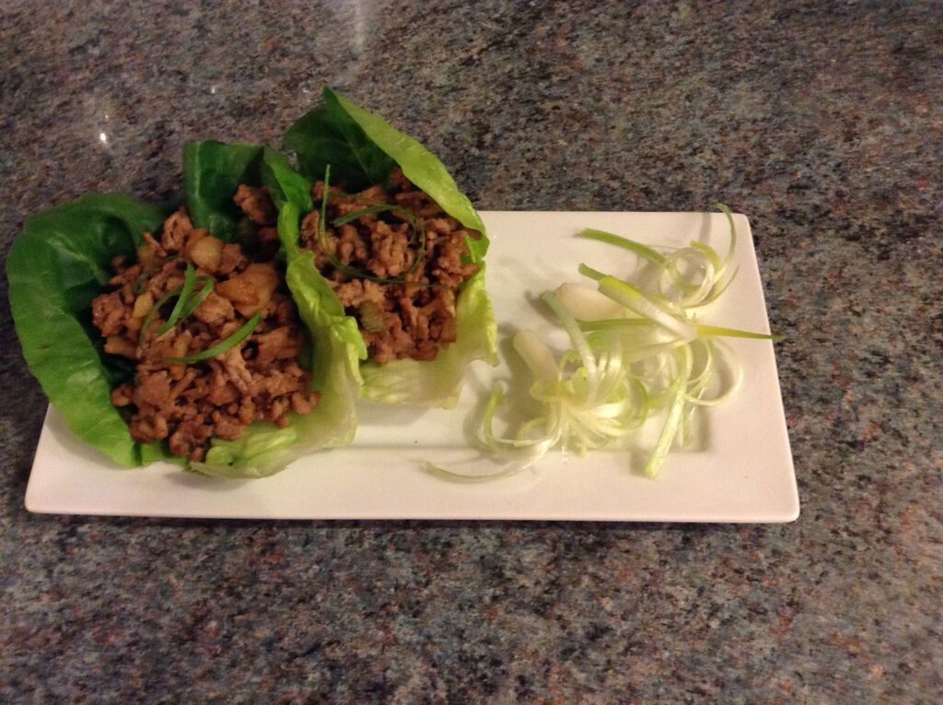
4 little gem lettuce leaves
1 ½ cm fresh ginger
1 garlic clove
2 spring onions
1 celery stick
½ x 220g can water chestnuts (optional)
Spray oil
250g pork mince
1 x 15ml spoon reduced salt light soy sauce
1 x 15ml spoon oyster sauce

Equipment
Vegetable peeler, vegetable knife, grater, chopping board, large non-stick frying pan, measuring spoons, wooden spoon.

Method
- Prepare the vegetables:
  - wash the lettuce and dry being careful not to tear the leaves;
  - peel and very finely slice or grate the ginger;
  - peel and very finely chop the garlic;
  - slice the spring onions into fine rings;
  - finely dice the celery;
  - drain and chop water chestnuts, if using, into small pieces.
- Spray a non-stick frying pan with spray oil. Add the garlic, ginger and spring onions.
- Fry gently for 2-3 minutes, until the onions are soft but not browned.
- Add the pork mince and cook until browned. Thoroughly wash and dry hands if touched raw meat.
- Add the water chestnuts (if using) and celery to the pan and continue to cook over a medium heat for 5 minutes.
- Add the soy sauce and oyster sauce to the pan and stir. Cook until the sauce is reduced and the mixture becomes dry.
- If eating straight away, lay out a lettuce leaf and spoon the cooked mixture into the middle.

Top tips
- Chicken mince or a plant-based mince could be used instead of pork. Use another 1 x 15ml soy sauce instead of oyster sauce if making a vegetarian version.
- Try adding chopped shitake mushrooms. If using dried mushrooms, these should be soaked for 30 minutes to rehydrate.
- Traditionally, pork yuk sung is served in lettuce leaf cups or rolled in lettuce leaves to make parcels. However, the recipe could be served with boiled rice or noodles instead.
- Serve garnished with fine slices of spring onion and spring onion curls.

Food skills
- Weigh
- Measure
- Peel
- Grate
- Chop
- Slice
- Dice
- Drain
- Fry

Did you know?
Pork yuk sung is a Chinese dish which is usually served as an appetiser or a side dish. Pork mince is traditionally used but chicken mince or a plant-based mince could be used instead.

Water chestnuts are not chestnuts or nuts but are the corms of an aquatic vegetable that is found throughout Africa, Asia, Australia and the Pacific Islands. They are a popular ingredient in Chinese dishes and are eaten raw, slightly boiled, or grilled, and are often pickled or tinned. They also may be ground into flour which is used for making water chestnut cake, part of dim sum cuisine.

Spring onions are also known as scallions or green onions and are young onions harvested before the bulb has begun to swell. They can be eaten raw or cooked and are milder in flavour than onions.

