Safe storage
Cut out the Food cards. Place the foods where they should be stored.
Freezer
Cupboard
Fridge

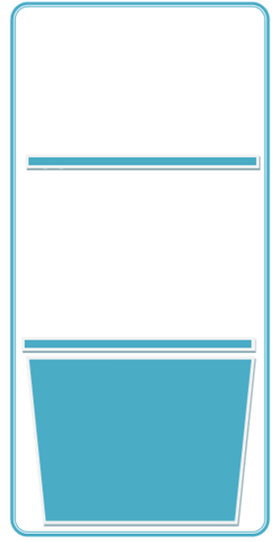
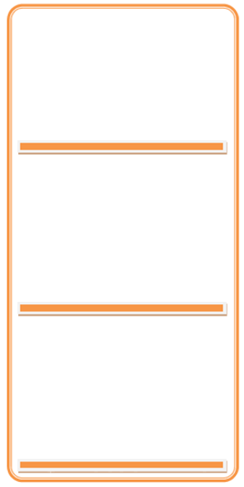

This resource meets the Guidelines for producers and users of school education resources about food.

