My favourite meal

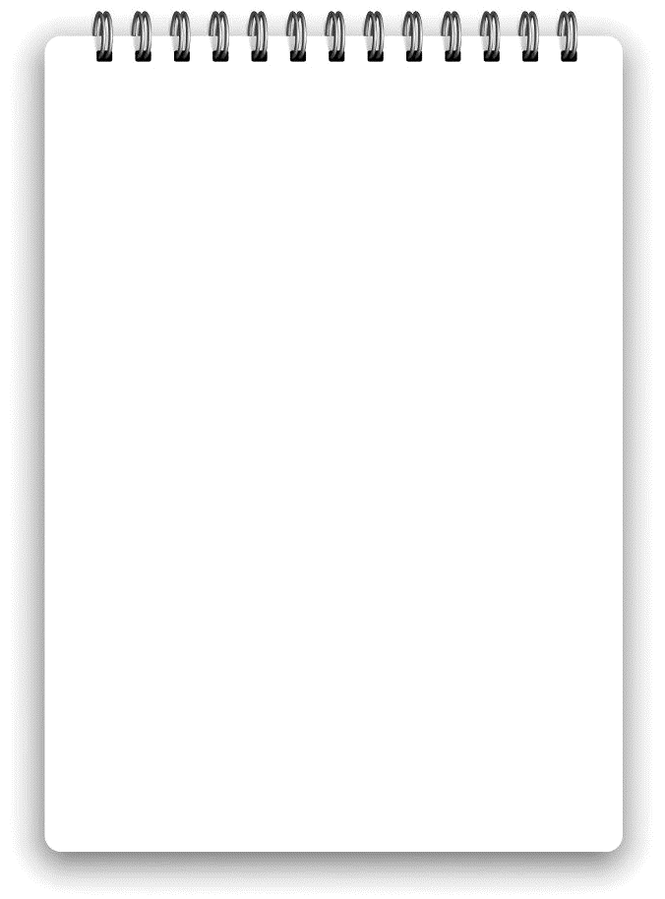
Draw a picture of your favourite meal. List the ingredients you need.
Ingredients list:

______________________________________________________________________________________________________________________________________________________

