Food labelling information sheet
Manufacturers include a range of information on food labels, some of which is legally required and some of which is useful to the consumer or supermarket.
Information that is legally required
The following eight pieces of information must appear by law on food labels:
- name of food or drink;
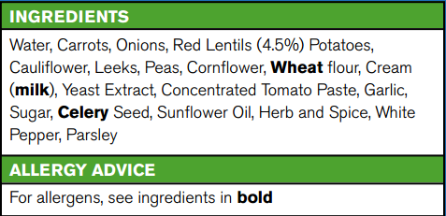
- list of ingredients in descending order (including additives and allergens);
- weight or volume;
- date mark;
- storage and preparation conditions;
- name and address of the manufacturer, packer or seller;
- country of origin and place of provenance;
- nutrition information*.
*Back of pack nutrition information is legally required. Front of pack nutrition information is voluntary, but if a food business chooses to provide this additional declaration, only the following information may be provided:
- energy only;
- energy along with fat, saturates, sugar and salt.
Information that may be included but is not legally required
Manufacturers might also include other information that would be useful to the consumer or supermarket. This might include:
- price;
- customer guarantee;
- serving suggestion;
- photograph or image of the food;
- bar code.

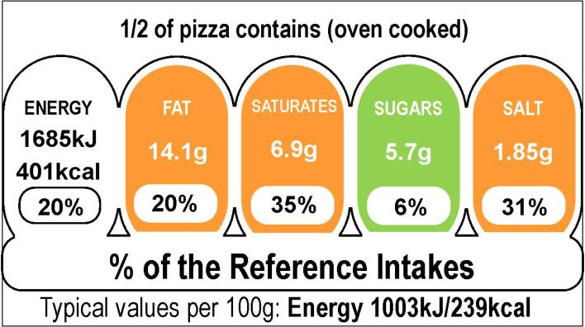
Allergens that must be identified
- Celery (and celeriac).
- Cereals containing gluten.
- Eggs.
- Fish.
- Lupin.
- Milk.
- Molluscs.
- Mustard.
- Nuts.
- Peanuts.
- Sesame seeds.
- Sulphur dioxide.

