Mushroom risotto
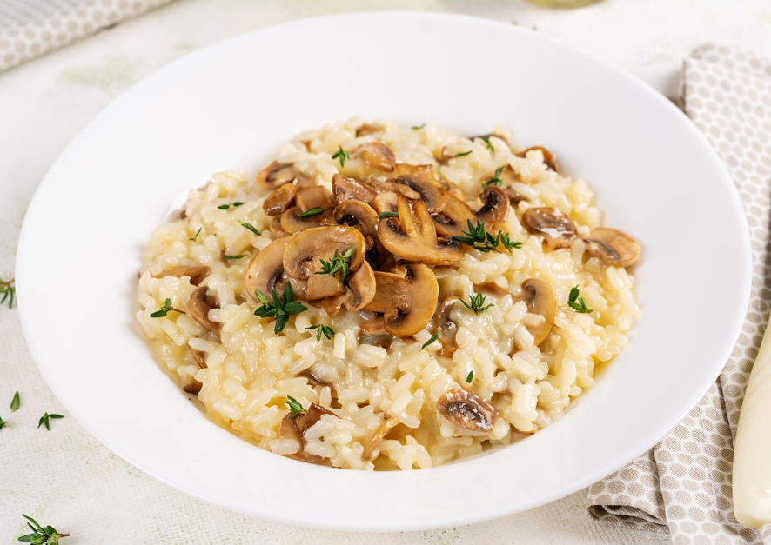

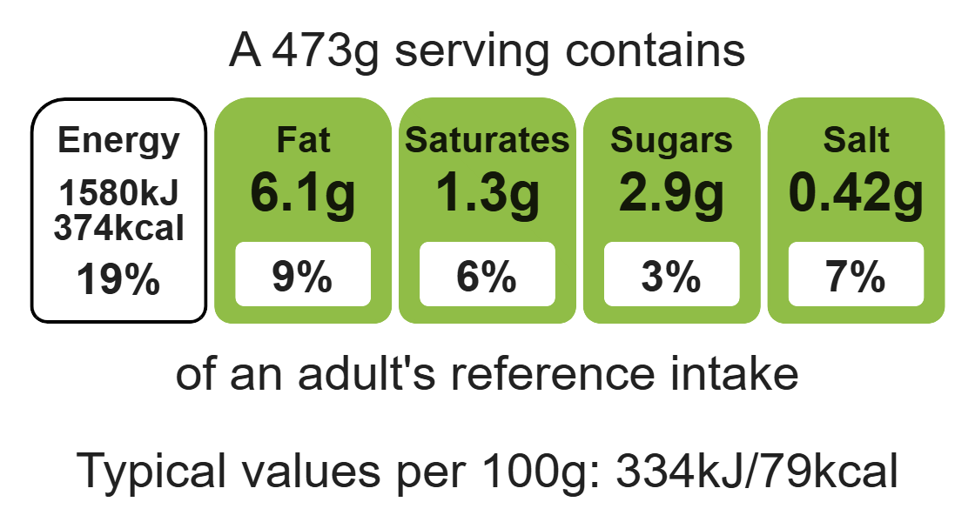

Ingredients (serves 3)

150g mushrooms

1 onion
Complexity: medium

2 cloves garlic

1 x 15ml spoon vegetable oil

Equipment

Chopping board

Sharp knife

Garlic press

Weighing scales

Measuring spoons

Frying pan

Heat- resistant spoon

Kettle

Measuring jug

250g risotto rice

1 reduced-salt vegetable stock cube

1-1.5 litres water, boiling

1 x 15ml spoon parmesan

1 x 10ml spoon thyme

Method
- Prepare the ingredients on a clean chopping board:
- peel and chop the onion;
- slice the mushrooms;
- peel and crush the garlic;
- grate the cheese;
- chop the thyme (if using fresh).
- Add oil to the pan and fry the onion and garlic until softened.
- Add the mushrooms and fry for another 2 minutes.
- Stir in the risotto rice.
- Mix the stock powder with the hot water.
- Add a little of the stock to the rice - gradually. Wait for the stock to be absorbed, stirring constantly.
- Continue adding the stock until the rice cooks – this will take 20-25 minutes. The rice should be soft but still retain a slight bite.
- Stir in the parmesan and thyme into the rice and serve.

Top tips
- Reduce food waste: Use up any leftover vegetables such as spinach or courgette.
- Vary your protein: Add chicken, prawns or beans to increase the protein content of the dish.
- Turn up the flavour: Add different herbs and spices e.g. basil, parsley or chilli.

Food skills
Weigh, measure, peel, cut, chop, slice, dice and trim, grate, fry and sauté, mix, stir and combine, melt, simmer and boil.

