Session 7: Feel the rub

Welcome
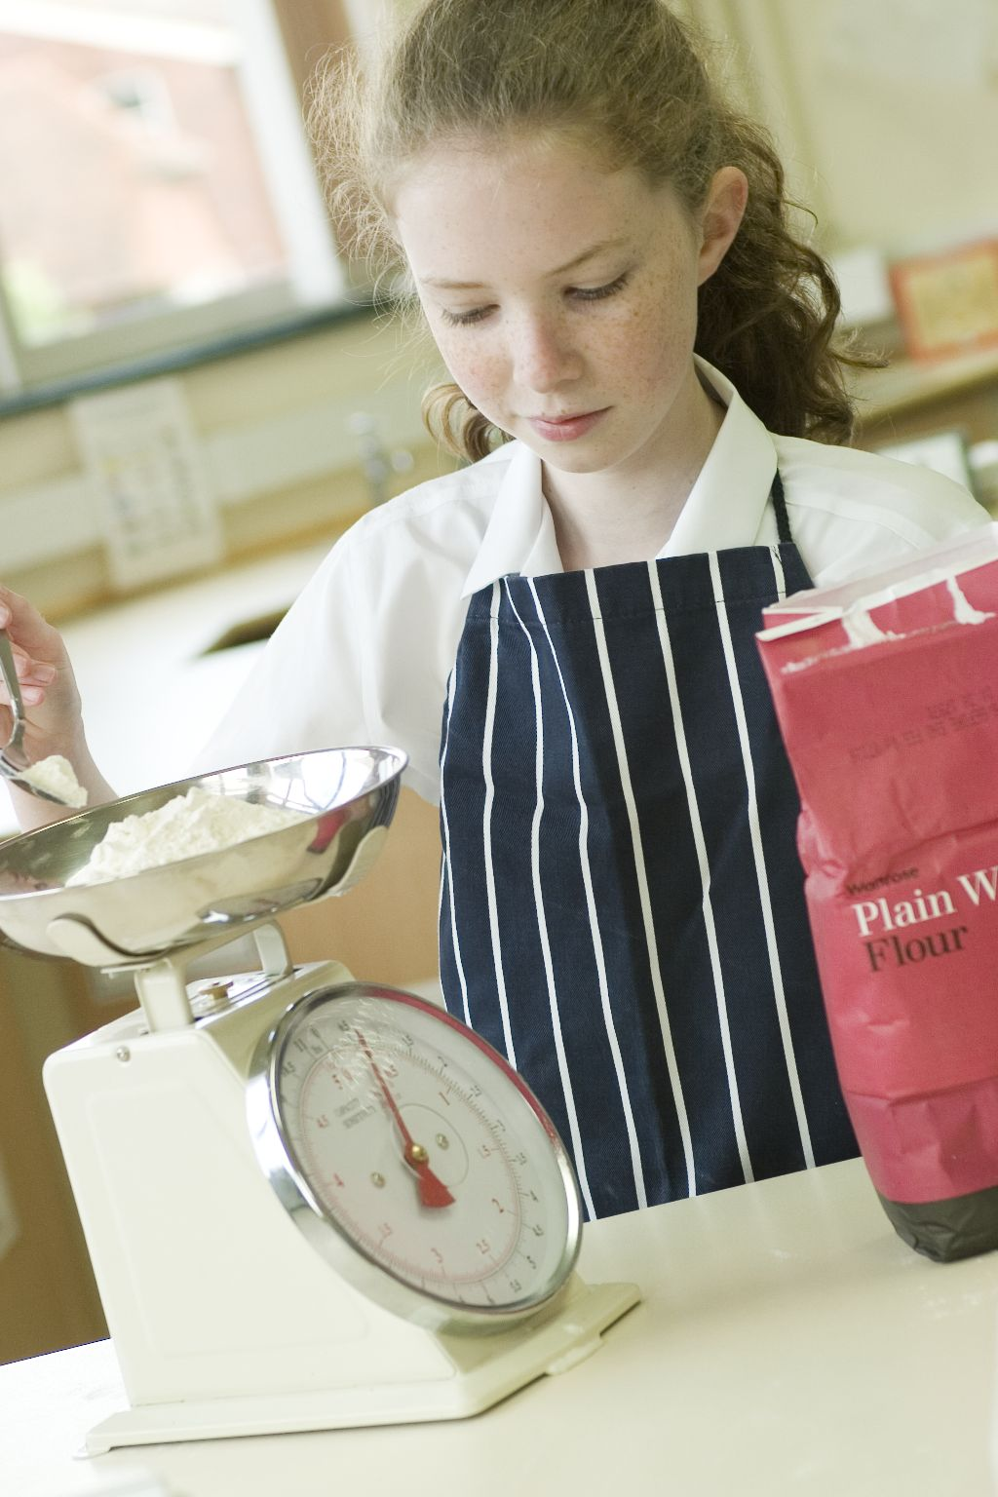
This session revisits the rubbing in technique, to consolidate learning, and extends to forming and shaping the rubbed-in dough. This additional dimension is a progression from Session 6, as students will need to carefully control the amount of liquid added to the mixture, to prevent it from becoming too dry or sticky, and shape the dough in a uniform manner. As with other sessions, it provides you with the opportunity to assess students’ practical capability. You could use the practical observation sheet to help.

During this session, students will make either cheesy scones, rocking rock cakes or scone based pizza. These have been chosen as they consolidate the rubbing in technique (from Session 6), plus help students form, shape or cut out dough. If you would like to extend this session, look at Session 7 Extension.

There is lots of room for students to be creative, selecting different ingredients that could be combined into the dishes. You could get your students to use the cheesy scones or rocking rock cakes recipe writing frames before cooking to develop their own ideas. The students’ own recipe creations could then be used in this session.

If you have an established lesson plan and/or recipe, which supports the aims and objectives of this session, feel free to use it instead. Look at the support materials provided within this session as they support this activity and may well be useful in your own lessons, e.g. worksheets, PowerPoint presentations.

This session can act as a stand-alone lesson, focusing on the rubbing in method and the safe use of the oven. Alternatively, it could be integrated into a series of lessons, e.g. exploring the use of a basic scone recipe to make a range of dishes.

Aims and objectives

Aim
For students to:
- build confidence in using the rubbing in technique and forming a dough.

Objectives
Students should be able to:
- weigh and measure ingredients accurately;
- prepare ingredients, e.g. slicing;
- demonstrate the rubbing in technique;
- carefully form and shape a dough;
- use the oven safely;
- make a baked dish, e.g. cheesy scones or rocking rock cakes.

Cooking session
Two cooking session plans, based on the Licence to Cook recipes are supplied within this session.

If you have your own tried and tested scones, scone based pizza or rock cakes recipe, feel free to use it instead. You may wish to make other types of dishes, such as plain scones or Victoria scones.

Each plan refers to aspects of healthy eating, wise food shopping and food safety and hygiene which are themes which run through each session.

Before the cooking session
There are a number of factors that you need to consider before the cooking session. More detailed guidance is available in the Cooking session guide.

You will need to consider:
- Ingredients: who will be providing the ingredients and where will they be stored?
- Recipe: are pupils going to use a printed-out copy or follow instructions on an interactive whiteboard?
- Equipment: is all the equipment needed for the session available, clean and in good working order? Check that all the ovens have two shelves available, plus oven gloves nearby. Weighing scales and cooling racks should also be provided for students use. Non-stick baking trays should be available (line with grease proof paper, or another alternative such as Teflon sheets, to reduce washing-up).
- Aprons: do you have enough and are they clean?
- Hair: do you have ties/bands for long hair?
- Containers: will students be able to take away the scones/rock cakes they make? If so, in what?
- Waste: do you have adequate disposal facilities, including recycling or composting?
- Cooking area: is it clean and ready to use?

Differentiation and inclusion
Before this practical session, you will need to consider the age, ability, previous experience and any special requirements of your students. This will determine recipe selection, any advanced ingredient preparation and equipment used.

Do any of your students need:
- ingredients pre-measured, to allow them time to complete the recipe?
- to make plain scones, in order to make the recipe easier?
- assistance rolling out or shaping the dough? Some students may find cutting a circle of dough into 8 wedges easier than using a pastry cutter.
- to follow different recipes? The rocking rock cakes recipe is easier then cheesy scones.
- challenging, by allowing them to modify the recipes with their own ingredients?

Demonstration
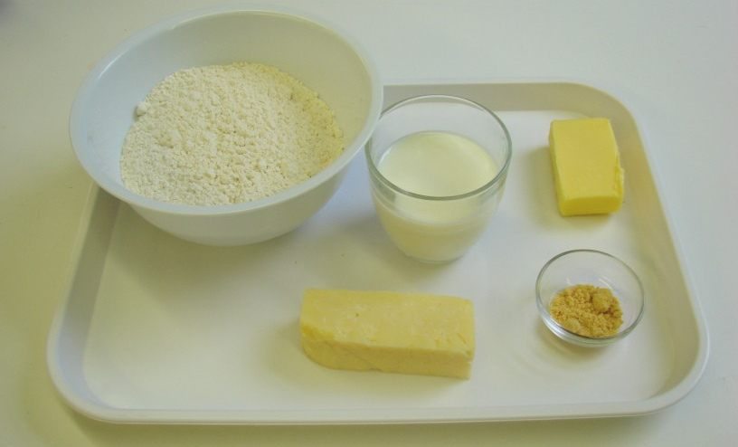
During the session you will be demonstrating the rubbing in technique once more, although this time it will be formed into a dough and shaped. It would also be useful to remind students about the safe use of the oven which they should have covered in Sessions 1 to 5.

Ensure that you have all the ingredients and equipment you need before the session, perhaps on trays for ease, for your demonstration.

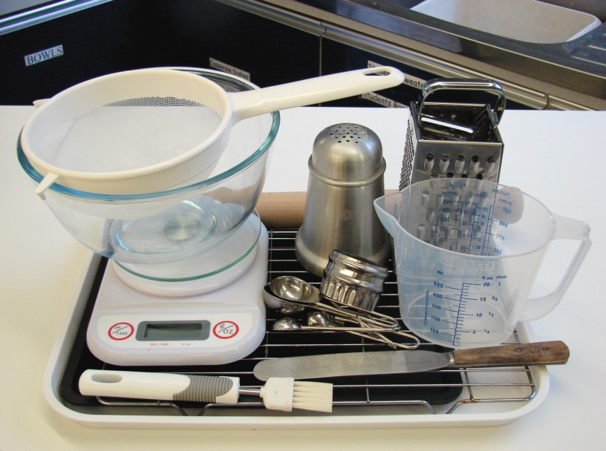
Think about:
- describing the ingredients and equipment used;
- highlighting the technique of rubbing-in, forming and shaping a dough;
- showing how to turn on and set the oven temperature;
- ensuring that students have followed and understood the method.

More detailed guidance is available in the Demonstrating guide.

Risk assessment

The two cooking session plans and recipes highlight a number of different hygiene and safety issues which need to be considered before, during and after the cooking session.

Before the cooking session, you will need to assess these risks in relation to the number of students being taught, as well as their experience, and consider measures that can be put into place to manage the risk. Below are examples of potential risks, along with preventative measures.

Cheesy scones
Potential risk | Measure | Likelihood
Out of date date-marks | Always read the date-mark | Low
Dirty hands used for rubbing-in | Wash hands thoroughly and regularly during cooking | Med
Burn from placing and removing scones in oven | Demonstrate safe use of the oven, promote the use of oven gloves and monitor students’ use | Low/Med

Rocking rock cakes
Potential risk | Measure | Likelihood
Dirty hands used for rubbing-in | Wash hands thoroughly and regularly during cooking | Med
Contamination from egg shell in mixture | Crack egg into a separate bowl to check for shell, then add to main bowl | Low/Med
Burn from placing and removing rock cakes in oven | Demonstrate safe use of the oven, promote the use of oven gloves and monitor students’ use | Low/Med

Time
The session plans are based on a 60 minute session.

If you have less time available, you will need to modify the session plan to better suit your circumstances. For example, within this session you might:
- demonstrate key aspects from the recipe, rather than every stage;
- have ingredients pre-measured and/or pre-prepared, e.g. grated cheese;
- make plain scones, removing the grating of cheese step;
- use ready lined baking trays, to save washing up and therefore time;
- allow students to work with a partner.
During the lesson
Time (mins) | Activity: cheesy scones | Equipment/ Resources
0 | Registration.  Explain to the students that they will be making cheesy scones. Go through the aims and objectives for the lesson. | PowerPoint Cheesy scones recipe
5 | Gather the students around a demonstration area, with your tray of ingredients and equipment. Ensure that all students have their apron on, hair tied back and hands washed.  Briefly talk through the recipe – note your expectations, for example:  * preheating and using the oven safely;  * measuring accurately;  * using the rubbing in technique;  * forming a soft dough – avoiding making it too dry/wet;  * using a rolling pin;  * cutting out the dough to make scones;  * being hygienic and safe when preparing food. | Aprons  Demonstration ingredient and equipment tray
Demonstration
* Place out the mixing bowl, sieve, palette knife, rolling pin and flour dredger.
* Remind students about pre-heating the oven. Remind students that when placing and removing items from the oven they must always wear oven gloves.
* Demonstrate the rubbing-in method. Explain that this technique is the basis of many other recipes, e.g. pastry. Sieve the flour (and mustard) into the bowl, and add the cold fat (cut into small pieces). The fat is cold so that it does not easily melt into your fingers and helps to form breadcrumbs. Start to push the fat into the flour using your fingertips – thumb pressing down onto the fingers. Repeat this, moving your hands above the bowl. Shake the bowl, on the work surface, to bring any large pieces of butter to the surface. Rub-in until it looks like fine breadcrumbs. Clean your hands before you continue. Stir in the grated cheese.
* Next, make a well in the flour and add most of the milk and mix to form a soft dough. As you stir everything together, check that the mixture is not too sticky (if so, you have added too much milk – this can be corrected by adding a little flour) or not too dry (if so, you need to add more milk).

15  25 | * Put the bowl to one side and lightly use the flour dredger to sprinkle flour over the work surface. Place the dough on the floured surface. Sprinkle flour over the rolling pin. Gently roll over the dough. Turn it by 45º, then roll over it again. Continue this until the dough is about 1.5cm thick. If the dough sticks to the surface or rolling pin, sprinkle with flour. Do not use too much, as it will make the dough dry.  * Dust the scone cutter in the flour and cut into the dough. Cut right next to the edge. Place each scone onto the baking tray and continue cutting. Carefully roll out any leftover dough and cut into scones.  * Lightly brush each scone with milk and place in the oven, using oven gloves.  Ensure that all students wash their hands. Allow them to start making their cheesy scones.  During this time, circulate the room to ensure that students are preparing ingredients and using the oven safely. In this time, students should:  * preheat the oven;  * measure their ingredients;  * rub in the butter into the flour, using the rubbing-in technique;  * grate the cheese safely;  * form a soft dough – ensuring that it is not too dry or wet, just smooth.  At this stage most students should have formed a soft dough. Check all the doughs before students cut out the scones. Then, students should:  * cut out scone shapes;  * brush the scones with a little milk;  * place in the oven, using oven gloves.
35 | All scones should be baking, as they take at least 15 minutes in the oven. During this time students should be washing up, cleaning work surfaces and putting away equipment
50 | Give a 5 minute time warning.  Remind students that all washing up should be completed, work surfaces should be clean, and their cheesy scones should be on a cooling rack, ready to be placed into their containers. If time, allow the scones to cool on a cooling rack.  Circulate the room, ensuring that sinks are clean, and equipment is put away properly.
55 | Plenary  Pose the following questions to the students:  * What were the main skills demonstrated today?  * Name 5 other savoury ingredients that could be used.  * How could this recipe be modified to make it healthier?
60 | Finish

After the session
Check that the room is clean and tidy. Students should leave the room as they find it.

The cheesy scones will need to be stored after the lesson, due to their heat, and may need to be kept until the end of the school day. If so, ensure that each container is loosely covered and clearly labelled with the student’s name and group.

If the same students are with you for another cooking session in the next few days or week, remind them of the ingredients and/or containers they need to bring, if appropriate. You may wish to provide students with recipes or writing frames.

During the lesson
Time (mins) | Activity: Rocking rock cakes | Equipment/ Resources
0 | Registration.  Explain to the students that they will be making rocking rock cakes. Go through the aims and objectives for the lesson. | PowerPoint Rocking rock Cakes recipe
5 | Gather the students around a demonstration area, with your tray of ingredients and equipment. Ensure that all students have their apron on, hair tied back and hands washed.  Briefly talk through the recipe – note your expectations, for example:  * preheating and using the oven safely;  * measuring accurately;  * using the rubbing-in technique;  * cracking open and whisking an egg;  * forming a soft dough – avoiding making it too dry/wet;  * dividing the dough into 10 ‘rocks’ with spoons;  * being hygienic and safe when preparing food. | Aprons  Demonstration ingredient and equipment tray
 | Demonstration  * Place out the mixing bowl, sieve, palette knife, rolling pin and flour dredger.  * Remind students about pre-heating the oven. Remind students that when placing and removing items from the oven they must always wear oven gloves.  * Demonstrate the rubbing-in method. Explain that this technique is the basis of many other recipes, e.g. pastry. Sieve the flour into the bowl, and add the cold fat (cut into small pieces). The fat is cold so that it does not easily melt into your fingers and helps to form breadcrumbs. Start to push the fat into the flour using your fingertips – thumb pressing down onto the fingers. Repeat this, moving your hands above the bowl. Shake the bowl, on the work surface, to bring any large pieces of butter to the surface. Rub-in until it looks like fine breadcrumbs.  Clean your hands before you continue. Stir in the sugar and dried fruit.  * Crack the egg into a separate bowl, then whisk with a fork. | Aprons  Demonstration ingredient and equipment tray
* Next, make a well into the flour and add the egg - mix to form a soft, yet firm, dough. As you stir everything together, check that the mixture is not too sticky (if so, this can be corrected by adding a little flour) or not too dry (if so, you need to add a little water).
* Using two spoons, divide the mixture into 10 ‘rocks’. Start by scooping a little mixture in one spoon and scraping it off with the other. Make 10 ‘rocks’, then share the remaining mixture.
* Place in the oven, using oven gloves.
15  25 | Ensure that students all wash their hands. Allow them to start making their Rocking rock cakes.  During this time, circulate the room to ensure that students are preparing ingredients and using the oven safely. In this time, students should:  * preheat the oven;  * measure their ingredients;  * rub the fat into the flour;  * stir in the dried fruit and sugar;  * whisked the egg;  * formed a soft, yet firm, dough.  At this stage most students should have formed a dough. Check all the doughs before students make the ‘rocks’. Then, students should:  * shape rock cakes;  * use the oven safely.  * place in the oven, using oven gloves. | Ingredients  Basic equipment  Oven gloves
35 | All rock cakes should be baking, as they take 15 minutes in the oven. During this time students should be washing up, cleaning work surfaces and putting away equipment.
50 | Give a 5 minute time warning.  Remind students that all washing up should be completed, work surfaces should be clean and their rocking rock cakes should be served in a container. If time, allow the rock cakes to cool on a cooling rack.  Circulate the room, ensuring that sinks are clean and equipment is put away properly.
55 | Plenary  Pose the following questions to the students:  * What were the main skills demonstrated today?  * Name 5 other ingredients that could be used in the rock cakes.  * How could this recipe be modified to make it healthier?
60 | Finish

After the session
Check that the room is clean and tidy. Students should leave the room as they find it.The rocking rock cakes will need to be stored after the lesson, due to their heat, and may need to be kept until the end of the school day. If so, ensure that each container is loosely covered and clearly labelled with the student’s name and group.

If the same students are with you for another cooking session in the next few days or week, remind them of the ingredients and/or containers they need to bring, if appropriate. You may wish to provide students with recipes or writing frames.

Areas of learning

Healthy eating
- Use wholemeal flour, instead of white, for additional fibre.
- Experiment with different types of dried fruit, such as apricots, papaya and fig.

Wise food shopping
- Buy mixed fruit or economy brand to save money.
- Freeze the scones or rock cakes for another time.

Food safety and hygiene
- When getting ready to cook, always wear an apron, tie back long hair, roll up long sleeves, remove any jewellery and wash your hands.
- Check that the eggs are within their date-mark and that the shells are not damaged.

Extending this activity
This session provides a great opportunity to be integrated into existing lessons or be developed into a mini-scheme of work.

For example, students could:
- explore the range of scones and rock cakes available to buy in shops, noting their ingredients and sensory appeal;
- plan, and create new recipe ideas for scones based on inspirations for an European country, e.g. Italy;
- evaluate their own, and class friend’s recipes, suggesting possible modifications in relation to healthy eating.

Appropriate aspects of ICT could also be integrated, including:
- recording the nutritional profile of a recipe;
- creating a recipe plan or flow-chart;
- modelling cost for economy or luxury versions of a recipe;
- exploring the internet for inspiration through travel websites.

Shopping list

Cheesy scones
Ingredient | x 1 | x 10 | x 20
Self raising flour | 250g | 2.25kg | 4.5kg
Mustard powder | 1x5ml spoon | 10x5ml spoon | 20x5ml spoon
Butter or baking fat/block | 40g | 400g | 800g
Hard cheese | 75g | 750g | 1.5kg
Semi-skimmed milk | 125ml | 1.25 litres | 2.5 litres

Rocking rock cakes
Ingredient | x 1 | x 10 | x 20
Self raising flour | 200g | 2kg | 4kg
Butter or baking fat/block | 75g | 750g | 1.5kg
Sugar | 75g | 750g | 1.5kg
Mixed dried fruit | 75g | 750g | 1.5kg
Eggs (each) | 1 | 10 | 20

Equipment list

Cheesy scones

Weighing scales, sieve, mixing bowl, measuring spoons, grater, chopping board, palette knife, measuring jug, flour dredger, rolling pin, scone cutter, non-stick baking tray (lined), pastry brush, cooling rack.

Rocking rock cakes
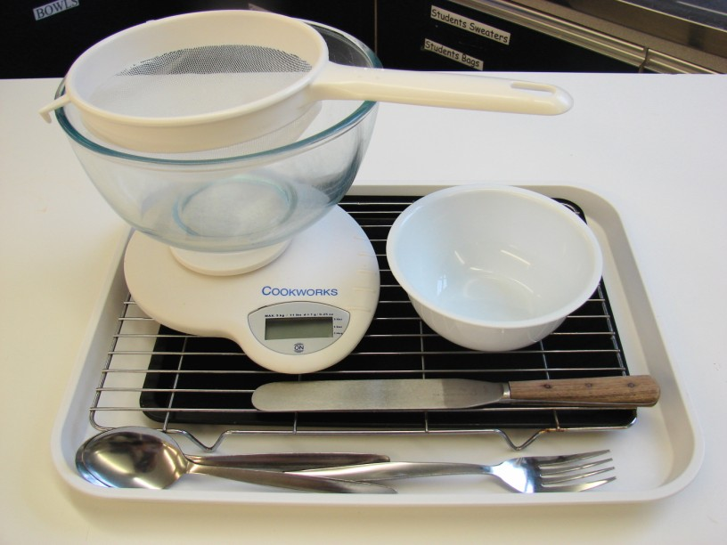
Sieve, mixing bowl, weighing scales, palette knife, small bowl, fork, spoons, non-stick baking tray (lined), cooling rack.

Containers

If students take their baked items home, they will need to bring (or be provided with by the school) a suitable container, such as a plastic tub and lid, or a paper bag.

