Energy needs

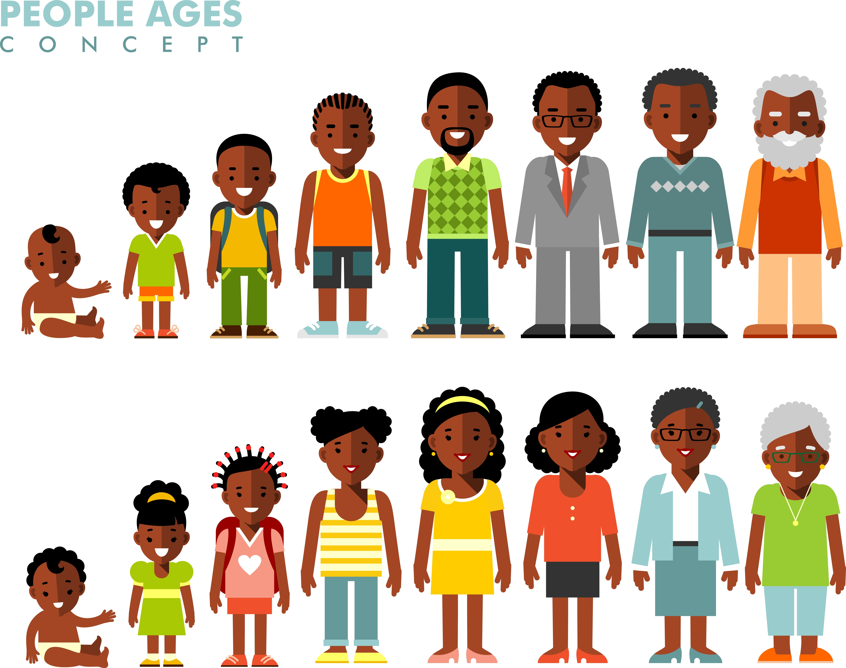
Take a look at the people on this sheet. With a partner or in a group, talk about how much energy you think they will need.

Think about
- What do you notice about the amount of energy you need throughout life?
- Why do some people need more energy than others?
What reasons can you give?

Energy needs
1 year old girl (3,000 kJ / 717 kcals)
5 year old boy (6,200 kJ / 1482 kcals)
10 year old girl (8,100 kJ / 1936 kcals)
10 year old boy (8,500 kJ / 2032 kcals)
16 year old boy (12,400 kJ / 2964 kcals)
45 year old lady (8,800 kJ / 2103 kcals)
75 year old man (9,600 kJ / 2294 kcals)

