Croque-monsieur

- List 5 different types of bread that could be used to make a croque-monsieur or toastie.

- Suggest 4 different toastie combinations, listing the ingredients for each.

- How could the croque-monsieur be made healthier?
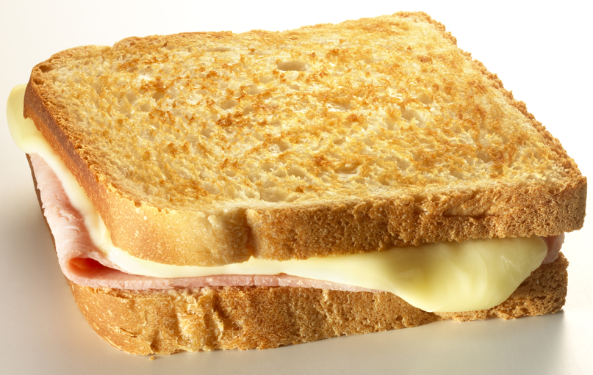

- What would be your top tips for using a hot grill?

