Paska (Eastern European Easter bead)

Ingredients
Complexity: medium

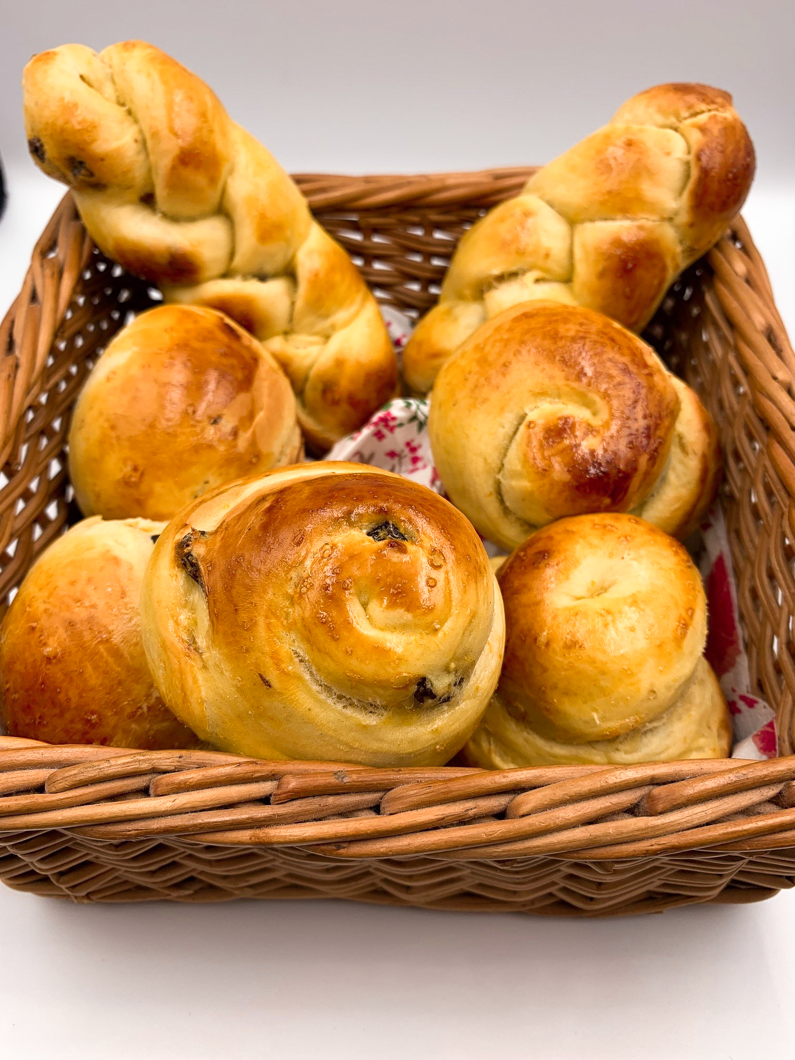
1 orange

1 egg

60ml milk

25g butter or reduced fat spread

35g sugar

250g strong flour

1 sachet quick action yeast

¼ x 5ml spoon salt

50g raisins (optional)

1 egg or 2 x 15ml spoon milk (for glazing)

Equipment
Baking tray and greaseproof paper or muffin tin and spray oil, zester or grater, vegetable knife, chopping board, juicer, small bowl, fork, microwavable bowl or jug, sieve, large mixing bowl, mixing spoon, knife, pastry brush.

Method
- Line a baking tray with greaseproof paper or spray a muffin tin with oil.
- Zest the orange.
- Cut the orange in half and juice.
- Crack the egg into a small bowl and beat with a fork.
- Place the milk, butter or spread and 35g sugar into a microwavable bowl or jug and microwave for 30 second intervals until the butter is melted. Take care that the liquid does not become too hot.
- Add the orange zest, juice and beaten egg to the warmed liquid and stir well.
- Sift the flour into a large mixing bowl and add the yeast, salt and raisins. Mix well.
- Add half the liquid to the mixing bowl and mix with a spoon. Add more liquid until the dough comes together in a soft, but not sticky ball. You may not need all the liquid.
- Turn onto the worksurface and knead for 8-10 minutes.
- Cut into 8 pieces and shape into rolls. Traditionally, religious shapes were made with part of the dough to decorate the bread/rolls.
- Alternatively, cut into 8 pieces and cook in a muffin tin. Spray the tin with oil before using.
- Separate the egg and brush the rolls with the egg yolk before baking. Alternatively, brush with milk.
- Place the bread into a COLD oven and then immediately turn up the heat to the highest temperature.
- Cook for 15-20 minutes, until golden brown.

Top tips
- Plait the dough and twist into a ramekin dish or clean small pineapple can.
- A lemon can be used instead of an orange, or the citrus fruit can be omitted altogether.
- To reduce food waste, freeze the egg white and defrost when needed.

Food skills
- Weigh
- Measure
- Zest
- Juice
- Beat
- Microwave
- Sieve
- Mix
- Knead
- Divide
- Form and shape
- Glaze
- Bake

Did you know?
After the strict fasting of Lent, many Eastern Europeans enjoy slightly sweet yeast loaves to celebrate. These loaves often have names that are some form of the word ‘Paska’ which means Easter.

Bulgarian Easter bread is known as Kozunak and is made at Christmas, Easter and other special occasions. It is an egg-rich braided loaf full of rum-soaked raisins.

Easter bread dolls (Primorski uskrsne bebe) are popular in Croatia and have twisted dough bodies and mini sugar coated chocolate eggs for heads.

Chałka is a Polish (Ho-kah) egg twist bread that may or may not contain raisins. It is similar to Bohemian-Czech hoska, Jewish challah, and French brioche.

Russian Easter bread takes the form of kulich, a tall, cylindrical sweet yeast-risen bread.

