Middle Eastern cuisines –

a brief overview

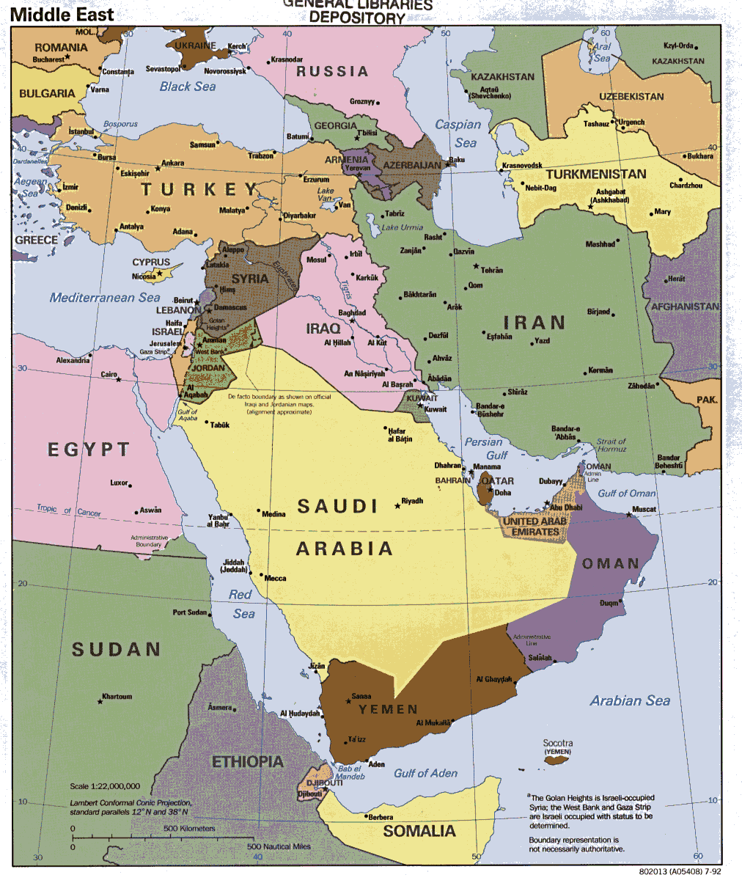
- The Middle East is an unofficial grouping of countries geographically located in the region where Asia touches Africa (to the west) and Europe (to the north).
- There is no definitive list of Middle Eastern countries, but the following are generally accepted as the core group: Bahrain, Iran, Iraq, Israel, Jordan, Kuwait, Lebanon, Oman, Palestine, Qatar, Saudi Arabia, Syria, Turkey, United Arab Emirates, Yemen. Often Egypt is also included and sometimes Cyprus.
- These countries are located primarily in Western Asia, Egypt is in North Africa, and a part of Turkey lies in Southeast Europe and therefore there is a wide variety of influences on food and cuisine in the region.
- Geographically the region is at the crossroads between Europe, Asia, the Caucasus and North Africa leading to exchange of food and recipes over the centuries.
- Religion also influences the cuisines; the most prominent religions practiced in the Middle East are Islam, Judaism, and Christianity. For example, lamb is the most popular meat as both Jews and Muslims do not eat pork.
- Around the Mediterranean area, Persian Gulf and the Red Sea there is a wide variety of seafood, river and lake fish are also widely consumed.
- With the holy shrines of Christianity, Islam and Judaism located in the Middle East, millions of pilgrims visit the region every year and enjoy the food and culture.
- The food is greatly influenced by the Mediterranean climate in the north of the region and is generally hot and dry.
Staple food
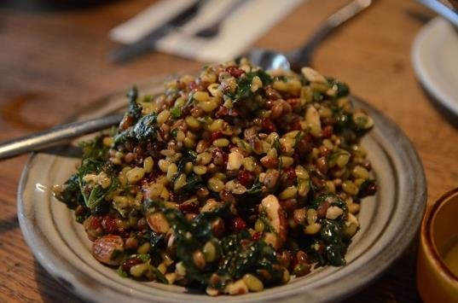
Grains are the staple food across the region and include wheat, rice and barley. Bread is popular in different forms and is eaten at almost every meal. Wheat is also used to make couscous, freekeh (young, green wheat) and Burghul (cracked wheat).
Popular breads
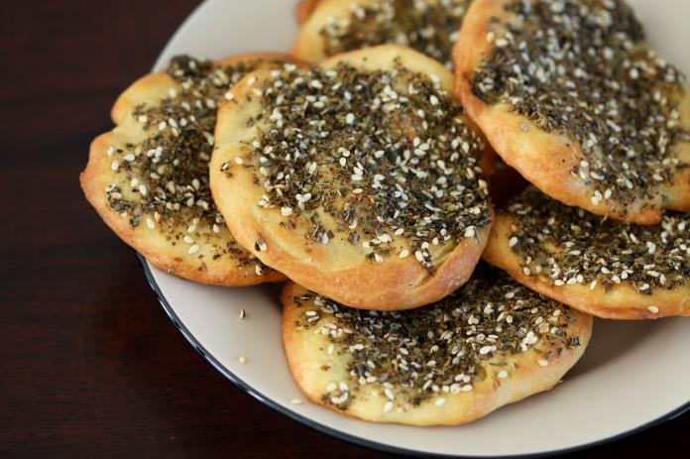
Lavash is a thin, soft flatbread popular in Turkey, Iran, and other Middle Eastern countries, is made with flour, water, and salt. Lavash is served with dips like​ hummus or baba ghanoush and used for wraps and other sandwiches.
Freekeh
Maneesh is another flatbread which has a flavoured with the popular za’atar spice mix. It is often served with a meze and topped with cheese.
Manaeesh

Pitta bread is well known around the world – as well as being served with dips it can easily be split and used as a pocket which can be filled with falafel, shawarma (barbecued meats), kufta (version of hamburgers), and/or salad.

Popular food and dishes
Hummus – a popular dish all over the world made by blending chickpeas with tahini, garlic, and citrus juice. It is often served as part of a mezze with pitta bread.
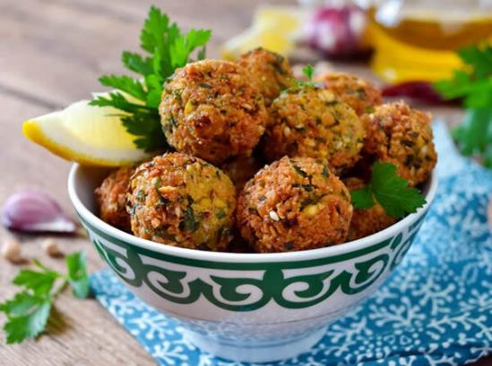
Falafel - is a popular Middle Eastern “fast food” made of a mixture of chickpeas, fresh herbs (parsley, coriander and dill), and spices (cumin, coriander, and cayenne pepper) that are formed into a small patties or balls. It’s thought that falafel originated in Egypt as Coptic Christians looked for a replacement for meat during long seasons of fasting or lent. As a street food they are often served hot with a tahini sauce or as a sandwich in warm pitta pockets with salad.
Fattoush is a bread salad, thought to have originated in Northern Lebanon. Lebanese farmers would fry leftover pita known as "Fatta," or "Fatte” and use it to top a seasonal salad with a dressing and the spice sumac – made from ground sumac berries which have a sharp, citrus flavour.

Did you know?
These dishes are well known around the world however, greater awareness of food from this region amongst modern consumers has allowed Middle Eastern cuisine to become more widespread with an increasing range of food and recipes available. Why? The Middle East has some of the highest social media usage in the world, food influencers are therefore connecting with a global community and sharing the diverse cuisines of the region.
Saudi Arabia
As part of Islamic and Bedouin culture, it is a great honour to be able to feed a traveller or visitor to the home. Food is often served on communal platters and eaten by hand.
The food is linked to the terrain (mainly dessert) and many traditional dishes reflect the ancient trade caravans and nomadic lifestyles of desert dwellers. A typical Saudi breakfast is simple, dates and qahwa (Arabic coffee) or bread with cheese.
Lunch is traditionally the main meal of the day, and nearly always includes a rice dish, like kabsa, considered the national dish of Saudi Arabia. Kabsa is richly spiced and is topped with roast chicken, meat or fish. Tomato and chili salsa is often served on the side with a simple chopped salad.

Oman
The cuisine of Oman is a mixture of Indian, Indonesian, Arab and East African influences. Various spices, herbs, onions, garlic and lime are widely used, but unlike other Arabic cuisines, the food of Oman is not hot. Chicken, mutton and fish are main ingredients, often accompanied by rice. The main meal in Oman is usually eaten at midday followed by a light dinner.

Popular dishes include Shuwa a dish traditionally served during festivals. It uses meat that has been seasoned with spices and herbs and then cooked very slowly, sometimes up to two days, in an underground oven. Maqbous, a rice dish that is yellow due to the saffron used. It is cooked and served over a spicy red or white meat. Mashuai is a dish that consists of a whole spit-roasted kingfish that is then served with lemon rice.

Omani Laban - Laban means sour milk in Arabic. The Omani Laban is made of yoghurt and buttermilk. It is a salty drink that is served everywhere in Oman and is usually flavoured with cardamon, mint or cumin.

Iran
The ancient Babylonians, Assyrians, Persians, Greeks, Romans, and Turks have all had an influence on Iranian culture and its cuisine – the food is very diverse across the provinces but is generally not heavily spiced.
Traditional Iranian food is mainly rice (plain or infused) aubergine, potato, beans, lentils, onions, and tomatoes. Meat dishes include lamb, beef, chicken and fish. Most popular are various kinds of kebabs (skewered meat), which are popular street foods. Yogurt is commonly used and there is often a ‘sour’ flavour to the dishes due to the addition of citrus or pomegranate.

Abgusht (means water and meat) is a stew which is traditionally known as Dizi too (the name of the stone pot in which it's prepared). It is a slow-cooked dish. Its main ingredients are lamb, chickpeas, white beans, onions, potatoes, tomatoes and dried lime. The liquid is then strained away and served in a bowl on the side, the diner given a pestle-type instrument to crush and mash to a pulp the solid part (gusht-e kubideh) which stays in the stone pot. It is typically served with flat bread (piti) and pickled vegetables.

Street food snacks are very popular and include steamed, spiced fava beans, Laboo - roasted red beets and Persian chickpea cookies.

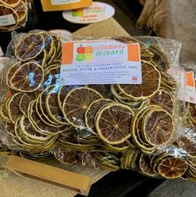
Ingredients popular in Middle Eastern cuisine
Dried limes (limoo amani) also known as black lime is a lime which has been dried and is used whole, sliced or ground. They add a smoky, sour flavour to dishes and are often used is soups and stews.
Advieh is a mixture of cinnamon, turmeric, ginger, cumin, caraway, coriander, cloves and cardamom. It is widely used in savoury meat dishes and in sweet Persian rice puddings.
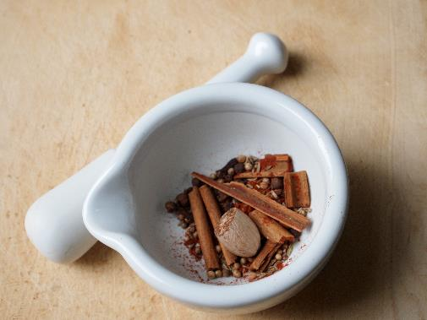
Baharat is a spice mix is used across the Middle East, with each area having its own addition to the basic mix of paprika, nutmeg, pepper, coriander, cinnamon, cardamom, cloves, cumin. In Persian cooking, dried black lime is often added to Baharat.

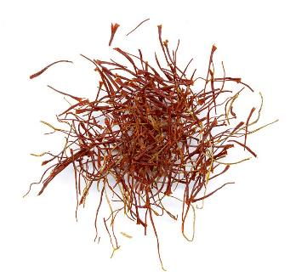
Barberries are small red berries similar to cranberries. They grow in the same areas as saffron and the two are often used together. They are used to flavour rice pilaff and often is stuffing for chicken dishes. The berries are also very high in pectin so are often used in jams or jellies.
Saffron – although expensive saffron is used in Persian cooking to flavour the rice, as well as with meat and poultry dishes and in some desserts.
Panir is the Persian word for cheese, however, it often refers specifically to a feta-like white cheese.
Rosewater is a fragrant extract made from steeping rose petals in oil, water or alcohol. Its delicate flavour and aroma is used extensively to flavour Iranian dishes and desserts.

