Rock cakes
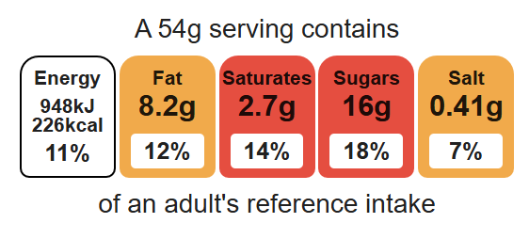
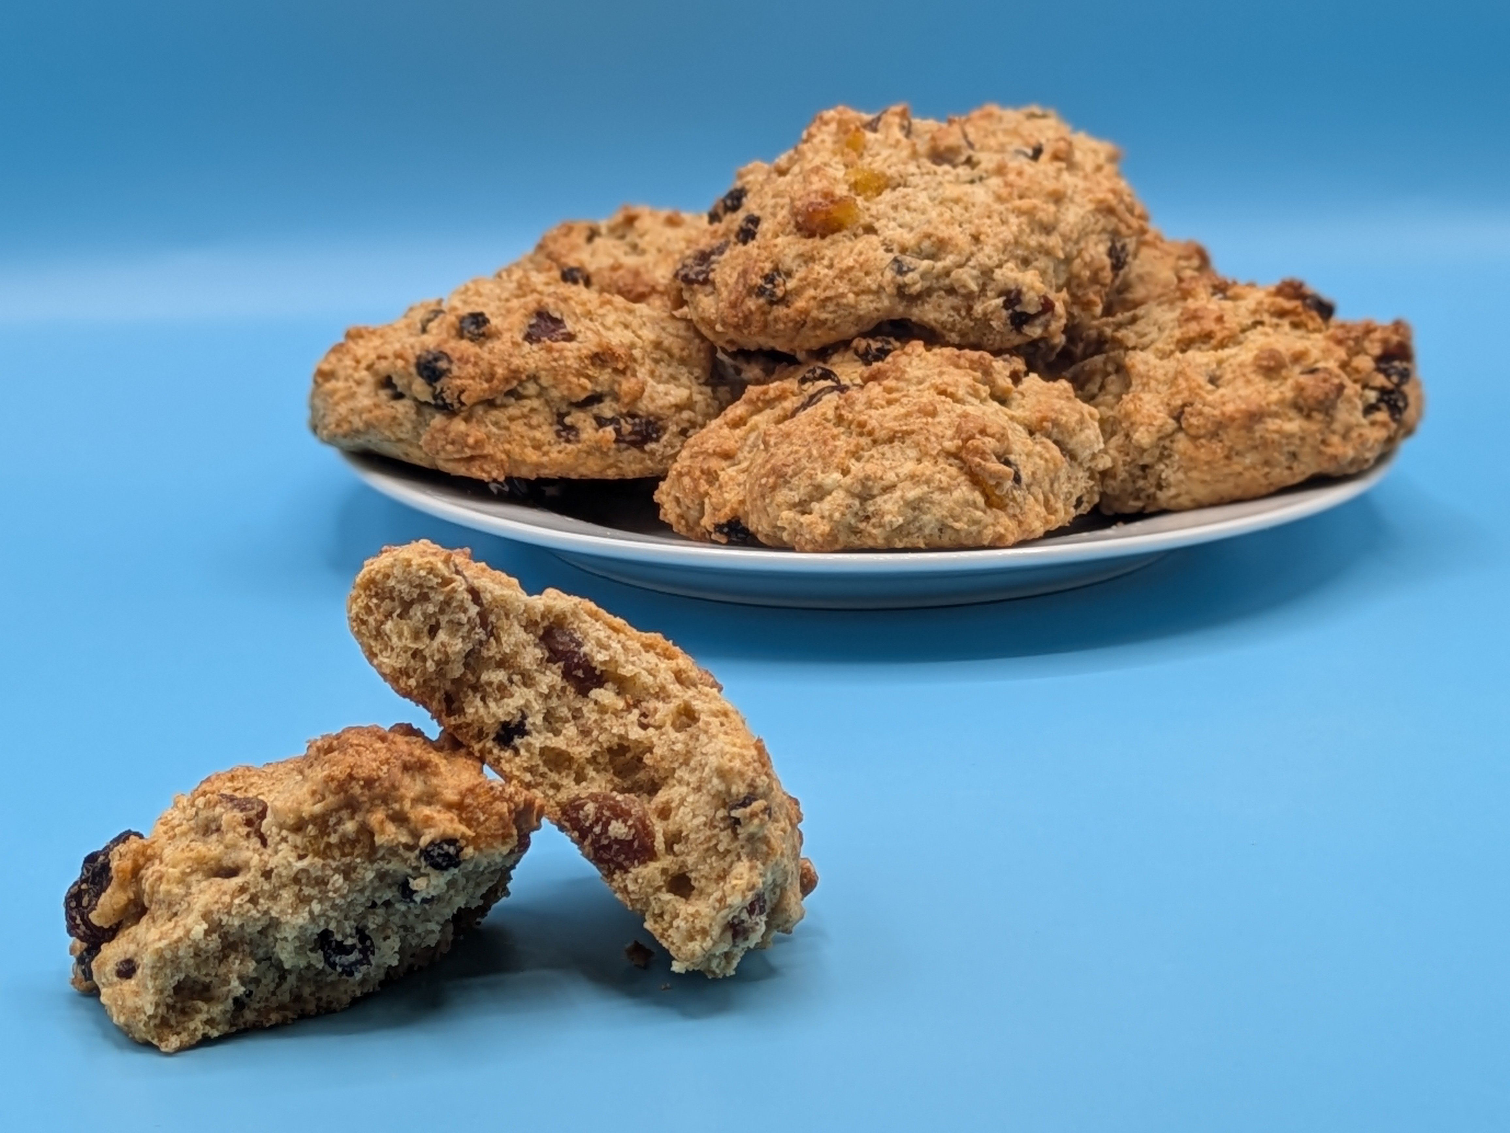

Equipment

Weighing scales

Sieve

Mixing bowl

Palette knife

Small bowl

Fork

2 metal spoons

Baking tray

Cooling rack

Complexity: Low – medium

Ingredients (makes 8)
100g self-raising white flour
100g self-raising wholemeal flour
75g baking fat/ block
75g caster sugar
75g mixed dried fruit
1 egg

Method
- Preheat oven to 220°C or gas mark 7.
- Line or grease the baking tray.
- Sift the flour into the bowl.
- Using your fingertips, rub the fat into the flour until it resembles breadcrumbs.
- Stir in the sugar and dried fruit.
- Crack the egg into a small bowl and whisk lightly.
- Make a well in the middle of the flour and carefully add the egg. Mix to form a soft, yet firm dough using the palette knife. Add a few drops of water or milk if the dough is too dry.
- Using 2 spoons, divide the dough into 8 ‘rocks’ and place on the baking tray.
- Bake for 12 – 15 minutes, until golden brown.
- Allow to cool on a cooling rack.

Top tips
- Turn up the flavour: Use 50g of desiccated coconut or cherries instead of dried fruit.
- Reduced food waste: Add leftover soft fruit such as blueberries or chopped strawberries.
- Focus on fibre: Replace the white flour with 50g wholemeal flour for an extra fibre boost.

Food skills
Weigh, sift, rub-in, mix, stir and combine, whisk, portion/ divide, form and shape, bake.

