Food commodities: Dairy
- Food is sourced, processed and sold in different ways
- Food production and processing ensures that food is edible and safe

Dairy farming
- There are thousands of dairy farms in the UK. The farming techniques and the size of dairy farms differ around the UK. Although different feed, housing and milking parlours may be used, the health and welfare of the dairy cows remains the highest priority for farmers.
- Dairy farms are mainly based in the western half of Britain where the warm, wet climate is ideal for grass growth.
- In the UK most cows eat grass during the summer and silage (dried grass or maize) in the winter. This is usually supplemented with dry feeds such as cereals and protein feeds to ensure they have a nutritionally balanced diet.
- Dairy cows eat 25-50kg of food a day and drink around 60 litres of water.
- A dairy cow needs to give birth to a calf to produce milk. A cow is milked 2-3 times a day and can produce around 22 litres of milk a day.
- Holstein-Friesen cows, which are black and white, are the most common type of dairy cow in the UK.
- Cows wear ear tags so they can be identified. Traceability from the farm is important when producing food.
- After milking, the milk is chilled and stored, ready to be taken away to be processed by the dairy.
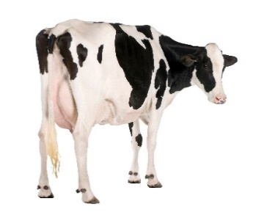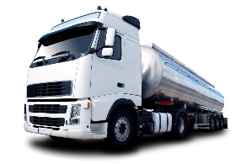

Processing cheese
- Pasteurisation - the first stage in the process of making cheese is the pasteurisation of the milk.
- Curdling - a starter culture, similar to freeze dried natural yogurt, is then added to the pasteurised milk. This begins to acidify the milk and allows the bacteria to grow and begin fermentation. Rennet is added so the milk curdles and separates into curds and whey. This is then drained on cooling tables.
- Cheddaring - as the liquid is drained off a solid mass is created, called curd mats, which are cut into sections and piled on top of each other and turned regularly. Salt is added to act as a preservative and to prevent the cheese from going rancid during the maturing process. It is then stored in a cool room to ripen.

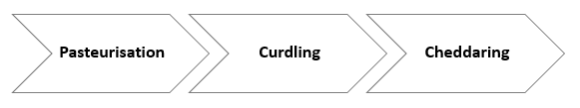
Processing milk
- After the milk is delivered to the dairy it is pasteurised. Pasteurisation is a process used to kill harmful microorganisms that may be present in the milk.
- Pasteurisation involves heating the milk to a temperature of no less than 71.7⁰C for 25 seconds. This process extends the shelf life of milk.
- The milk is then cooled for packing, labelling, storage, transportation and then distributed to retailers.
- Sterilisation is a process that destroys all micro-organisms present in a food.
- Ultra-heat treatment (UHT) destroys all micro-organisms in the food without causing as much damage to the product as sterilisation.
For more information, go to: https://bit.ly/3qhSK57
Types and nutrition of milk
There are a number of different types of milk available for consumers to buy. The fat content of cow’s milk will vary according to the type:
- Whole milk contains 3.5%
- Semi-skimmed milk 1.7%
- Skimmed milk is 0.1-0.3%

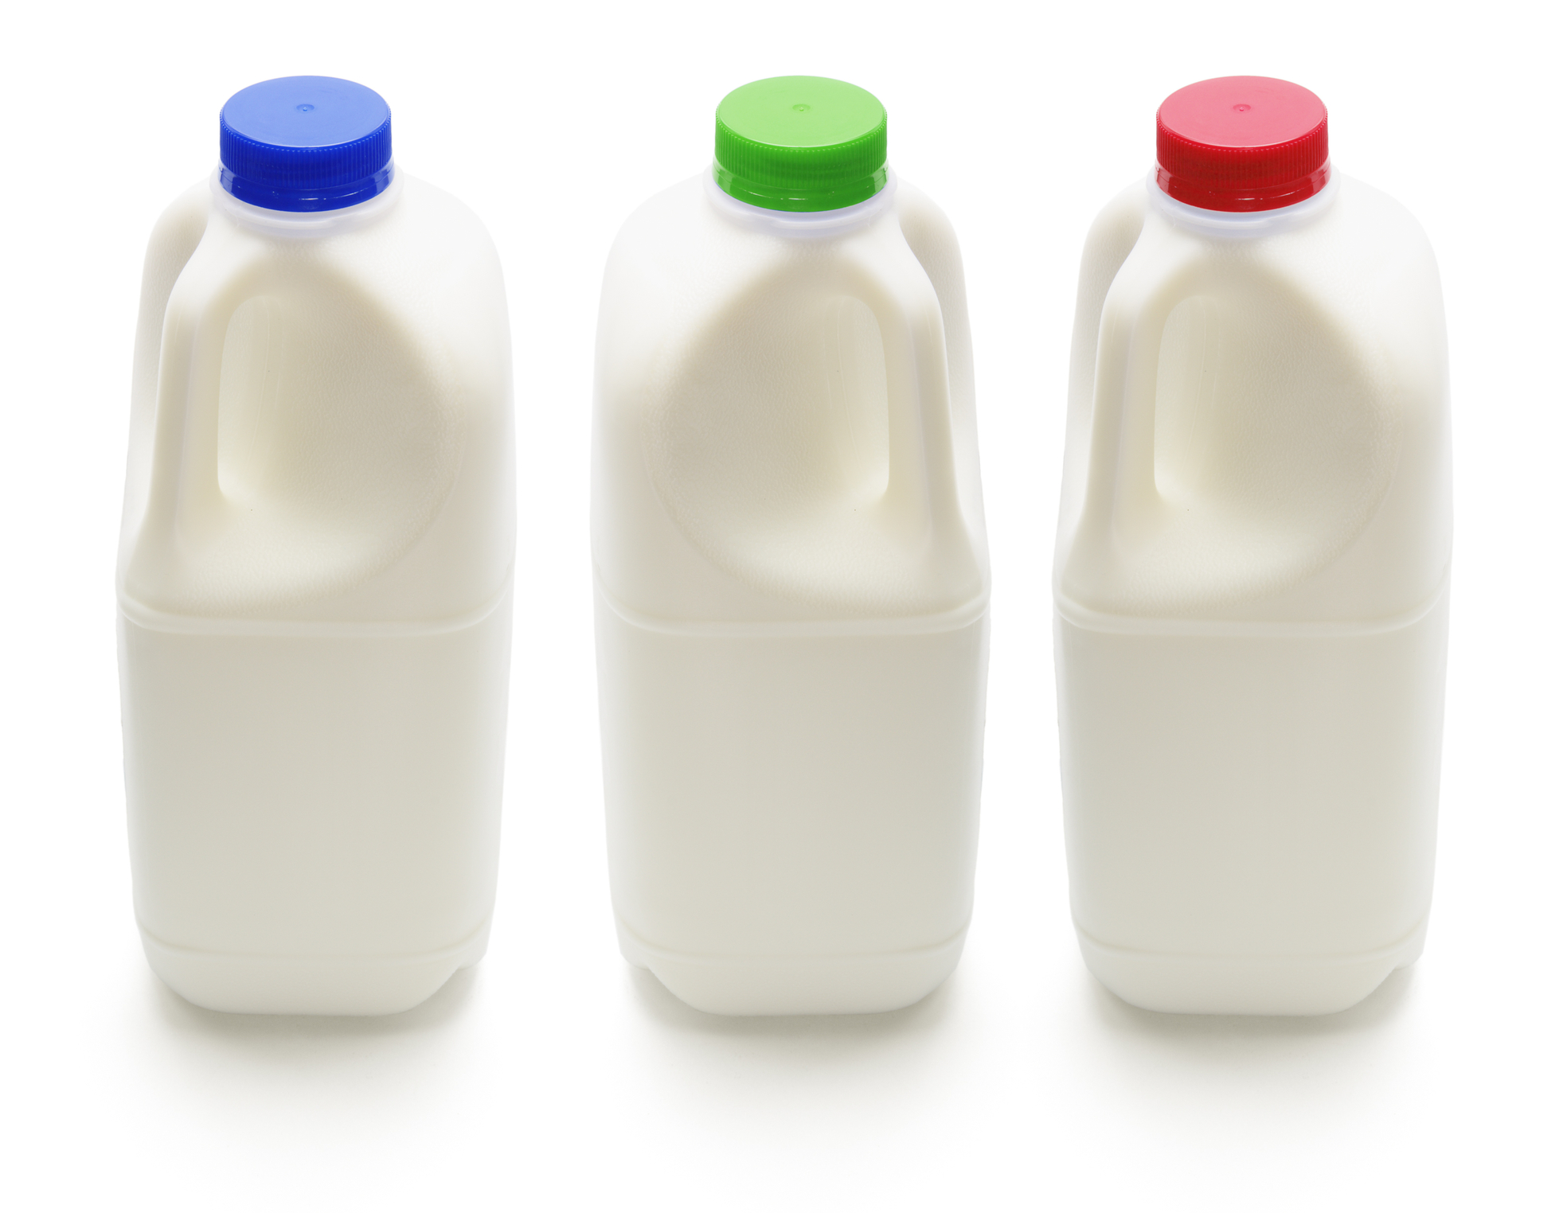
Dairy foods provide protein, calcium, B vitamins and iodine.
Dairy alternative milks include oat, soy, coconut, almond. Choose those that are fortified with calcium and ideally other vitamins and minerals.
Tasks
- Create an infographic on dairy farming in the UK.
- Research and explain the different stages involved with producing cheese.

Regional cheese
In the UK, there are a variety of regional cheeses.
Some that are unique to a region and have protected name status.


Other dairy foods
There are different types of dairy products, which are defined as foods made from the milk of animals. These include:
- butter;
- condensed milk;
- cream;
- ice cream;
- milk powder;
- yogurt.

Key terms
Milking: The primary process in making dairy products.
Milking parlour: A building where cows are milked on a dairy farm.
Traceability: A system to track food through the stages of production, processing and distribution.
Pasteurisation: The process of heating food to kill most food spoilage organisms and pathogenic organisms, e.g., milk.
Sterilisation: The severe heating of food to kill all micro-organisms, e.g., sterilised milk.
Ultra-heat treatment (UHT): The heating of food to kill or inactivate all micro-organisms without causing damage to the product, e.g., UHT milk.
Rennet: A mixture of enzymes in cheese production. Makes the milk ‘curdle’.
Curds: A solid product formed during cheesemaking, through coagulation.
Whey: The liquid remaining after the curds have been separated from the milk.
Cheddaring: A secondary process in making cheese.

For example, West Country Farmhouse Cheddar will have met the conditions of being made with milk from herds reared and milked in Cornwall, Devon, Somerset or Dorset and following the traditional process of cheddaring. Cheddar is matured for at least 9 months.

The dairy industry
In Britain, we drink about 6 billion litres of milk each year. Of all the milk produced on British dairy farms, just under half is for drinking and the rest is made into cheese, yogurt and other dairy products.
